**Sri Venkateshwaraa College of Engineering & Technology**

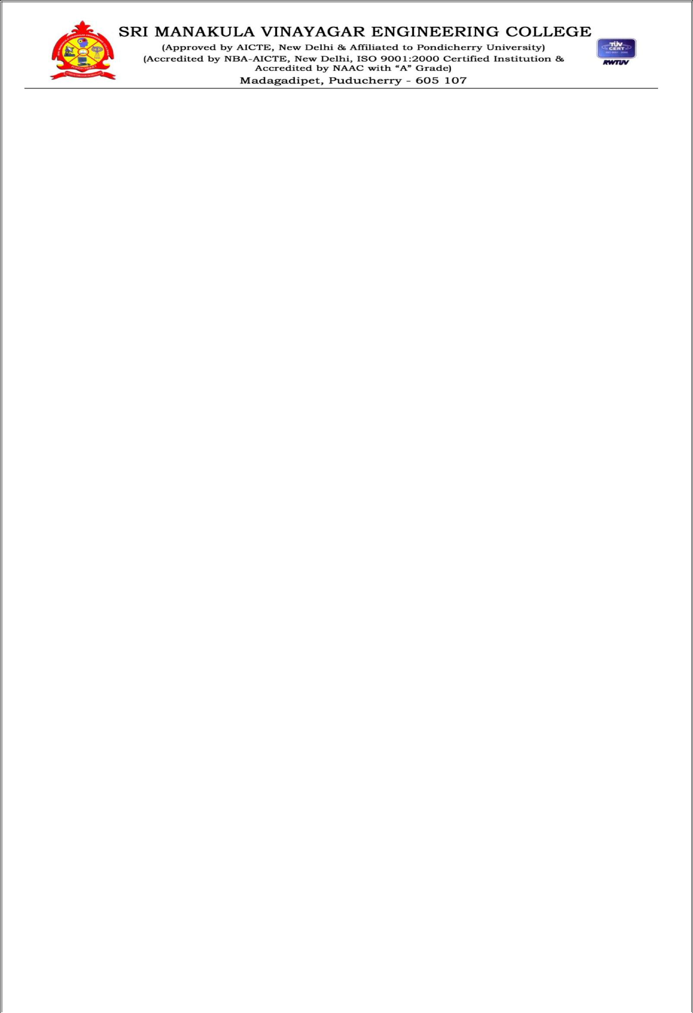

**Department of Computer Science and Engineering**

Subject Name: **COMPUTER HARDWARE AND NETWORK TROUBLESHOOTING**

Subject Code: **CS T72**

**Prepared By :**

Dr. N. Balaji, Professor & HOD / CSE

**Verified by:** **Approved by:**

**UNIT – II**



**Mother board components:** Chip sets **–** TraditionalNorth/South Bridge architecture–Sixth andSeventh generation Chipsets – VIA, SiS and NVIDIA chipsets. Desktop versus Laptop motherboards.

**Bus standards:** ISA–PCI–PCI Express–AGP–MCA–System Resources–Interrupts–DMAchannels – I/O Port addresses.

**Power Supply:** SMPS–Power specifications - Connectors–Switches–RTC/NVRAM batteries.

**BIOS:** Shadowing–Upgrading–CMOS setup–Plug and Play–Error messages.



**2 Marks**

1. **Write the Mother board Components?**
   * Chipsets
   * Northbridge
   * Southbridge
2. **What is meant by Chipsets?**

The chipset is the "glue" that connects the microprocessor to the rest of the motherboard and therefore to the rest of the computer. On a PC, it consists of two basic parts -- the **Northbridge** and the **Southbridge**.

1. **What is meant by Northbridge?**

The north bridge connects directly to the processor via the front side bus (FSB). A memory controller is located on the north bridge, which gives the CPU fast access to the [memory.](http://computer.howstuffworks.com/computer-memory.htm) The north bridge also connects to the AGP or [PCI Express](http://computer.howstuffworks.com/pci-express.htm) bus and to the memory itself.

1. **What is meant by Southbridge?**

The south bridge is slower than the north bridge, and information from the CPU has to go through the north bridge before reaching the south bridge. Other busses connect the south bridge to the PCI bus, the [USB](http://computer.howstuffworks.com/usb.htm) ports and the [IDE](http://computer.howstuffworks.com/ide.htm) or SATA hard disk connections.

**1** **Computer Hardware and Network Troubleshooting**

**Sri Venkateshwaraa College of Engineering & Technology**

1. **Define Bus?**

A bus is a circuit that connects one part of the motherboard to another. The more data a bus can handle at one time, the faster it allows information to travel. The **speed** of the bus, measured in megahertz (MHz).

1. **What is ISA?**

Industry Standard Architecture (ISA) is a computer [bus](http://en.wikipedia.org/wiki/Bus_%28computing%29) standard for [IBM PC compatible](http://en.wikipedia.org/wiki/IBM_PC_compatible) computers introduced with the [IBM Personal Computer](http://en.wikipedia.org/wiki/IBM_Personal_Computer) to support its [Intel 8088microprocessor's](http://en.wikipedia.org/wiki/Intel_8088) 8-bit external data bus and extended to 16 bits for the [IBM Personal Computer/AT's](http://en.wikipedia.org/wiki/IBM_Personal_Computer/AT) [Intel 80286](http://en.wikipedia.org/wiki/Intel_80286) processor.

1. **What is EISA?**

The ISA bus was further extended for use with 32-bit processors as [Extended Industry StandardArchitecture](http://en.wikipedia.org/wiki/Extended_Industry_Standard_Architecture) (EISA). For general desktop computer use it has been supplanted by later buses such as [IBM Micro Channel,](http://en.wikipedia.org/wiki/Micro_Channel_architecture) [VESA Local Bus,](http://en.wikipedia.org/wiki/VESA_Local_Bus) [Peripheral Component Interconnect](http://en.wikipedia.org/wiki/Peripheral_Component_Interconnect) and other successors. A derivative of the AT bus structure is still used in the [PC/104](http://en.wikipedia.org/wiki/PC/104) bus, and internally within[Super I/O](http://en.wikipedia.org/wiki/Super_I/O) chips.

1. **What is PCI? (APR 2011)**

The PCI-Bus (Peripheral Component Interconnect) was originally designed to speed up the display of graphics on Intel-based personal computers, but the standard itself is processor independent and suitable for other hardware add-ons that require high bandwidth, including network, video and SCSI.

1. **Write about MCA? (NOV 2014)**

MCA stands for "Micro Channel Architecture." It is an expansion bus created by IBM that was used in the company's PS/2 desktop computers. An expansion bus allows additional cards to be connected to the computer's motherboard, expanding the number of I/O ports. These include SCSI, USB, Firewire, AGP, and DVI connections, as well as many others.

1. **State the purpose of SMPS. (NOV 2014)**
2. **Define SMPS?**

A switched-mode power supply (switching-mode power supply, SMPS, or switcher) is an electronic [power supply](http://en.wikipedia.org/wiki/Power_supply) that incorporates a switching regulator to convert electrical power efficiently. Like other power supplies, an SMPS transfers power from a source, like [mains power,](http://en.wikipedia.org/wiki/Mains_electricity) to a load, such as a [personal computer,](http://en.wikipedia.org/wiki/Personal_computer) while converting [voltage](http://en.wikipedia.org/wiki/Voltage) and [current](http://en.wikipedia.org/wiki/Electric_current) characteristics. An SMPS is usually employed to efficiently provide a regulated output voltage, typically at a level different from the input voltage.

1. **Give the types of SMPS?**

Switched-mode power supplies can be classified according to the circuit topology.

* + [Buck converter](http://en.wikipedia.org/wiki/Buck_converter) (single [inductor;](http://en.wikipedia.org/wiki/Inductor) output voltage < input voltage)
  + [Boost converter](http://en.wikipedia.org/wiki/Boost_converter) (single inductor; output voltage > input voltage)

**2** **Computer Hardware and Network Troubleshooting**

**Sri Venkateshwaraa College of Engineering & Technology**

* + - * [buck-boost converter](http://en.wikipedia.org/wiki/Buck-boost_converter) (single inductor; output voltage can be more or less than the input voltage)
      * [fly back converter](http://en.wikipedia.org/wiki/Flyback_converter) allows multiple outputs and input-to-output isolation
      * Half-Forward Topology
      * [Push-Pull Topology](http://en.wikipedia.org/wiki/Push-pull_converter)
      * Half-Bridge Topology
      * Full-Bridge Topology
      * Resonance, zero voltage switched
  1. **What is meant by power supply unit (PSU)?**

A **power supply unit** (**PSU**) converts [mains AC](http://en.wikipedia.org/wiki/Mains_electricity) to low-voltage regulated DC power for the internal components of the computer. Modern personal computers universally use a [switched-mode powersupply.](http://en.wikipedia.org/wiki/Switched-mode_power_supply) Some power supplies have a manual selector for input voltage, while others automatically adapt to the supply voltage.

* 1. **Write some power supply connectors?**
     + PC Main power connector (usually called P1)
     + 12V only power connector (labelledP1, with the ATX 20 or 24 pin connector)
     + 12V only System monitoring (P10)
     + ATX12V 4-pin power connector (also called the P4 power connector)
     + 4-pin Peripheral power connectors
     + 4-pin Molex (Japan) Ltd power connectors (usually called Mini-connector)
     + Auxiliary power connectors
     + [Serial ATA](http://en.wikipedia.org/wiki/Serial_ATA#Power_supply) power connectors
     + 6-pin and 6+2 pin

1. **What is RTC/NVRAM Batteries (CMOS Chips)?**

All 16-bit and higher systems have a special type of chip in them that combines a real-time clock (RTC) with at least 64 bytes (including the clock data) of Non-Volatile RAM (NVRAM) memory. This chip is officially called the RTC/NVRAM chip but is often referred to as the CMOS chip or CMOS RAM because the type of chip used is produced using a CMOS (Complementary Metal-Oxide Semiconductor) process.

1. **What do you mean by BIOS? (NOV 2012)**

BIOS, in [computing,](http://en.wikipedia.org/wiki/Computing) stands for Basic Input/output System also incorrectly known as Basic Integrated Operating System. BIOS refer to the [software code](http://en.wikipedia.org/wiki/Source_code) run by a computer when first powered on.

1. **What is Shadowing in BIOS?**

A technique used to increase a [computer's](http://www.webopedia.com/TERM/C/computer.html) speed by using high-speed [RAMmemory](http://www.webopedia.com/TERM/R/RAM.html) in place of slower [ROM](http://www.webopedia.com/TERM/R/ROM.html) memory (RAM is about three times as fast as ROM). On [PCs,](http://www.webopedia.com/TERM/P/PC.html) for example, all [code](http://www.webopedia.com/TERM/C/code.html) to control hardwaredevices, such as [keyboards,](http://www.webopedia.com/TERM/K/keyboard.html) is normally [executed](http://www.webopedia.com/TERM/E/execute.html) in a special ROM [chip](http://www.webopedia.com/TERM/C/chip.html) called

**3** **Computer Hardware and Network Troubleshooting**

**Sri Venkateshwaraa College of Engineering & Technology**

the [*BIOS ROM*.](http://www.webopedia.com/TERM/B/BIOS.html) However, this chip is slower than the general-purpose RAM that comprises [mainmemory.](http://www.webopedia.com/TERM/M/main_memory.html) Many PC manufacturers, therefore, configure their PCs to [copy](http://www.webopedia.com/TERM/C/copy.html) the BIOS code into RAM when the computer [boots.](http://www.webopedia.com/TERM/B/boot.html) The RAM used to hold the BIOS code is called *shadow RAM.*

1. **What is Upgrading?**

A [software upgrade](http://financialsoft.about.com/od/glossaryindexu/g/Upgrade_def.htm) is a purchase of a newer version of software you currently use of a more fully-featured version of your current software. There is usually a cost for a software upgrade, although you can often upgrade at a reduced price.

1. **What is CMOS?**

A complementary metal oxide [semiconductor](http://www.wisegeek.com/how-do-semiconductors-work.htm) (CMOS) is a type of integrated circuit technology. The term is often used to refer to a battery-powered chip found in many [personal computers](http://www.wisegeek.com/what-are-personal-computers.htm) that holds some basic information, including the date and time and system configuration settings, needed by the basic input/output system [(BIOS)](http://www.wisegeek.com/what-is-bios.htm) to start the computer.

1. **What is PnP?**
2. **What is meant by Plug and Play? (NOV 2013)**

In [computing,](http://en.wikipedia.org/wiki/Computing) plug and play is a term used to describe the characteristic of a [computer bus,](http://en.wikipedia.org/wiki/Computer_bus) or device specification, which facilitates the discovery of a hardware component in a system, without the need for physical device configuration, or user intervention in resolving resource conflicts.

**22. Define Error Messages?**

An **error message** is information displayed when an unexpected [computer](http://en.wikipedia.org/wiki/Computer) or other device. On modern operating systems with messages are often displayed using [dialog boxes.](http://en.wikipedia.org/wiki/Dialog_box)

**23. Define IDE. (NOV 2010)**

condition occurs, usually on a [graphical user interfaces,](http://en.wikipedia.org/wiki/Graphical_user_interfaces) error

**Integrated Drive Electronics** or **IBM Disc Electronics**, **IDE** is more commonly known as[**ATA**](http://www.computerhope.com/jargon/a/ata.htm)or **Parallel ATA** (**PATA**) and is a standard interface for IBM compatible hard drives and CD or DVD drives. IDE is different from the Small Computer Systems Interface [(SCSI)](http://www.computerhope.com/jargon/s/scsi.htm) and Enhanced Small Device Interface (ESDI) because its controllers are on each drive, meaning the drive can connect directly to the motherboard or controller. IDE and its updated successor, Enhanced IDE (EIDE), are common drive interfaces found in IBM compatible computers. Below is a picture of the IDE connector on the back of a hard drive, a picture of what an IDE cable looks like, and the IDE channels it connects to on the motherboard.

1. **Differentiate LAN and WAN. (NOV 2010)**

A **LAN** (local area network) is a group of computers and network devices connected together, usually within the same building. By definition, the connections must be high speed and relatively inexpensive (e.g., token ring or Ethernet).

A **WAN**(wide area network), in comparison to a LAN, is not restricted to a geographical location, although it might be confined within the bounds of a state or country. A WAN connects several LANs, and may be limited to an enterprise (a corporation or an organization) or accessible to the

**4** **Computer Hardware and Network Troubleshooting**

**Sri Venkateshwaraa College of Engineering & Technology**

public. The technology is high speed and relatively expensive. The Internet is an example of a worldwide public WAN.

1. **Define MODEM. (APR 2011), (APR 2012)**

Modulator-demodulator. [Electronic](http://www.businessdictionary.com/definition/electronic.html) [device](http://www.businessdictionary.com/definition/device.html) that allows computers to communicate over [telephone](http://www.businessdictionary.com/definition/telephone.html)[wires.](http://www.businessdictionary.com/definition/wire.html)One [computer's](http://www.businessdictionary.com/definition/computer.html) modem converts its [digital signals](http://www.businessdictionary.com/definition/digital-signal.html) into [analog signals.](http://www.businessdictionary.com/definition/analog-signal.html) The other computer's modem reconverts the analog [signals](http://www.businessdictionary.com/definition/signal.html) into digital signals. [Conversion](http://www.businessdictionary.com/definition/conversion.html) of one type of signals to another is [called](http://www.businessdictionary.com/definition/call.html) [modulation,](http://www.businessdictionary.com/definition/modulation.html) their reconversion to the [original](http://www.businessdictionary.com/definition/original.html) type is called demodulation.

1. **Expand SCSI. (APR 2012) , (NOV 2012)**

The Small Computer System Interface (SCSI) is a set of parallel interface standards developed by the American National Standards Institute (ANSI) for attaching printers, disk drives, scanners and other peripherals to computers. SCSI (pronounced "skuzzy") is supported by all major operating systems.

1. **Write an example of peripheral devices. (NOV 2012)**

A peripheral device connects to a computer system to add functionality. Examples are a mouse, keyboard, monitor, printer and scanner.

1. **What are the two types of system boards? (NOV 2012)**

AT Motherboard ATX Motherboard

1. **Expand: ISA, PCI, MCA and SMPS. (NOV 2013)**

ISA– Industry Standard Architecture

PCI– Peripheral Component Interconnect

MCA – Micro Channel Architecture SMPS – Switched-mode power supplies

**5** **Computer Hardware and Network Troubleshooting**

**Sri Venkateshwaraa College of Engineering & Technology**

* 1. **MARKS**

1. **What are the Components available in the Mother board? Explain Briefly.**
2. **Describe the detail about mother board architecture. (NOV 2012)**

**COMPONENTS**

1. System Case ( with SMPS)
2. Motherboard
3. RAM
4. Processor
5. Processor Fan
6. Hard Disk Drive
7. Floppy Disk Drive
8. CD-ROM Drive
9. Power Cord
10. Mouse
11. Keyboard
12. Monitor
13. IDE and Floppy Data Cables
14. Power Cords

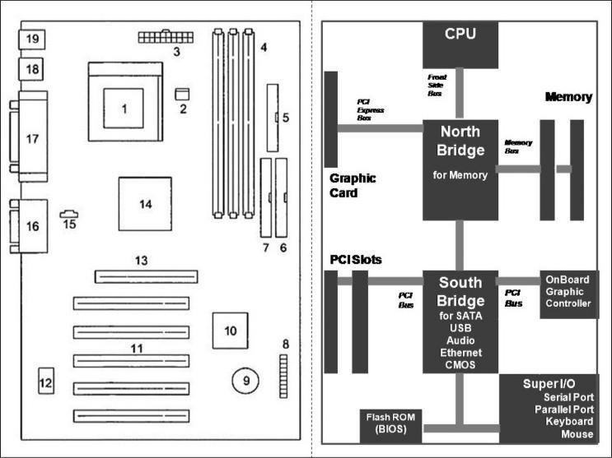

Mother board architecture diagram

A motherboard is one of the most essential parts of a computer system. It holds together many of the

crucial components of a computer, including the central processing unit (CPU), memory and connectors

for input and output devices. The base of a motherboard consists of a very firm sheet of non-conductive

material, typically some sort of rigid plastic. Thin layers of copper or aluminum foil, referred to as

*traces*, are printed onto this sheet. These traces are very narrow and form the circuits between the

various components. In addition to circuits, a motherboard contains a number of sockets and slots to

connect the other components.

**6** **Computer Hardware and Network Troubleshooting**

**Sri Venkateshwaraa College of Engineering & Technology**

* + A CPU socket - the actual CPU is directly soldered onto this socket. Since high speed CPUs generate a lot of heat, there are heat sinks and mounting points for fans right next to the CPU socket.
  + A power connector to distribute power to the CPU and other components.
  + Slots for the system's main memory, typically in the form of DRAM chips.
  + A chip forms an interface between the CPU, the main memory and other components. On many types of motherboards this is referred to as the Northbridge. This chip also contains a large heat sink.
  + A second chip controls the input and output (I/O) functions. It is not connected directly to the CPU but to the Northbridge. This I/O controller is referred to as the Southbridge. The Northbridge and Southbridge combined are referred to as the *chipset*.
  + Several connectors, which provide the physical interface between input and output devices and the motherboard. The Southbridge handles these connections.
  + Slots for one or more hard drives to store files. The most common types of connections are Integrated Drive Electronics (IDE) and Serial Advanced Technology Attachment (SATA).
  + A Read-only memory (ROM) chip, which contains the firmware, or startup instructions for the computer system. This is also called the BIOS.
  + A slot for a video or graphics card. There are a number of different types of slots, including Accelerated Graphics Port (AGP) and Peripheral Component Interconnect Express (PCIe).
  + Additional slots to connect hardware in the form of Peripheral Component Interconnect (PCI) slots.

1. **Explain briefly about Chipset.**

**The chip set**

The motherboard’s busses are regulated by a number of controllers. These are small circuits which have been designed to look after a particular job, like moving data to and from EIDE devices (hard disks, etc.).

A number of controllers are needed on a motherboard, as there are many different types of hardware devices which all need to be able to communicate with each other. Most of these controller functions are grouped together into a couple of large chips, which together comprise the *chip set*.

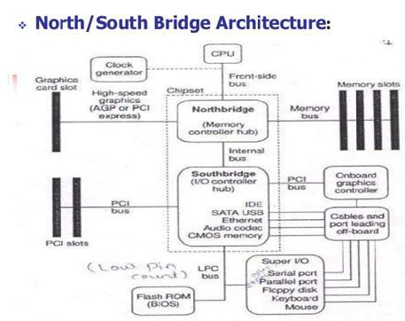

Fig. 2.1 The two chips which make up the chipset, and which connect the motherboard’s busses.

**7** **Computer Hardware and Network Troubleshooting**

**Sri Venkateshwaraa College of Engineering & Technology**

The most widespread chipset architecture consists of *two* chips, usually called the *north* and *southbridges*. This division applies to the most popular chipsets from VIA and Intel. The north bridge andsouth bridge are connected by a powerful bus, which sometimes is called a *link channel*:

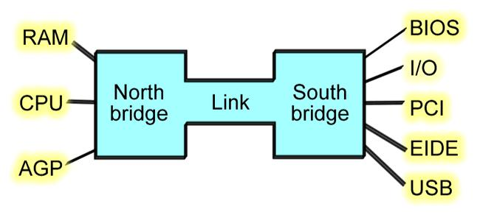

Fig. 2.2 The north bridge and south bridge share the work of managing the data traffic on the motherboard.

**The north bridge**

The north bridge is a controller which controls the flow of data between the CPU and RAM, and to the AGP port.

The north bridge, which has a large heat sink attached to it. It gets hot because of the often very large amounts of data traffic which pass through it.

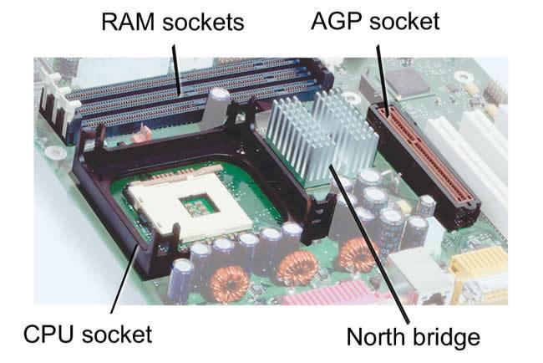

Fig. 2.3. The north bridge and its immediate surroundings. A lot of traffic runs through the north bridge, hence the heat sink.

The AGP is actually an I/O port. It is used for the video card. In contrast to the other I/Odevices, the AGP port is connected directly to the north bridge, because it has to be as close to the RAM as possible. The same goes for the PCI Express x16 port, which is the replacement of AGP in new motherboards.

**The south bridge**

The south bridge incorporates a number of different controller functions. It looks after the transfer of data to and from the hard disk and all the other I/O devices, and passes this data into the link channel which connects to the north bridge. The south bridge is physically located close to the PCI slots, which are used for I/O devices.

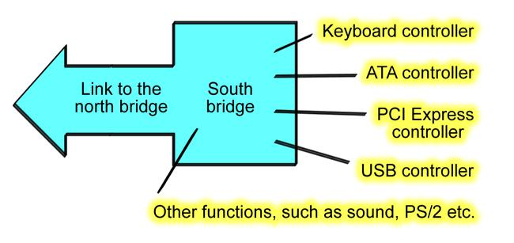

Fig.2.4 The chipset’s south bridge combines a number of controller functions into a single chip.

**8** **Computer Hardware and Network Troubleshooting**

**Sri Venkateshwaraa College of Engineering & Technology**

1. **Write about Sixth and Seventh generation Chipsets.**

Sixth generation chipsets:

* P6
* Pentium Pro
* Pentium II
* Pentium III

Pentium Pro, Celeron and Pentium II/III were essentially the same processor with different cache designs and minor internal revisions, the same chipsets could be used for socket 8(Pentium Pro), Socket370 (Celeron /Pentium III) and Slot 1 (Celeron/Pentium II/III) designs.

Pentium Pro chipsets:

* 450KK(Orion)
* 450GX(Orion Server)
* 450FX(Natoma)

P6 Processor chipsets:

* 440 FX
* 440 LX
* 440 EX

P6 (Pentium III/Celeron) processor chipsets

|  |  |  |  |  |  |
| --- | --- | --- | --- | --- | --- |
| • | 810 | • | 440EX | • | 820 E |
| • | 810E | • | 440 GX | • | 840 |
| • | 8153 | • | 440 NX | • | 815 P |
| • | 815 E3 | • | 440 ZX | • | 815 EG |
| • | 815 EP | • | 820 | • | 815 G |

Seventh/ Eighth generation chipsets:

The Pentium 4 and Celeron processors using Socket 423 and those made for Socket 478 are essentially the same processors with different cache designs and minor internal revisions, So the same chipset can be used for both processors. The Pentium 4 processor in Socket 775 is different from its predecessors, consequently, most 9XX series chipsets support only the Socket 775 version of the Pentium 4 as well as the newer core 2 series of processors.

Pentium 4 8XX series chipsets:

|  |  |  |  |  |  |
| --- | --- | --- | --- | --- | --- |
| • | 850 | • | 865 PE | • | 865 G |
| • | 850E | • | 845 GL | • | 865 GV |
| • | 845 | • | 845 G | • | 875 |
| • | 845E | • | 845 GE | • | 848 P |
| • | 848 P | • | 845 GV | • | 865 P |
| • | 865 P | • | 845 PE | • | 865 PE |

Intel 9XX series chipsets for Pentium 4:

* 910 GL
* 915 P
* 915 PL

**9** **Computer Hardware and Network Troubleshooting**

**Sri Venkateshwaraa College of Engineering & Technology**

Intel 9XX series chipsets for Core 2, Pentium D, Pentium Extreme Edition and Pentium 4:

|  |  |  |  |  |  |
| --- | --- | --- | --- | --- | --- |
| • | 975 X | • | 915 GL | • | 945 P |
| • | 955 X | • | 925 X | • | 945 PL |
| • | 915 G | • | 925 XE |  |  |
| • | 915 GV | • | 945 G |  |  |

1. **Explain briefly about third party chipsets VIA, SiS and NVIDIA. VIA chipsets**

VIA Technologies, Inc., was the largest chipset and processor supplier outside of Intel and AMD. Originally founded in 1987, VIA is based in Taipei, Taiwan, and is the largest integrated cir- cuit design firm on the island. VIA is a fabless company, which means it farms out the manufacturing to other companies with chip foundry capability.

VIA Technologies produced a number of chipsets for Pentium 4 processors in its P4X, P4M, PT8 and PM8 series, as well as South Bridge chips (VT series). The PT8 and PM series also supported Intel’s Core 2 processors.

**SiS chipsets**

SiS offered several chipsets for Intel processors, including integrated chipsets, chipsets for use with dis- crete video accelerator cards, and some that support Rambus RDRAM. SiS chipsets for the Pentium 4 and Pentium D use one of several high-speed South Bridge equivalents (SiS 96x series Media I/O chips) instead of integrating North and South Bridge functions into a single chip.

SiS has produced a variety of chipsets for the Athlon, Duron, Athlon XP and Athlon 64 processors, some of which use a single-chip design and others of which use a high-speed two-chip design similar to other vendors’ chipsets.

**NVIDIA chipsets**

NVIDIA, although best known for its popular GeForce line of graphics chipsets, also became a popular vendor of chipsets for the AMD Athlon/Duron/Athlon XP processor family thanks to its nForce prod- uct families. The original nForce was a descendant of the custom chipset NVIDIA created for the Microsoft Xbox console game system.

NVIDIA produced chipsets for Intel processors from the Pentium 4 through the Core 2 Extreme series. Current offerings include the nForce 600 and nForce 700i series, and the GeForce 7 and GeForce 9000 series with integrated video.

**6.** **Compare Desktop vs Laptop motherboards.**

Personal computing began in the early 1970s and has since evolved to suit the needs and wishes of consumers of all types. The motherboard is the central nervous system of personal computers, and they differ greatly between desktops and laptops.

**Layout**

Modern desktop computers use a modular layout for the motherboard, which makes it easier to upgrade components such as video and sound cards and memory. Laptops, however, have precious little space to work with, so laptop motherboards are designed to fit each type of laptop specifically.

**10** **Computer Hardware and Network Troubleshooting**

**Sri Venkateshwaraa College of Engineering & Technology**

**Expansion**

Computer technology evolves rapidly, and the motherboards in desktop computers provide more expansion slots than those in laptops, allowing for easier upgrading to increase the longevity and performance of the computer. Each laptop, with its unique motherboard layout, sacrifices expansion to allow for ever-thinner and lighter models.

**Compatibility**

Laptop and desktop motherboards also differ in the type of components they are compatible with. Some laptop manufacturers use proprietary memory modules, which means you can only expand the memory capacity of the computer if you buy the memory stick from your computer's manufacturer. Desktops, on the other hand, support an extensive choice of component manufacturers.

1. **What is Bus? Explain the Bus Standards : ISA,PCI and MCA.**
2. **Explain the following: a) ISA, b) PCI, c) PCI Express, d) AGP, e)MCA(APR 2012)(NOV 2010)** A bus is simply a circuit that connects one part of the motherboard to another. The more data a bus

can handle at one time, the faster it allows information to travel. The **speed** of the bus, measured in megahertz (MHz), refers to how much data can move across the bus simultaneously.

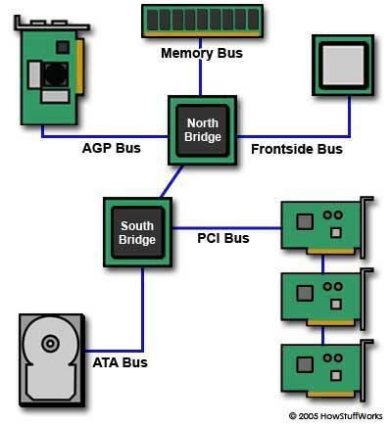

Bus speed usually refers to the speed of the **front side bus** (FSB), which connects the CPU to the northbridge. FSB speeds can range from 66 MHz to over 800 MHz. Since the CPU reaches the memory controller though the northbridge, FSB speed can dramatically affect a computer's performance. Here are some of the other busses found on a motherboard:

* The **back side bus** connects the CPU with the level 2 (L2) [cache,](http://computer.howstuffworks.com/cache.htm) also known as secondary or external cache. The processor determines the speed of the back side bus.
* The **memory bus** connects the northbridge to the memory.
* The [**IDE**](http://computer.howstuffworks.com/ide.htm)or **ATA** bus connects the southbridge to the [disk drives.](http://computer.howstuffworks.com/floppy-disk-drive.htm)
* The [**AGP**](http://computer.howstuffworks.com/agp.htm)bus connects the [video card](http://computer.howstuffworks.com/graphics-card.htm) to the memory and the [CPU.](http://computer.howstuffworks.com/microprocessor.htm) The speed of the AGP bus is usually 66 MHz.
* The [**PCI**](http://computer.howstuffworks.com/pci.htm)bus connects PCI slots to the southbridge. On most systems, the speed of the PCI bus is 33 MHz. Also compatible with PCI is [**PCI Express**,](http://computer.howstuffworks.com/pci-express.htm) which is much faster than PCI but is still compatible with current software and operating systems. PCI Express is likely to replace both PCI and AGP busses.

**11** **Computer Hardware and Network Troubleshooting**

**Sri Venkateshwaraa College of Engineering & Technology**

The faster a computer's bus speed, the faster it will operate -- to a point. A fast bus speed cannot make up for a slow processor or chipset.

**Industry Standard Architecture (ISA)**

In the early days of microprocessor chip based microcomputers, all microcomputers were built using their own proprietary bus designs. Before long someone had the bright idea that if designers used the same design specifications, you could build a computer out of "boards" from different companies. This idea created the the S-100, a bus that is still in use today in some areas. About the middle of 1975 Apple used an expansion bus on their Apple II, and its success set the stage for the desk top computers that followed, including the IBM PC when it appeared in 1981. The original PC used Intel's 8088 processor which was a 16-bit CPU that spoke to the world through an 8-bit data path. The original [PC 8-bit bus slot](http://philipstorr.id.au/pcbook/images/xt8bit.jpg) is still used by some simple I/O cards today. The 8088 ran at 4.77MHz, which was fine for the expansion cards, and running the expansion slots at the same clock speed as the CPU made the system boards easier to design and cheaper to build.

The IBM AT introduced a 16 bit data bus and the expansion slots had to handle 16 data bits. The industry wanted to be able to use existing 8-bit cards, so the new "AT" slot had to be designed to be backward compatible with the PC slots. The AT extension connector was added to the end of the **62 pinedge connector** of the original 8-bit bus slot. This **extension is a 36 pin edge connector**. This bus slotwas later given the name [Industry Standard Architecture (ISA)](http://philipstorr.id.au/pcbook/images/isa1.jpg) and has survived to this day. One important aspect of this bus was that IBM never made any specification about bus speeds.

In the original 6MHz IBM AT, and the subsequent 8MHz version, the bus simply ran along at the same speed as the CPU. It was not surprising that as clone vendors started looking for a marketing edge over IBM, they simply kept the bus running at the CPU speed as they boosted speeds to 10MHz, 12MHz, and even faster. This lead to problems with users starting to run into problems. Boards that ran fine in a 6 or 8 MHz computer were not reliable in faster ones. The problem was especially severe with network cards. It turned out that they couldn't run at these higher clock speeds. The industry eventually settled on 8MHz as the standard maximum clock speed and the name **Industry Standard Architecture.PCI The Universal Bus**

PCI is platform independent and was soon used in computers built around the PowerPC chip. This is one of the few times a standard I/O bus has been used across platforms and so this has to be a big feature in it'sfavour. The various companies involved in the PowerPC development, including Apple and IBM adopted the PCI-Bus for PowerPC based computers. Apple had been using the Macintosh NuBus for many years, but switched to the PCI-Bus for it's PowerPC products. It is ironical that the largest user of Motorola based processors lined up to buy bus technology from Intel.

Other computer manufacturers are also using the PCI-Bus in there computer platforms with Digital Equipment Corp. (DEC) with their Alpha RISC-based systems, and Hewlett-Packard and SUN Microsystems all including PCI-Bus slots in there products. Intel licensed its patents on the PCI Bus free of royalties to all who wished to use it.

**12** **Computer Hardware and Network Troubleshooting**

**Sri Venkateshwaraa College of Engineering & Technology**

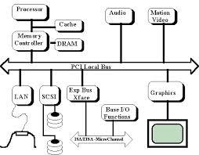

PCI BUS Structure

By adopting an established industry standard the manufacturers of the other computer platforms

are ensuring lower costs and more options for both users and developers who are no longer locked into

their own proprietary options. The wide range of cards that have followed the use of the PCI-Bus on PC

systems are available for the first time to users of other hardware. All that should be required is

alternative driver software for the various platforms.

**Peripheral Component Interconnect Express**

Peripheral Component Interconnect Express (PCIe or PCI-E) is a [serial](http://whatis.techtarget.com/definition/serial) expansion bus standard for connecting a computer to one or more peripheral devices.

PCIe provides lower [latency](http://whatis.techtarget.com/definition/latency) and higher data transfer rates than [parallel](http://whatis.techtarget.com/definition/parallel) busses such as PCI and PCI-X. Every device that's connected to a [motherboard](http://whatis.techtarget.com/definition/motherboard) with a PCIe link has its own dedicated point-to-point connection. This means that devices are not competing for [bandwidth](http://searchenterprisewan.techtarget.com/definition/bandwidth) because they are not sharing the same [bus.](http://searchstorage.techtarget.com/definition/bus)

Peripheral devices that use PCIe for data transfer include graphics adapter cards, [networkinterface cards](http://searchnetworking.techtarget.com/definition/network-interface-card) (NICs), storage accelerator devices and other high-performance peripherals.

With PCIe, data is transferred over two signal pairs: two wires for transmitting and two wires for receiving. Each set of signal pairs is called a "lane," and each lane is capable of sending and receiving eight-bit data packets simultaneously between two points.

PCIe can scale from one to 32 separate lanes; it is usually deployed with 1, 4, 8, 12, 16 or 32 lanes. The lane count of a PCIe card is a determining factor in its performance and therefore in its price. For example, an inexpensive PCIe device like NICs might only use four lanes (PCIe x4). By comparison, a high-performance graphics adapter that uses 32 lanes (PCIe x32) for top-speed transmission would be more expensive.

PCIe bus slots are typically backward compatible with other PCIe bus slots, allowing PCIe links that use fewer lanes to use the same interface as PCIe links that use more lanes. For example, a PCIe x8 card could plug into a PCIe x16 slot. PCIe bus slots are not [backwards compatible,](http://searchenterpriselinux.techtarget.com/definition/backward-compatible) however, with connection interfaces for older bus standards.

**13** **Computer Hardware and Network Troubleshooting**

**Sri Venkateshwaraa College of Engineering & Technology**

With PCIe, data center managers can take advantage of high-speed networking across server backplanes, and connect to [Gigabit Ethernet,](http://searchnetworking.techtarget.com/definition/Gigabit-Ethernet) [RAID](http://searchstorage.techtarget.com/definition/RAID) and [Infiniband](http://searchstorage.techtarget.com/definition/InfiniBand) networking technologies outside of the server rack. The PCIe bus also interconnects clustered computers that use [HyperTransport.](http://whatis.techtarget.com/definition/HyperTransport)

For laptops and mobile devices, mini PCI-e cards can be used to connect wireless adaptors, solid state device storage and other performance boosters. External PCI Express (ePCIe) is used to connect the motherboard to an external PCIe interface. In most cases, designers use ePCIe when the computer requires an unusually high number of PCIe ports.

**Accelerated Graphics Port (AGP)**

In the mid 1990s, Intel created AGP as a new bus specifically designed for high-performance graphics and video support. AGP is based on PCI, but it contains several additions and enhancements and is physically, electrically, and logically independent of PCI. For example, the AGP connector is similar to PCI, although it has additional signals and is positioned differently in the system. Unlike PCI, which is a true bus with multiple connectors (slots), AGP is more of a point-to-point high-performance connection designed specifically for a video card in a system because only one AGP slot is allowed for a single video card. Intel originally released the AGP specification 1.0 in July 1996 and defined a 66MHz clock rate with 1x or 2x signaling using 3.3V. AGP version 2.0 was released in May 1998 and added 4x signaling as well as a lower 1.5V operating capability. The final revision for the AGP specification for PCs is AGP 8x, also called AGP 3.0. AGP 8x defines a transfer speed of 2,133MBps, which is twice that of AGP 4x. The AGP 8x specification was publicly announced in November 2000. Although AGP 8x (2,133MBps) is 16 times faster than 32-bit 33MHz PCI (133MBps), AGP 8x is only about half as fast as PCI Express x16 (4,000MBps). Starting in mid-2004, motherboard and system vendors began to replace AGP 8x with PCI Express x16 expansion slots in high-performance systems. By early 2006, most motherboards featured PCI Express x16 slots in place of AGP.

**Micro Channel Architecture (MCA)**

IBM tried to regain control of the PC computer market with it's PS/2 range and the [Micro Channel(MCA) bus.](http://philipstorr.id.au/pcbook/images/mca.jpg) The response from a number of influential clone manufacturers was to get together and design the [Extended Industry Standard Architecture (EISA) bus,](http://philipstorr.id.au/pcbook/images/eisa1.jpg) providing a 32-bit data path. The advantage of the EISA design over Micro Channel was that it remained backward compatible with ISA boards, right back to 8-bit cards. The cost of the computers using the MCA or EISA buses were high and so these new busses failed to get much of a market share. Computer purchasers went on buying more ISA Bus machines than anything else.

The PCI-Bus (Peripheral Component Interconnect) was originally designed to speed up the display of graphics on Intel-based personal computers, but the standard itself is processor independent and suitable for other hardware add-ons that require high bandwidth, including network, video and SCSI adaptors. PCI was developed by INTEL but it did take some time to get it to work reliably. By the middle of 1993 the VESA-Bus became firmly entrenched in the market place and almost all DOS computer systems had

**14** **Computer Hardware and Network Troubleshooting**

**Sri Venkateshwaraa College of Engineering & Technology**

VESA-Bus slots as standard. The wide acceptance of local bus technology only took a few months and by default, VESA-Bus become the first Local Bus standard.

. 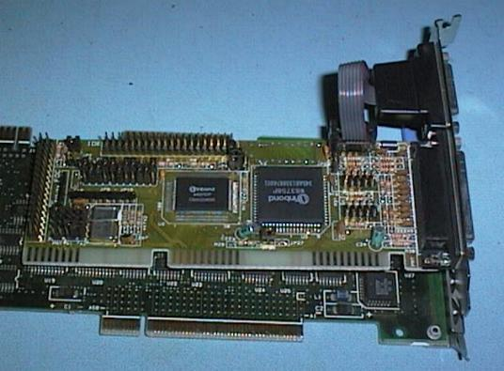

For a while, many people in the computer industry saw a local-bus war between the two competing local-bus standards (VESA-Bus and PCI-Bus) but in reality they were not in the same battlefield. The PCI and VESA Local-Busses did basically the same thing - both speed up PC computers by letting peripherals like graphics adaptors and hard disk controllers run at up to 33MHz, instead of the 8MHz that the ISA-Bus limited them to. The similarity breaks down when we start talking about how the two designs work.

The VESA-Bus bypassed the ISA bus by using the same bus the CPU is connected to it's RAM memory by and so it was relatively cheap and easy for system and peripheral makers to implement. Intel's PCI-Bus on the other hand, was a whole new bus, in much the same way the EISA and MCA busses were. The PCI bus gave only a slight speed improvement when used with 486 based systems, but it was far ahead when used with the Pentium chip.

**9. Describe the features of PCI Bus, also list out the pins and signals available in PCI bus. (NOV 2014)**

**Features of PCI Bus:**

The various features of PCI Architecture are given below:

**Synchronous Bus Architecture**: PCI is a synchronous Bus . All data transfers in PCI bus takes placeaccording to a system clock. The first PCI which was launched by Intel , supports 33 Mhz maximum clock rate while the newer PCI Buses now supports maximum clock frequency of 66 MHz.

**64 Bit Addressing**: PCI Bus also supports 64 bit addressing. With PCI Bus, 64 Bit addressing can beimplemented with the same 32 Bit connector. Dual address cycles are issued in which the lower order 32 bits addresses are driven onto during the first address phase and higher order 32 bits are driven onto during a second address phase. It does not requires a longer connector with additional 32 bit data signals.

**Linear Burst Mode Data Transfer**: PCI supports the feature of 'Burst Data Transfer'. With Burst DataTransfer, the data can be transferred at very high speeds. In Burst Data Transfer, a single address cycle can be followed by multiple data cycles. Thus , in Burst Data Transfer, Data is read and written to a single address location, which goes on automatically increment. In short, the data will be present on the bus, on each clock cycle. With this, we can achieve very high data transfer speeds that is 266 MB/sec for 32 bit data. With each clock cycle, a new data will be placed on the bus. If the cycle frame signal is active only for one data cycle, an ordinary transfer takes place. But if it is active for multiple clock cycles then the Burst Data Transfer takes place.

**15** **Computer Hardware and Network Troubleshooting**

**Sri Venkateshwaraa College of Engineering & Technology**

**Large Bandwidth**: PCI bus has much larger bandwidth than its previous buses (ISA, EISA and MCA).It can handle both 32 bit as well as 64 bit data. For 32 bit data, the maximum bandwidth will be 132 MB/sec which becomes more when Burst Data Transfer mode is used . It comes out to 364 MB/sec when Burst Data Transfer is used. Thus the bandwidth of PCI bus is very larger.

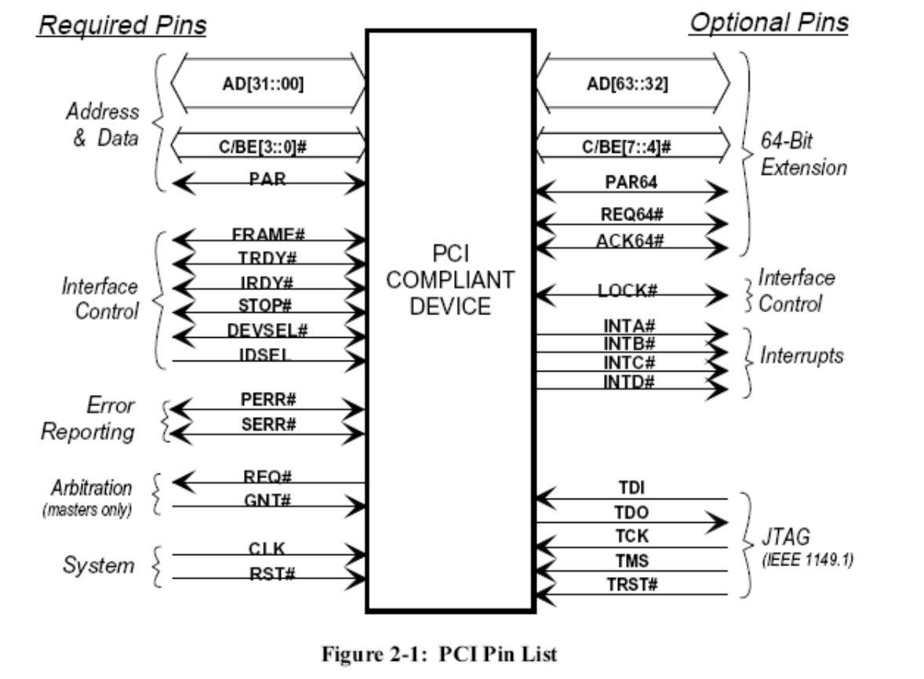

1. **Explain briefly about the system resources Interrupts, DMA channels and I/O Port addresses** System resources are the communications channels, addresses, and other signals that hardware

devices use to communicate on the bus. At their lowest level, these resources typically include the following:

* Memory addresses
* IRQ (interrupt request) channels
* DMA (direct memory access) channels
* I/O port addresses

These resources are required and used by many components of your system. Adapter cards need these resources to communicate with your system and accomplish their purposes. Not all adapter cards have the same resource requirements. A serial communications port, for example, needs an IRQ chan- nel and I/O port address, whereas a sound card needs these resources and at least one DMA channel. As systems increased in complexity from the late 1980s on, the chance for resource conflicts also increased. The configuration problem came to a head in the early 1990s, when manual configuration was the norm. Starting around that time, Microsoft and Intel developed PnP, which allowed for auto-matic detection, management and configuration of hardware, usually without user involvement. Windows 95 was the first PnP-aware PC operating system (OS), and by the time it was released, most hardware began supporting the PnP standard. Plug and Play was later superceded by Advanced Configuration and Power Interface (ACPI), which combined device configuration and power manage-

**16** **Computer Hardware and Network Troubleshooting**

**Sri Venkateshwaraa College of Engineering & Technology**

ment into a single specification. Modern systems with ACPI and modern buses such as PCI and PCI Express rarely have problems con- figuring these resources. In virtually all cases, the configuration will be automatic and trouble free.

**INTERRUPTS**

Interrupt request channels, or hardware interrupts, are used by various hardware devices to signal the motherboard that a request must be fulfilled. This procedure is the same as a student raising his hand to indicate that he needs attention.

These interrupt channels are represented by wires on the motherboard and in the slot connectors. When a particular interrupt is invoked, a special routine takes over the system, which first saves all the CPU register contents in a stack and then directs the system to the interrupt vector table. This vector table contains a list of memory addresses that correspond to the interrupt channels. Depending on which interrupt was invoked, the program corresponding to that channel is run. The pointers in the vector table point to the address of whatever software driver services the card that generated the interrupt. For a network card, for example, the vector might point to the address of the network drivers that have been loaded to operate the card; for a hard disk controller, the vector might point to the BIOS code that operates the controller. After the particular software routine performs whatever function the card needed, the interrupt-control software returns the stack contents to the CPU registers, and the system resumes whatever it was doing before the interrupt occurred. Through the use of interrupts, your system can respond to external events in a timely fashion. Each time a serial port presents a byte to your system, an interrupt is generated to ensure that the system reads that byte before another comes in. Keep in mind that in some cases a port device in particular, a modem with a 16550 or higher UART chip incorporates a byte buffer that allows multiple characters to be stored before an interrupt is generated. Hardware interrupts are generally prioritized by their numbers; with some exceptions, the highest-priority interrupts have the lowest numbers. Higher-priority interrupts take precedence over lower-priority interrupts by interrupting them. As a result, several interrupts can occur in your system con-currently, with each interrupt nesting within another. The ISA bus uses edge-triggered interrupt sensing, in which an interrupt is sensed by a changing signal sent on a particular wire located in the slot connector. A different wire corresponds to each possible hardware interrupt. Because the motherboard can’t recognize which slot contains the card that used an interrupt line and therefore generated the interrupt, confusion results if more than one card is set to use a particular interrupt. Each interrupt, therefore, is usually designated for a single hardware device. Most of the time, interrupts can’t be shared. Originally, IBM developed ways to share interrupts on the ISA bus, but few devices followed the nec- essary rules to make this a reality. The PCI bus inherently allows interrupt sharing; in fact, virtually all PCI cards are set to PCI interrupt A and share that interrupt on the PCI bus. The real problem is that there are technically two sets of hardware interrupts in the system: PCI interrupts and ISA interrupts. For PCI cards to work in a PC, the PCI interrupts are first mapped to ISA interrupts, which are then configured as non shareable. Therefore, in many cases you must assign a non conflicting

**17** **Computer Hardware and Network Troubleshooting**

**Sri Venkateshwaraa College of Engineering & Technology**

interrupt for each card, even PCI cards. The conflict between assigning ISA IRQs for PCI interrupts caused many configuration problems for early users of PCI motherboards and continued to cause problems even after the development of Windows 95 and its PnP technology. The solution to the interrupt sharing problem for PCI cards was something called PCI IRQ Steering, which has been supported in OSs (starting with Windows 95 OSR 2.x) and BIOSs for more than a decade. PCI IRQ Steering allows a plug-and-play operating system such as Windows to dynamically map or ―steer‖ PCI cards (which almost all use PCI INTA#) to standard PC interrupts and allows several PCI cards to be mapped to the same interrupt. More information on PCI IRQ Steering is found in the section ―PCI Interrupts,‖ later in this chapter. Hardware interrupts are sometimes referred to as maskable interrupts, which means you can mask or turn off the interrupts for a short time while the CPU is used for other critical operations. It is up to the sys- tem BIOS and programs to manage interrupts properly and efficiently for the best system performance.

**DMA CHANNELS**

Communications devices that must send and receive information at high speeds use direct memory access (DMA) channels. Conflicts between devices needing to use the same DMA channel were common on systems using ISA slots, but are no longer an issue on modern systems.

**I/O PORT ADDRESSES**

Computer’s I/O ports enable communications between devices and software in the system. They are equivalent to two-way radio channels. If we want to talk to the serial port, we need to know on which I/O port (radio channel) it is listening. Similarly, if we want to receive data from the serial port, we need to listen on the same channel on which it is transmitting. Unlike IRQs and DMA channels, our systems have an abundance of I/O ports. There are exactly 65,536 ports numbered from 0000h to FFFFh which is a feature of the Intel x 86 processor designs. Even though most devices use up to eight ports for themselves, with that many to spare, you won’t run out anytime soon. The biggest problem we have to worry about is setting two devices to use the same port. Most modern plug-and-play systems resolve port conflicts and select alternative ports for one of the conflicting devices. One confusing issue is that I/O ports are designated by hexadecimal addresses similar to memory addresses. They are not memory; they are ports. The difference is that when you send data to memory address 1000h, it is stored in your system’s DIMM memory. If you send data to I/O port address 1000h, it is sent out on the bus on that ―channel,‖ and anybody listening in could then ―hear‖ it. If nobody is listening to that port address, the data reaches the end of the bus and is absorbed by the bus terminating resistors. Driver programs are primarily what interact with devices at the various port addresses. The driver must know which ports the device is using to work with it, and vice versa. That is not usually a prob- lem because the driver and device come from the same company. Motherboard and chipset devices usually are set to use I/O port addresses 0h–FFh, and all other devices use 100h–FFFFh.

**18** **Computer Hardware and Network Troubleshooting**

**Sri Venkateshwaraa College of Engineering & Technology**

1. **Explain the working principle SMPS with functional block diagram. (APR 2012), (NOV 2012) (NOV 2013)**
2. **Explain the working principle of SMPS. What are the types of SMPS, Explain?**

A switched-mode power supply (switching-mode power supply, SMPS, or switcher) is an electronic

[power supply](http://en.wikipedia.org/wiki/Power_supply) that incorporates a switching regulator to convert electrical power efficiently. Like other power supplies, an SMPS transfers power from a source, like [mains power,](http://en.wikipedia.org/wiki/Mains_electricity) to a load, such as a [personalcomputer,](http://en.wikipedia.org/wiki/Personal_computer) while converting [voltage](http://en.wikipedia.org/wiki/Voltage) and [current](http://en.wikipedia.org/wiki/Electric_current) characteristics. An SMPS is usually employed to efficiently provide a regulated output voltage, typically at a level different from the input voltage.

Unlike a linear power supply, the pass transistor of a switching-mode supply continually switches between low-dissipation, full-on and full-off states, and spends very little time in the high dissipation transitions (which minimizes wasted energy). Ideally, a switched-mode power supply dissipates no power. Voltage regulation is achieved by varying the ratio of on-to-off time. In contrast, a linear power supply regulates the output voltage by continually dissipating power in the pass transistor. This higher power conversion efficiency is an important advantage of a switched-mode power supply. Switched-mode power supplies may also be substantially smaller and lighter than a linear supply due to the smaller transformer size and weight.

Switching regulators are used as replacements for the linear regulators when higher efficiency, smaller size or lighter weights are required. They are, however, more complicated, their switching currents can cause electrical noise problems if not carefully suppressed, and simple designs may have a poor [powerfactor.](http://en.wikipedia.org/wiki/Power_factor)

A switched-mode power supply, switch-mode power supply, or SMPS, is an electronic [powersupply](http://en.wikipedia.org/wiki/Power_supply) unit (PSU) that incorporates a switching regulator — an internal control circuit that switches power transistors (such as [MOSFETs)](http://en.wikipedia.org/wiki/MOSFET) rapidly on and off in order to stabilize the output voltage or current. Switching regulators are used as replacements for the [linear regulators](http://en.wikipedia.org/wiki/Linear_regulator) when higher efficiency, smaller size or lighter weights are required. They are, however, more complicated and their switching currents can cause [noise](http://en.wikipedia.org/wiki/Noise) problems if not carefully suppressed, and simple designs may have a poor [power factor.](http://en.wikipedia.org/wiki/Power_factor) The power output to cost crossover point between SMPS and linear regulating alternatives has been falling since the early 1980s as SMPS technology was developed and integrated into dedicated silicon chips. In early 2006 even very low power linear regulators became more expensive than SMPS when the cost of copper and iron used in the transformers increased abruptly on world markets.

SMPS can also be classified into four types according to the input and output waveforms, as follows.

* AC in, DC out: [rectifier,](http://en.wikipedia.org/wiki/Rectifier) off-line converter
* DC in, DC out: voltage converter, or current converter, or [DC to DC converter](http://en.wikipedia.org/wiki/DC_to_DC_converter)
* AC in, AC out: [frequency changer,](http://en.wikipedia.org/wiki/Frequency_changer) [cycloconverter](http://en.wikipedia.org/wiki/Cycloconverter)
* DC in, AC out: [inverter](http://en.wikipedia.org/wiki/Inverter_%28electrical%29)

AC and DC are abbreviations for [alternating current](http://en.wikipedia.org/wiki/Alternating_current) and [direct current.](http://en.wikipedia.org/wiki/Direct_current)

**19** **Computer Hardware and Network Troubleshooting**

**Sri Venkateshwaraa College of Engineering & Technology**

**SMPS compared with linear PSUs**

There are two main types of regulated power supplies available: SMPS and Linear. The reasons for choosing one type or the other can be summarized as follows.

* Size and weight — Linear power supplies use a [transformer](http://en.wikipedia.org/wiki/Transformer) operating at the mains [frequency](http://en.wikipedia.org/wiki/Frequency) of 50/60 Hz. This component is larger and heavier by several times than the corresponding smaller [transformer](http://en.wikipedia.org/wiki/Transformer) in an SMPS, which runs at a higher frequency (always above the highest [audiblefrequency,](http://en.wikipedia.org/wiki/Audio_frequency) around 50 [kHz](http://en.wikipedia.org/wiki/Kilohertz) to 200 kHz)
* [Efficiency](http://en.wikipedia.org/wiki/Electrical_efficiency) — Linear power supplies regulate their output by using a higher voltage in the initial stages and then expending some of it as heat to improve the power quality. This power loss is necessary to the circuit, and can be reduced but never eliminated by improving the design, even in theory. SMPSs draw current at full voltage based on a variable duty cycle, and can increase or decrease their power consumption to regulate the load as required. Consequently, a well designed SMPS will be more efficient.
* [Heat](http://en.wikipedia.org/wiki/Heat) output or [powerdissipation](http://en.wikipedia.org/wiki/Electric_power) — A linear supply will regulate the voltage or current by wasting excess voltage or current as heat, which is very inefficient. A regulated SMPS will regulate using [Pulse Width Modulation](http://en.wikipedia.org/wiki/Pulse-width_modulation) or, at power ratings below 30W, ON/OFF control. In all SMPS topologies, the transistors are always fully on or fully off. Thus, an "ideal" SMPS will be 100% efficient. The only heat generated is because ideal components do not exist. Switching losses in the main switching transistors, non-zero resistance in the "on" state and rectifier voltage drop will produce a fair amount of heat. However, by optimizing SMPS design, the amount of heat produced can be minimized. A good design can have an efficiency of more than 95%.
* Complexity — A linear regulator ultimately consists of a power transistor, voltage regulating IC and a noise filtering capacitor. An SMPS typically contains PWM controller, one or several power transistors and diodes as well as power transformer, inductor and filter capacitors. Multiple voltages can be generated by one transformer core. For this an SMPS has to use [pulse width modulation](http://en.wikipedia.org/wiki/Pulse-width_modulation) on the primary winding and "post-regulating" such as [phase control](http://en.wikipedia.org/wiki/Phase_control) on the secondary windings, while the linear PSU normally uses independent voltage regulators for the auxiliary outputs. Both need a careful design for their transformers, which therefore are often produced in series and available in stock. Due to the high frequencies in SMPS the inductances and capacitances of the traces become important.
* [Radio frequency interference](http://en.wikipedia.org/wiki/Radio_frequency_interference) — The currents in a SMPS are switched at a [high frequency.](http://en.wikipedia.org/wiki/High_frequency) This high-frequency currents can generate undesirable [electromagnetic interference.](http://en.wikipedia.org/wiki/Electromagnetic_interference) EMI filters and [RFshielding](http://en.wikipedia.org/wiki/RF_shielding) are needed to reduce the disruptive interference. Linear PSUs, however, generally do not produce interference.
* [Electronic noise](http://en.wikipedia.org/wiki/Electronic_noise) at the output terminals — Inexpensive linear PSUs with poor regulation may experience a small AC voltage "riding on" the DC output at twice mains frequency (100/120 Hz). These "ripples" are usually on the order of millivolts, and can be suppressed with larger [filter](http://en.wikipedia.org/wiki/Filter_capacitor)

**20** **Computer Hardware and Network Troubleshooting**

**Sri Venkateshwaraa College of Engineering & Technology**

capacitors or better [voltage regulators.](http://en.wikipedia.org/wiki/Voltage_regulator) This small AC voltage can cause problems in some circuits. Quality linear PSUs will suppress ripples much better. SMPS usually do not exhibit ripple at the power-line frequency, but do have generally noisier outputs than linear PSUs; the noise may be correlated with the SMPS switching frequency or it may also be more broad-band.

* [Acoustic noise](http://en.wikipedia.org/wiki/Noise_%28acoustic%29) — Linear PSUs typically give off a faint, low frequency hum at mains frequency, but this is seldom audible. (The transformer is responsible.) SMPSs, with their much higher operating frequencies, are not usually [audible to humans](http://en.wikipedia.org/wiki/Psychoacoustic_model) (unless they have a fan, in the case of most computer SMPSs). A malfunctioning SMPS may generate high-pitched sounds, since they do in fact generate acoustic noise at the oscillator frequency.
* [Power factor](http://en.wikipedia.org/wiki/Power_factor) — The current drawn by simple SMPS is [non-sinusoidal](http://en.wikipedia.org/wiki/Sinusoidal) and do not follow the supply's input voltage waveform, so the early SMPS designs have a mediocre power factor of about 0.6, and their use in personal computers and compact fluorescent lamps presented a growing problem for power distribution. [Power factor correction](http://en.wikipedia.org/wiki/Power_factor_correction) (PFC) circuits can reduce this problem, and are required in some countries (European in particular) by regulation. Linear PSUs also do not have unity power factors, but are not as problematic as SMPSs.
* [Electronic noise](http://en.wikipedia.org/wiki/Electronic_noise) at the input terminals — In a similar fashion, very low cost SMPS may couple electrical noise back onto the mains power line; Linear PSUs rarely do this.

**How an SMPS works**

If the SMPS has an AC input, then its first job is to convert the input to DC. This is called [*rectification*.](http://en.wikipedia.org/wiki/Rectifier) The rectifier circuit can be configured as a voltage doubler by the addition of a switch operated either manually or automatically. This is a feature of larger supplies to permit operation from nominally 120 volt or 240 volt supplies. The rectifier produces an unregulated DC voltage which is then sent to a large filter capacitor. The current drawn from the mains supply by this rectifier circuit occurs in short pulses around the AC voltage peaks. These pulses have significant high frequency energy which reduces the [power factor.](http://en.wikipedia.org/wiki/Power_factor) Special control techniques can be employed by the following SMPS to force the average input current to follow the sinusoidal shape of the AC input voltage thus the designer should try [correcting the power factor.](http://en.wikipedia.org/wiki/Power_factor_correction) A SMPS with a DC input does not require this stage. A SMPS designed for AC input can often be run from a DC supply, as the DC passes through the rectifier stage unchanged.

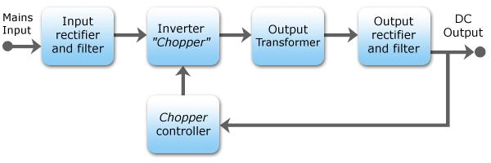

Block diagram of a mains operated AC-DC SMPS with output voltage regulation.

**21** **Computer Hardware and Network Troubleshooting**

**Sri Venkateshwaraa College of Engineering & Technology**

**Input rectifier stage**

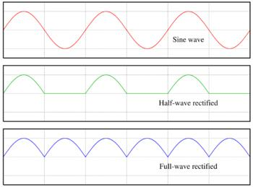

AC, half-wave and full wave rectified signals

If an input range switch is used, the rectifier stage is usually configured to operate as a [voltagedoubler](http://en.wikipedia.org/wiki/Voltage_doubler) when operating on the low voltage (~120 VAC) range and as a straight rectifier when operating on the high voltage (~240 VAC) range. If an input range switch is not used, then a full-wave rectifier is usually used and the downstream inverter stage is simply designed to be flexible enough to accept the wide range of dc voltages that will be produced by the rectifier stage. In higher-power SMPSs, some form of automatic range switching may be used.

**Inverter stage**

The inverter stage converts DC, whether directly from the input or from the rectifier stage described above, to AC by running it through a power oscillator, whose output transformer is very small with few windings at a frequency of tens or hundreds of [kilohertz](http://en.wikipedia.org/wiki/Kilohertz) (kHz). The frequency is usually chosen to be above 20 kHz, to make it inaudible to humans. Computer supplies run at 360 volts DC. The output voltage is optically coupled to the input and thus very tightly controlled. The switching is implemented as a multistage (to achieve high gain) [MOSFETs](http://en.wikipedia.org/wiki/MOSFET) amplifier. [MOSFETs](http://en.wikipedia.org/wiki/MOSFET) are a type of [transistor](http://en.wikipedia.org/wiki/Transistor) with a low on-[resistance](http://en.wikipedia.org/wiki/Electrical_resistance) and a high current-handling capacity. This section refers to the block marked "Chopper" in the block diagram.

**Voltage converter and output rectifier**

If the output is required to be isolated from the input, as is usually the case in mains power supplies, the inverted AC is used to drive the primary winding of a high-frequency [transformer.](http://en.wikipedia.org/wiki/Transformer) This converts the voltage up or down to the required output level on its secondary winding. The output transformer in the block diagram serves this purpose.

If a DC output is required, the AC output from the transformer is rectified. For output voltages above ten volts or so, ordinary silicon diodes are commonly used. For lower voltages, [Schottky diodes](http://en.wikipedia.org/wiki/Schottky_diode) are commonly used as the rectifier elements; they have the advantages of faster recovery times than silicon diodes (allowing low-loss operation at higher frequencies) and a lower voltage drop when conducting. For even lower output voltages, [MOSFET](http://en.wikipedia.org/wiki/MOSFET) transistors may be used as [synchronousrectifiers;](http://en.wikipedia.org/wiki/Synchronous_rectifier) compared to Schottky diodes, these have even lower "on"-state voltage drops.

The rectified output is then smoothed by a filter consisting of [inductors](http://en.wikipedia.org/wiki/Inductor) and [capacitors.](http://en.wikipedia.org/wiki/Capacitor) For higher switching frequencies, components with lower capacitance and inductance are needed.

**22** **Computer Hardware and Network Troubleshooting**

**Sri Venkateshwaraa College of Engineering & Technology**

Simpler, non-isolated power supplies contain an inductor instead of a transformer. This type includes [*boost converters*,](http://en.wikipedia.org/wiki/Boost_converter) [*buck converters*,](http://en.wikipedia.org/wiki/Buck_converter) and the so called [*buck-boost converters*.](http://en.wikipedia.org/wiki/Buck-boost_converter) These belong to the simplest class of single input, single output converters which utilise one inductor and one active switch [(MOSFET)](http://en.wikipedia.org/wiki/MOSFET). The buck converter reduces the input voltage, in direct proportion, to the ratio of the active switch "on" time to the total switching period, called the Duty Ratio. For example an ideal buck converter with a 10V input operating at a duty ratio of 50% will produce an average output voltage of 5V. A feedback control loop is employed to maintain (regulate) the output voltage by varying the duty ratio to compensate for variations in input voltage. The output voltage of a [*boost converter*](http://en.wikipedia.org/wiki/Boost_converter)is always greater than the input voltage and the buck-boost output voltage is inverted but can be greater than, equal to, or less than the magnitude of its input voltage. There are many variations and extensions to this class of converters but these three forms the basis of almost all isolated and non-isolated DC to DC converters. By adding a second inductor the [Ćuk](http://en.wikipedia.org/wiki/Cuk_converter) and [SEPIC](http://en.wikipedia.org/wiki/SEPIC_converter) converters can be implemented or by adding additional active switches various bridge converters can be realised.

Other types of SMPS use a [capacitor](http://en.wikipedia.org/wiki/Capacitor)-[diodevoltage multiplier](http://en.wikipedia.org/wiki/Diode) instead of inductors and transformers. These are mostly used for generating high voltages at low currents. The low voltage variant is called [charge pump.](http://en.wikipedia.org/wiki/Charge_pump)

**Regulation**

A [feedback](http://en.wikipedia.org/wiki/Feedback) circuit monitors the output voltage and compares it with a reference voltage, which is set manually or electronically to the desired output. If there is an error in the output voltage, the feedback circuit compensates by adjusting the timing with which the MOSFETs are switched on and off. This part of the power supply is called the switching regulator. The "Chopper controller" shown in the block diagram serves this purpose. Depending on design/safety requirements, the controller may or may not contain an isolation mechanism (such as [opto-couplers)](http://en.wikipedia.org/wiki/Opto-isolator) to isolate it from the DC output. Switching supplies in computers, TVs and VCRs have these opto-couplers to tightly control the output voltage.

*Open-loop regulators* do not have a feedback circuit. Instead, they rely on feeding a constantvoltage to the input of the transformer or inductor, and assume that the output will be correct. Regulated designs work against the parasiticcapacity of the transformer or coil, monopolar designs also against the [magnetic hysteresis](http://en.wikipedia.org/wiki/Magnetic_hysteresis) of the core.

The feedback circuit needs power to run before it can generate power, so an additional non-switching power-supply for stand-by is added.

**Power factor**

Early switched mode power supplies incorporated a simple full wave rectifier connected to a large energy storing capacitor. Such SMPS draws current from the AC line in short pulses when the mains instantaneous voltage exceeds the voltage across this capacitor. During the remaining portion of the AC cycle the capacitor provides energy to the power supply. As the result, input current of such basic switched mode power supplies has high [harmonics](http://en.wikipedia.org/wiki/Harmonic) content and relatively low [power factor.](http://en.wikipedia.org/wiki/Power_factor) This

**23** **Computer Hardware and Network Troubleshooting**

**Sri Venkateshwaraa College of Engineering & Technology**

creates extra load on utility lines, increases heating of the utility [transformers,](http://en.wikipedia.org/wiki/Transformer) and may cause stability problems in some applications such as in emergency generator systems or aircraft generators. In 2001 the European Union put into effect the standard IEC/EN61000-3-2 to set limits on the harmonics of the AC input current up to the 40th harmonic for equipment above 75W. The standard defines four classes of equipment depending on its type and current waveform. The most rigorous limits (class D) are established for personal computers, computer monitors, and TV receivers. In order to comply with these requirements modern switched-mode power supplies normally include an additional [power factorcorrection](http://en.wikipedia.org/wiki/Power_factor_correction) (PFC) stage.

**Types**

Switched-mode power supplies can be classified according to the circuit topology.

* [Buck converter](http://en.wikipedia.org/wiki/Buck_converter) (single [inductor;](http://en.wikipedia.org/wiki/Inductor) output voltage < input voltage)
* [Boost converter](http://en.wikipedia.org/wiki/Boost_converter) (single inductor; output voltage > input voltage)
* [buck-boost converter](http://en.wikipedia.org/wiki/Buck-boost_converter) (single inductor; output voltage can be more or less than the input voltage)
* [fly back converter](http://en.wikipedia.org/wiki/Flyback_converter) (uses output [transformer;](http://en.wikipedia.org/wiki/Transformer) allows multiple outputs and input-to-output isolation)
* Half-Forward Topology
* [Push-Pull Topology](http://en.wikipedia.org/wiki/Push-pull_converter)
* Half-Bridge Topology
* Full-Bridge Topology
* Resonance, zero voltage switched

**Applications**

Switched-mode PSUs in domestic products such as [personal computers](http://en.wikipedia.org/wiki/Personal_computer) often have universal inputs, meaning that they can accept power from most mains supplies throughout the world, with rated frequencies from 50 [Hz](http://en.wikipedia.org/wiki/Hertz) to 60 Hz and voltages from 100 [V](http://en.wikipedia.org/wiki/Volt) to 240 V (although a manual voltage "range" switch may be required). In practice they will operate from a much wider frequency range and often from a DC supply as well. In 2006, [Intel](http://en.wikipedia.org/wiki/Intel) proposed the use of a single 12 V supply inside PCs, due to the high efficiency of switch mode supplies directly on the PCB.

Cars, trucks, telecom lines, and production plants, but not planes, supply DC to avoid hum and ease the integration of capacitors and batteries used to buffer the voltage.

In the case of TV sets, for example, one can test the excellent regulation of the power supply by using a [variac.](http://en.wikipedia.org/wiki/Variac) For example, in some models made by [Philips,](http://en.wikipedia.org/wiki/Philips) the power supply starts when the voltage reaches around 90 volts. From there, one can change the voltage with the variac, and go as low as 40 volts and as high as 260, and the image will show absolutely no alterations.

**24** **Computer Hardware and Network Troubleshooting**

**Sri Venkateshwaraa College of Engineering & Technology**

**13. Explain Power-Supply Connectors and switches.**

Power supplies employ several types of connectors; all are easy to identify and use. On the outside of the computer enclosure, a standard male AC plug and three-conductor wire (two power wires and a ground) draws current from a wall outlet, with a female connection entering the receptacle in the back of the power supply. On the inside are three types of connectors: the power main to the motherboard (which differ, as mentioned, in AT and ATX models) and two types of four-pin fittings to supply 5 volts and 3.3 volts of power to peripherals such as the floppy disk and hard disk drives. Let's take a close look at each in turn.

**AT-Style Connections to the Motherboard**

A pair of almost identical connectors, designated P8 and P9, link the power supply to the motherboard (see Figure 5.1). These connectors are seated into a row of six pins and matching plastic guides, or "teeth," on the motherboard. The P8 and P9 connectors *must* be placed in the proper orientation. The motherboard manual will show which fitting is for P8 and P9. If the connectors are not marked, make sure that the two black wires on each plug are side by side and that the orange wire (on P8) and the two red wires (on P9) are on the outside as you push them into place.

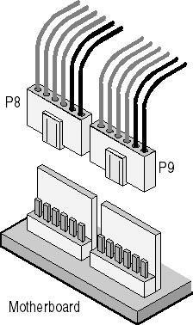

**Fig :***P8 and P9 connectors and motherboard fitting*

The following table of power cables shows voltage values for each of the color-coded wires on P8 and P9. The ground wires are considered 0 volts; all voltage measurements are taken between the black wires and one of the colored wires.

|  |  |  |
| --- | --- | --- |
| **Cable Color** | **Supply In** | **Tolerance** |
| Yellow | +12 | ±10% |
| Blue | -12 | ±10% |
| Red | +5 | ±5% |
| White | -5 | ±5% |

**ATX Motherboard Connections**

The newer ATX main power connection is much easier to install. A single 20-wire plug is set into a fitted receptacle and secured with a catch on the side of the plug that snaps over the fitting. Figure 5.3 shows the parts being seated. A small, flat-tip screwdriver is a handy tool for easing the pressure on the catch to remove the plug. In some cases, it can be used during installation as well.

**25** **Computer Hardware and Network Troubleshooting**

**Sri Venkateshwaraa College of Engineering & Technology**

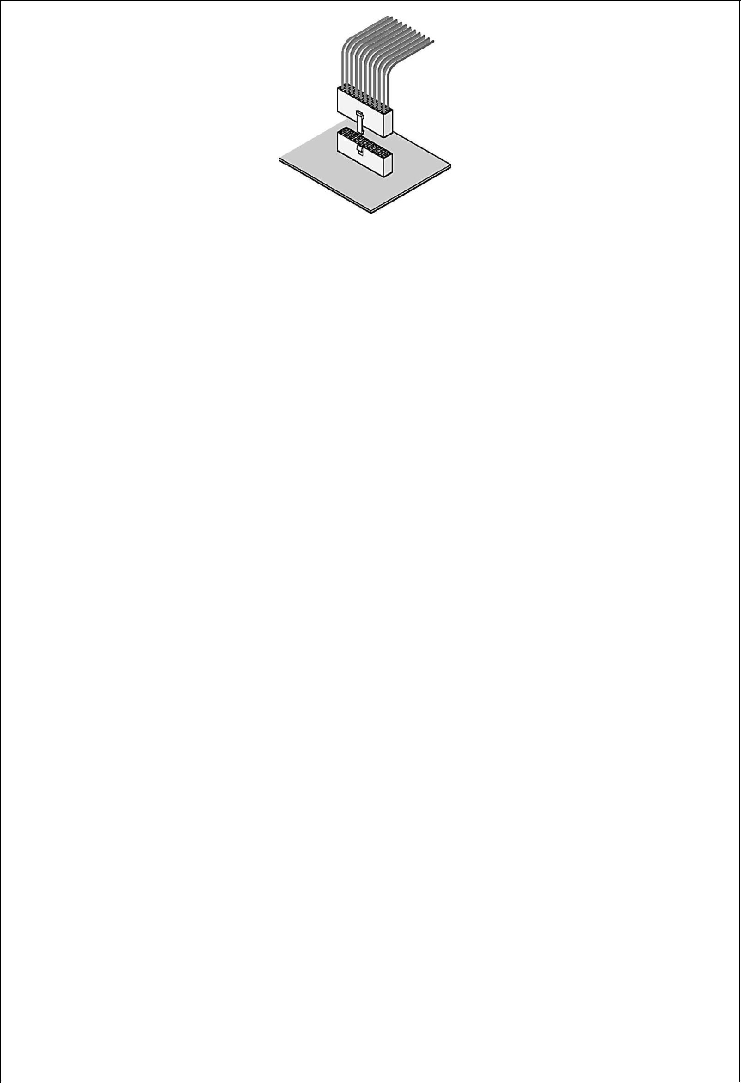

**Figure:***Placing an ATX plug in its motherboard receptacle*

**Connections to Peripheral Hardware**

Two standard types of connectors can connect to peripheral hardware:

* **Molex connector:** This is the most commonly used power connector. It provides both 12-voltand 5-volt power. Hard disk drives, internal tape drives, CD-ROM drives, DVD (digital video disc) drives, and older 5.25-inch floppy disk drives all use this fitting. The Molex connector has two rounded corners and two sharp corners to ensure that it will be properly installed.

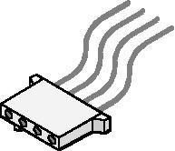

•

**Figure :***Molex connector (not to scale)*

* **Mini connector:** Most power supplies provide one or more "mini" connectors (see Figure 5.5).The mini, shown in Figure 5.4, is used primarily on 3.5-inch floppy-disk drives. It has four pin-outs and, usually, four wires. Most are fitted with keys that make it difficult, but not impossible, to install upside down. Be sure to orient the connector correctly; applying power with the connector reversed can damage or destroy the drive.

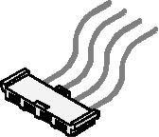

•

**Figure :***Mini connector (not to scale)*

**Two- and Three-Pin Mini Plugs**

A less common type of power connector is used to connect the fan of a Pentium II or III processor to the motherboard for power, to connect a CD-ROM drive to a sound card, and to provide power for 3.5-inch floppy disk drives. These connectors have two or three wires which are usually red and black or red, yellow, and black.

**26** **Computer Hardware and Network Troubleshooting**

**Sri Venkateshwaraa College of Engineering & Technology**

**Extenders and Splitters**

PCs can run out of power connections, and large cases can have drives beyond the reach of any plug on the supply. A good technician has a quick solution on hand to both of these common problems: extenders and splitters.

*Extenders* are wire sets that have a Molex connector on each end; they are used to extend a powerconnection to a device beyond the reach of the power supply's own wiring. *Splitters* are similar to extenders, with the exception that they provide two power connections from a single power supply connector.

* Power supplies come in a variety of sizes and shapes.
* There are two types of main power connectors: AT and ATX.
* A power supply must be capable of handling the requirements of the computer and all internal devices.
* Be careful when attaching some connectors-if connected incorrectly, they can damage the computer.
* Do not open the power-supply housing!
* Keeping a few splitters and extenders in the repair kit can help the technician easily solve some common problems.

Various connectors from a computer PSU.

Typically, power supplies have the following connectors:

* **PC Main** power connector (usually called **P1**): This is the connector that goes to the[motherboard](http://en.wikipedia.org/wiki/Motherboard) to provide it with power. The connector has 20 or 24 pins. One of the pins belongs to the PS-ON wire (it is usually green). This connector is the largest of all the connectors. In older [AT](http://en.wikipedia.org/wiki/AT_%28form_factor%29) power supplies, this connector was split in two: **P8** and **P9**. A power supply with a 24-pin connector can be used on a motherboard with a 20-pin connector. In cases where the motherboard has a 24-pin connector, some power supplies come with two connectors (one with 20-pin and other with 4-pin) which can be used together to form the 24-pin connector.

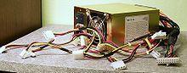

**27** **Computer Hardware and Network Troubleshooting**

**Sri Venkateshwaraa College of Engineering & Technology**

* + **12V only** power connector (labelled**P1**, though it is not compatible with the ATX 20 or 24 pinconnector): This is a 16-pin Molex connector supplying the [motherboard](http://en.wikipedia.org/wiki/Motherboard) with six 12V lines with common returns, a 'supply OK' signal, a 'PSU ON' signal and an 11V auxiliary supply. One pin is left unused.[[15]](http://en.wikipedia.org/wiki/Power_supply_unit_%28computer%29#cite_note-14)
  + **12V only System monitoring** (**P10**): This is a 171822-8 AMP or equivalent connector carryinga supply to the PSU fan and sense returns.[[16]](http://en.wikipedia.org/wiki/Power_supply_unit_%28computer%29#cite_note-15)
  + **ATX12V** 4-pin power connector (also called the **P4 power connector**). A second connector thatgoes to the motherboard (in addition to the main 24-pin connector) to supply dedicated power for the processor. For high-end motherboards and processors, more power is required, therefore EPS12V has an 8-pin connector.
  + **4-pin Peripheral** power connectors: These are the other, smaller connectors that go to the

various [disk drives](http://en.wikipedia.org/wiki/Disk_drives) of the computer. Most of them have four wires: two black, one red, and one yellow. Unlike the standard mains electrical wire [color-coding,](http://en.wikipedia.org/wiki/Domestic_AC_power_plugs_and_sockets) each *black wire* is a [ground,](http://en.wikipedia.org/wiki/Ground_%28electricity%29) the *red wire* is +5 V, and the *yellow wire* is +12 V. In some cases these are also used to provideadditional power to PCI cards such as [FireWire 800](http://en.wikipedia.org/wiki/FireWire_800) cards.

* + **4-pin Molex (Japan) Ltd** power connectors (usually called **Mini-connector** or "mini-Molex"):This is one of the smallest connectors that supplies a 3 1/2 inch [floppy drive](http://en.wikipedia.org/wiki/Floppy_drive) with power. In some cases, it can be used as an auxiliary connector for [AGP](http://en.wikipedia.org/wiki/Accelerated_Graphics_Port) video cards. Its cable configuration is similar to the Peripheral connector.
  + **Auxiliary** power connectors: There are several types of auxiliary connectors designed to provideadditional power if it is needed.
  + [**Serial ATA**](http://en.wikipedia.org/wiki/Serial_ATA#Power_supply) powerconnectors: a 15-pin connector for components which use SATA power

plugs. This connector supplies power at three different voltages: +3.3, +5, and +12 volts.

* + **6-pin** Most modern computer power supplies include 6-pin connectors which are generally usedfor [PCI Express](http://en.wikipedia.org/wiki/PCI_Express) graphics cards, but a newly introduced 8-pin connector should be seen on the latest model power supplies. Each PCI Express 6-pin connector can output a maximum of 75 W.
  + **6+2 pin** For the purpose of backwards compatibility, some connectors designed for use withhigh end [PCI Express](http://en.wikipedia.org/wiki/PCI_Express) graphics cards feature this kind of pin configuration. It allows either a 6-pin card or an 8-pin card to be connected by using two separate connection modules wired into the same sheath: one with 6 pins and another with 2 pins.
  + A[**IEC 60320 C14**](http://en.wikipedia.org/wiki/IEC_60320_C14) connector with an appropriate [C13](http://en.wikipedia.org/wiki/IEC_60320_C13) cord is used to attach the power supply to the local power grid.

1. **Explain briefly about RTC/NVRAM Batteries or (CMOS Chips)**

All 16-bit and higher systems have a special type of chip in them that combines a real-time clock (RTC) with at least 64 bytes (including the clock data) of Non-Volatile RAM (NVRAM) memory. This chip is officially called the RTC/NVRAM chip but is often referred to as the CMOS chip or CMOS RAM because the type of chip used is produced using a CMOS (Complementary Metal-Oxide

**28** **Computer Hardware and Network Troubleshooting**

**Sri Venkateshwaraa College of Engineering & Technology**

Semiconductor) process. CMOS design chips are known for very low power consumption. This special RTC/NVRAM chip is designed to run off a battery for several years.

The original chip of this type used in the IBM AT was the Motorola 146818 chip. Although the chips used today have different manufacturers and part numbers, they all are designed to be compatible with this original Motorola part.

These chips include a real-time clock. Its function should be obvious: The clock enables software to read the date and time and preserves the date and time data even when the system is powered off or unplugged.

The NVRAM portion of the chip has another function. It is designed to store basic system configuration, including the amount of memory installed, types of floppy and hard disk drives, and other information. Some of the more modern motherboards use extended NVRAM chips with as much as 2KB or more of space to hold this configuration information. This is especially true for Plug and Play systems, which store not only the motherboard configuration but also the configuration of adapter cards. This system can then read this information every time you power on the system.

These chips normally are powered by some type of battery while the system is off. This battery preserves the information in the NVRAM and powers the clock. Most systems use a lithium-type battery because they have a very long life, especially at the low power draw from the typical RTC/NVRAM chip.

Some systems have a chip that has the battery embedded within it. These are made by several companies—including Dallas Semiconductor and Benchmarq. These chips are notable for their long lives. Under normal conditions, the battery will last for 10 years—which is, of course, longer than the useful life of the system. If your system uses one of the Dallas or Benchmarq modules, the battery and chip must be replaced as a unit because they are integrated. Most of the time, these chip/battery combinations are installed in a socket on the motherboard just in case a problem requires an early replacement. You can get new modules direct from the manufacturers for $18 or less, which is often less than the cost of the older separate battery alone.

Some systems do not use a battery at all. Hewlett-Packard, for example, includes a special capacitor in some of its systems that is automatically recharged anytime the system is plugged in. Note that the system does not have to be running for the capacitor to charge; it only has to be plugged in. If the system is unplugged, the capacitor will power the RTC/NVRAM chip for up to a week or more. If the system remains unplugged for a duration longer than that, the NVRAM information is lost. In that case, these systems can reload the NVRAM from a backup kept in a special flash ROM chip contained on the motherboard. The only pieces of information that will actually be missing when you repower the system will be the date and time, which will have to be reentered. By using the capacitor combined with an NVRAM backup in flash ROM, these systems have a very reliable solution that will last indefinitely.

Many systems use only a conventional battery, which can be either directly soldered into the motherboard or plugged in via a battery connector. For those systems with the battery soldered in,

**29** **Computer Hardware and Network Troubleshooting**

**Sri Venkateshwaraa College of Engineering & Technology**

normally a spare battery connector exists on the motherboard where you can insert a conventional plug-in battery, should the original ever fail. In most cases, you would never have to replace the motherboard battery, even if it were completely dead.

Conventional batteries come in many forms. The best are of a lithium design because they will last from two to five years or more. I have seen systems with conventional alkaline batteries mounted in a holder; these are much less desirable because they fail more frequently and do not last as long. Also, they can be prone to leak, and if a battery leaks on the motherboard, the motherboard can be severely damaged. By far, the most commonly used battery for motherboards today is the 2032 lithium coin battery, which is about the size of a quarter and is readily available.

Besides the various battery types, the chip can require any one of several voltages. The batteries in PCs are typically 3.0v, 3.6v, 4.5v, or 6v. If you are replacing the battery, be sure your replacement is the same voltage as the one you removed from the system. Some motherboards can use batteries of several voltages. Use a jumper or switch to select the various settings. If you suspect your motherboard has this capability, consult the documentation for instructions on changing the settings. Of course, the easiest thing to do is to replace the existing battery with another of the same type.

Symptoms that indicate that the battery is about to fail include having to reset the clock on your PC every time you shut down the system (especially after moving it) and problems during the system's POST, such as drive-detection difficulties. If you experience problems such as these, you should make note of your system's CMOS settings and replace the battery as soon as possible.

**15. What is BIOS? How BIOS works?**

**BIOS**, in [computing,](http://en.wikipedia.org/wiki/Computing) stands for Basic Input/Output System also incorrectly known as Basic Integrated Operating System. BIO refers to the [software code](http://en.wikipedia.org/wiki/Source_code) run by a computer when first powered on. The primary function of the BIOS is to prepare the machine so other [software](http://en.wikipedia.org/wiki/Computer_software) programs stored on various media (such as [hard drives,](http://en.wikipedia.org/wiki/Hard_disk) [floppies,](http://en.wikipedia.org/wiki/Floppy_disk) and [CDs)](http://en.wikipedia.org/wiki/Compact_Disc) can load, execute, and assume control of the computer. This process is known as [booting](http://en.wikipedia.org/wiki/Booting) up.

BIOS can also be said to be a coded program embedded on a chip that recognises and controls various devices that make up the computer. The term BIOS is specific to [personal computer](http://en.wikipedia.org/wiki/Personal_computer) vendors. Among other classes of computers, the generic terms *boot monitor*, *boot loader* or *boot ROM* are commonly used.

The term first appeared in the [CP/M](http://en.wikipedia.org/wiki/CP/M) operating system, describing the part of CP/M loaded during [boot time](http://en.wikipedia.org/wiki/Boot_time) that interfaced directly with the [hardware](http://en.wikipedia.org/wiki/Hardware) (CP/M machines usually had a simple boot loader in [ROM,](http://en.wikipedia.org/wiki/Read-only_memory) and nothing else). Most versions of [DOS](http://en.wikipedia.org/wiki/DOS) have a file called ["IBMBIO.COM"](http://en.wikipedia.org/wiki/IBMBIO.COM) or ["IO.SYS"](http://en.wikipedia.org/wiki/IO.SYS) that is analogous to the CP/M disk BIOS.

**How the BIOS boots**

The BIOS runs off the [PROM,](http://en.wikipedia.org/wiki/PROM) [EPROM](http://en.wikipedia.org/wiki/EPROM) or, most commonly, [flash memory](http://en.wikipedia.org/wiki/Flash_memory) when the computer is powered on and it initializes and sometimes performs the [Power-on self-test](http://en.wikipedia.org/wiki/Power-on_self-test) (POST), a set of diagnostic tests on the hard drive, memory, video, chipset and other hardware. Subsequently, it typically

**30** **Computer Hardware and Network Troubleshooting**

**Sri Venkateshwaraa College of Engineering & Technology**

decompresses itself from the BIOS memory space into the system main memory and starts executing from there. Nearly all BIOS implementations can optionally execute a setup program interfacing the [nonvolatile BIOS memory (CMOS).](http://en.wikipedia.org/wiki/Nonvolatile_BIOS_memory) This memory holds user-customizable configuration data (time, [date,](http://en.wikipedia.org/wiki/Date) [hard drive](http://en.wikipedia.org/wiki/Hard_drive) details, etc.) accessed by BIOS code. The [80x86](http://en.wikipedia.org/wiki/80x86) source code for early PC and AT BIOS was included with the [IBM Technical Reference Manual.](http://en.wikipedia.org/w/index.php?title=IBM_Technical_Reference_Manual&action=edit)

In most modern BIOS implementations, users select which device boots first: [CD,](http://en.wikipedia.org/wiki/Compact_Disc) [hard disk,](http://en.wikipedia.org/wiki/Hard_disk)[floppy disk,](http://en.wikipedia.org/wiki/Floppy_disk) [flash key drive](http://en.wikipedia.org/wiki/USB_flash_drive) and the like. This is particularly useful for installing [operating systems](http://en.wikipedia.org/wiki/Operating_system) or booting to [Live CDs,](http://en.wikipedia.org/wiki/Live_CD) and for selecting the order of testing for the [presence](http://en.wikipedia.org/wiki/Presence_information) of bootable media.

Some BIOSes allow the user to select the operating [system](http://en.wikipedia.org/wiki/System) to load (e.g. load another OS from the second hard disk), though this is more [often](http://en.wikipedia.org/wiki/Often) handled by a second-stage [boot loader.](http://en.wikipedia.org/wiki/Boot_loader)

**The BIOS boot specification**

If the expansion ROM wishes to change the way the system boots (such as from a network device or a SCSI adapter for which the BIOS has no driver code), it can use the BIOS Boot Specification (BBS) API to register its ability to do so. Once the expansion ROMs have registered using the BBS APIs, the user can select among the available boot options from within the BIOS's user interface. This is why most BBS compliant PC BIOS implementations will not allow the user to enter the BIOS's user interface until the expansion ROMs have finished executing and registering themselves with the BBS API.

**The fall and rise of the BIOS**

Older [operating systems](http://en.wikipedia.org/wiki/Operating_systems) such as [DOS](http://en.wikipedia.org/wiki/DOS) called on the BIOS to carry out most input-output tasks within the PC; with the introduction of newer operating systems such as [Microsoft Windows](http://en.wikipedia.org/wiki/Microsoft_Windows) and [Linux,](http://en.wikipedia.org/wiki/Linux) the BIOS was relegated to principally providing initial hardware setup, and [bootstrapping.](http://en.wikipedia.org/wiki/Bootstrapping) Once it was up and running, the operating system does not have to rely on the BIOS for much.

In recent years, by way of systems such as [ACPI,](http://en.wikipedia.org/wiki/Advanced_Configuration_and_Power_Interface) the BIOS has taken on more complex functions such as aspects of [power management,](http://en.wikipedia.org/wiki/Power_management) [hotplug,](http://en.wikipedia.org/wiki/Hotplug) [thermal management](http://en.wikipedia.org/w/index.php?title=Thermal_management&action=edit) etc. This has led to renewed reliance on the BIOS by [operating system](http://en.wikipedia.org/wiki/Operating_system) producers, and an increase in complexity in the BIOS code. This in turn has led to invention of Intel's modern [Extensible Firmware Interface](http://en.wikipedia.org/wiki/Extensible_Firmware_Interface) (EFI) which in itself incorporates BIOS's extended options. [Microsoft](http://en.wikipedia.org/wiki/Microsoft) announced that support for EFI in [Windows Vista](http://en.wikipedia.org/wiki/Windows_Vista) will be dropped for the launch, but added in a later update for [64 bit](http://en.wikipedia.org/wiki/64_bit) version.

**BIOS shadowing**

The process of the contents of the [ROM](http://www.computerhope.com/jargon/r/rom.htm) being copied to the [RAM](http://www.computerhope.com/jargon/r/ram.htm) allowing the computer to access that information quicker. This process is also known as **Shadow BIOS ROM**, **Shadow Memory** and **Shadow RAM**.

Below are examples of messages commonly seen when the [computer](http://www.computerhope.com/jargon/c/computer.htm) is first booting indicating that the portions of a ROM are being copied to the system RAM. System BIOS shadowed

Video BIOS shadowed

**31** **Computer Hardware and Network Troubleshooting**

**Sri Venkateshwaraa College of Engineering & Technology**

Some computer BIOS setups may allow the user to enable and disable this feature. We recommend that it is left enabled; disabling this option could cause problems with some computers.

**BIOS Upgrading**

Sometimes, especially when upgrading the PC, may need to perform a BIOS upgrade in order to update your system to accept a new hardware part or to fix a bug. This procedure is quite obscure. In this tutorial we will give step-by-step procedures on how to upgrade your system BIOS.

BIOS is a program stored inside the ROM memory of your motherboard. There are three programs stored there: BIOS, setup and POST. As they are physically stored in the same memory chip, the majority of users calls setup and POST ―BIOS,‖ even though this is wrong, as they are three distinct programs. BIOS (Basic Input/Output System) teach the system processor how to deal with basic things, like how to access the hard disk drive and how to write text on the screen. POST (Power On Self Test) is executed whenever you turn on your PC in order to test system. It is in charge of that memory counting that happens every time turn on PC. And setup is that program that run by pressing Del during POST (i.e., during memory counting) that is used to configure your motherboard.

So, ―BIOS upgrade‖ really means an upgrade on the programs stored on the motherboard ROM memory. Even though the procedure name is ―BIOS upgrade,‖ actually upgrade all three programs (BIOS, POST and setup).

The way to update the motherboard ROM depends on the type of memory chip used in your PC. There are two types of ROM chips used in PCs: Mask-ROM (only on very old motherboards that cannot be updated by software) and Flash-ROM (on almost all motherboards, which is able to be updated by software). In this tutorial we will cover Flash-ROM.If we have a very old motherboard (manufactured more than 10 years ago) that uses a Mask-ROM chip BIOS upgrade is only possible by replacing the chip with a new one containing the latest BIOS version. This chip can be bought on the motherboard manufacturer's web site.

1. **Explain briefly about CMOS setup.**

The computers for Carbon dedicated cabinets are being built with both Asus and Gigabyte

motherboards. The BIOS settings are different for the two systems. To determine which motherboard is in your computer, check the audio ports on the computer rear panel. The Asus has four audio ports, and the Gigabyte has six audio ports.

If you are comfortable using the CMOS Setup Utility, connect a keyboard to the computer and press the **DEL** key during boot to run the Utility, select **Load Optimized Defaults** from the Main Menu, and then change the settings shown in the table below.

**32** **Computer Hardware and Network Troubleshooting**

**Sri Venkateshwaraa College of Engineering & Technology**

|  |  |  |  |
| --- | --- | --- | --- |
| **Menu** | **Item** | **Setting** |  |
| Standard CMOS Features | Drive A | None |  |
| Halt On | No Errors |  |
|  |  |
|  |  |  |  |
|  | First Boot Device | CDROM |  |
| Advanced BIOS Features | Second Boot Device | Hard Disk |  |
|  | Third Boot Device | Disabled |  |
| Integrated Peripherals | USB Keyboard Support | Enabled |  |
| USB Mouse Support | Enabled |  |
|  |  |
| Power Management Setup | AC Back Function | Full On |  |
| PC Health Status | CPU Smart FAN Control | Disabled |  |

1. Power off the computer and connect a keyboard to the computer. Power on and press the **DEL** key during boot. The CMOS Setup Utility Main Menu will appear:

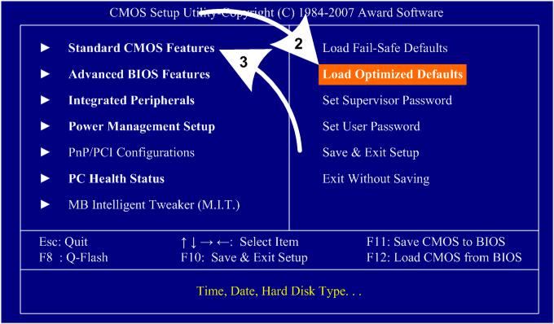

1. Use the Arrow keys (**↑↓→←**) to select **Load Optimized Defaults**, and press **Enter**. Press **Y** and **Enter** when prompted to confirm the change.
2. Use the Arrow keys to highlight **Standard CMOS Features**, and then

press**Enter**.

4. A screen similar to the following will appear:

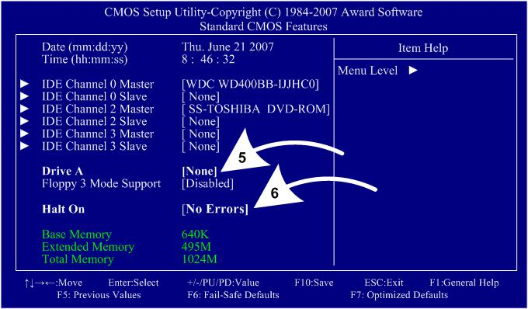

5. Use the Arrow keys to highlight the setting for **Drive A** and press **Enter**.

**33** **Computer Hardware and Network Troubleshooting**

**Sri Venkateshwaraa College of Engineering & Technology**

Use the **Page Up** and **Page Down** keys to change the setting to **None**.

1. Change the setting for **Halt On** to **No Errors** the same way. Press **ESC** to go back to the Main Menu.
2. Now use the Arrow keys to highlight **Advanced BIOS Features** and press **Enter**. A screen similar to the following will appear:
3. Use the Arrow keys to highlight the setting for **First Boot Device** and press **Enter**. Use the **Page Up**

and **Page Down** keys to change the setting to **DVDROM**.

1. Change the setting for **Second Boot Device** to **Hard Disk** the same way.
2. Change the setting for **Third Boot Device** to **Disabled**the same way. Press **ESC** to go back to the Main Menu.

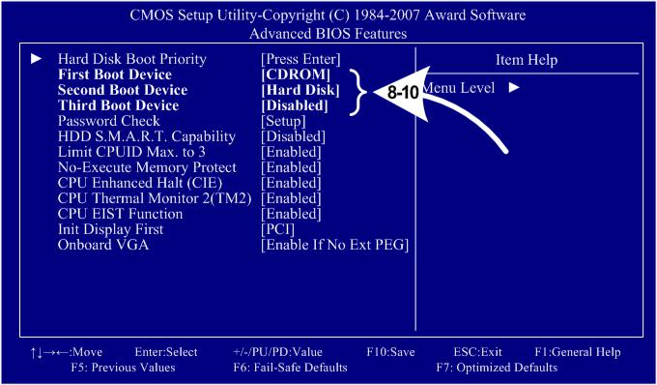

1. Now use the Arrow keys to highlight **Integrated Peripherals** and press **Enter**. A screen similar to the following will appear:

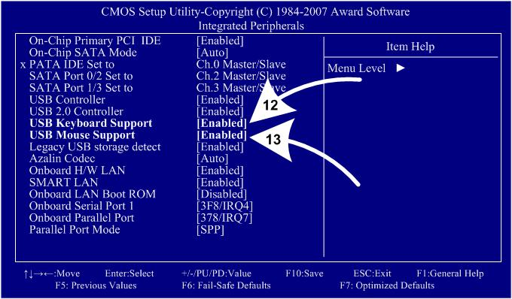

12. Use the Arrow keys to highlight the setting for **USB Keyboard Support** and press **Enter**. Use the **Page Up** and **Page Down** keys to change the setting to **Enabled**.

13. Use the Arrow keys to highlight the setting for **USB Mouse Support** and press **Enter**.

**34** **Computer Hardware and Network Troubleshooting**

**Sri Venkateshwaraa College of Engineering & Technology**

Use the **Page Up** and **Page Down** keys to change the setting to **Enabled**. Press **ESC** to go back to the Main Menu.

1. Now use the Arrow keys to highlight **Power Management Setup** and press **Enter**. A screen similar to the following will appear:
2. Use the Arrow keys to highlight the setting for **AC Back Function** and press **Enter**.

Use the **Page Up** and **Page Down** keys to change the setting to **Full-On**. Press **ESC** to go back to the Main Menu.

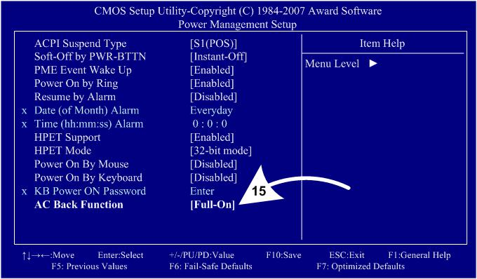

1. Now use the Arrow keys to highlight **PC Health Status** and press **Enter**. A screen similar to the following will appear:
2. Use the Arrow keys to highlight the setting for **CPU Smart FAN Control** and press **Enter**.

Use the **Page Up** and **Page Down** keys to change the setting to **Disabled**. Press **ESC** to go back to the Main Menu.

1. Now that all settings are correct, press F10. The following prompt will appear: Save to CMOS and EXIT (Y/N) Y
2. Make sure "Y" shows at the end of the prompt (use the arrow keys to select, if necessary), and press**Enter**to save the settings and exit.

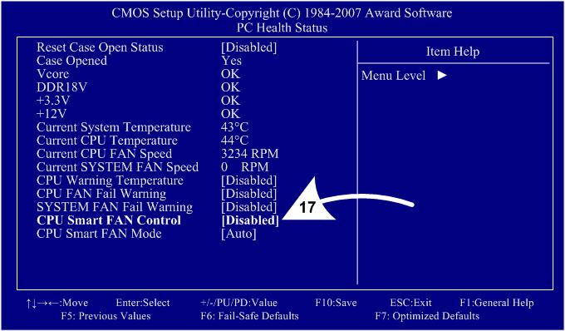

**35** **Computer Hardware and Network Troubleshooting**

**Sri Venkateshwaraa College of Engineering & Technology**

**17. What is Plug and Play BIOS. Explain.**

Plug and Play BIOS Specification defines new functionality to be provided in a PC compatible system BIOS to fulfill the goals of Plug and Play. To achieve these goals, several new components have been added to the System BIOS. Two key areas that are addressed by the System BIOS are resource management and runtime configuration. Resource management provides the ability to manage the fundamental system resources which include DMA, Interrupt Request Lines (IRQs), I/O and Memory addresses. These resources, termed ***system resources,*** are in high demand and commonly are over-allocated or allocated in a conflicting manner in ISA systems, leading to bootstrap and system configuration failures.

A plug and play system BIOS will play a vital role in helping to manage these resources and ensure a successful launch of the operating system. In its role as resource manager, a Plug and Play BIOS takes on the responsibility for configuring Plug and Play cards, as well as system board devices during the power-up phase. After the POST process is complete, control of the Plug and Play device configuration passes from the system BIOS to the system software. The BIOS does, however, provide configuration services for system board devices even after the POST process is complete. These services are known as Runtime Services. Runtime configuration is a concept that has not previously existed in a System BIOS before. The system BIOS has not previously provided the ability to dynamically change the resources allocated to system board devices after the operating system has been loaded. The Plug and Play BIOS Specification provides a mechanism whereby a Plug and Play operating system may perform this resource allocation dynamically at runtime. The operating system may directly manipulate the configuration of devices which have traditionally been considered static via a System BIOS device node structure. In addition, a Plug and Play System BIOS may also support event management. By means of the interfaces outlined in this document, the System BIOS may communicate the insertion and removal of newly installed devices which have been added to the system at runtime. The event management support defined by this specification are specific to devices controlled by the system BIOS, such as docking a notebook system to, or undocking it from, an expansion base. This event management does not encompass the insertion and removal of devices on the various expansion busses.

1. **What are the available Error Messages in BIOS? Explain.**
2. **List out the BIOS / MBR error messages and Explan. (NOV 2014)**

BIOS **(Basic Input and Output System) -** Error Codes/Beeps **-** Entering BIOS/CMOS

Software stored in a Read-Only Memory (ROM) chip on the motherboard (CMOS). It controls systems devices and test memory. It allows you to configure specific parameters about the hardware in your computer such as time, date, disk drive parameters and other device settings.

Beeps are emitted from a computer during the boot process when some problem is encountered and can be used to troubleshoot a dead computer. They indicate problems such as bad memory, bad keyboard or

**36** **Computer Hardware and Network Troubleshooting**

**Sri Venkateshwaraa College of Engineering & Technology**

bad motherboard. Usually if you hear beeps there is something real wrong and you should immediately turn off the computer and perform some troubleshooting. POST Beeping Error General Codes

* Bad Motherboard - 1 long and 1 short beep
* Disk drive related problem / Video card problem - 1 short beep then nothing happens
* Bad video card - 1 long and 2 short beeps
* Bad power supply - 1) continuous beeps, 2) non-stop short beeps
* Bad memory - 3 short beeps

These codes DO vary from one manufacturer to another. Almost all computers list the appropriate codes in the User's manual under technical information or the troubleshooting section, so be sure to check the manual and verify what the codes mean.

If no beeps are heard and no display is on the screen, it's most likely the power supply. Check for Keyboard lights or for hard drive/floppy drive lights. If lights come on then power supply is good. Next, inspect the motherboard for loose components. A loose or missing CPU, BIOS chip, Crystal Oscillator, or Chipset chip will cause the motherboard not to function. If there are lights, then it could be one of the I/O cards. Try removing each card one at a time and restarting the computer.

**Error Codes/Beeps for AMI, Award, Compaq, IBM, Phoenix , BIOS's**

**AMI Beep Codes**

Except for beep code #8, these codes are always fatal.

**1 beep** Refresh failure - try reseating the memory, if the error still occurs, replace the memory

**2 beeps** Parity error - try reseating the memory, if the error still occurs, replace the memory

**3 beeps** Base 64K memory failure - try reseating the memory, if the error still occurs, replace the

memory

**4 beeps** Timer not operational, system board bad

**5 beeps** Processor error, system board bad

**6 beeps** 8042 - gate A20 failure, try reseating the keyboard controller chip

**7 beeps** Processor exception interrupt error, system board bad

**8 beeps** Display memory video card read/write failure error, replace video memory or video card

**9 beeps** ROM checksum error, faulty BIOS chip(s), must replace them

**10 beeps** CMOS shutdown register read/write error, system board bad

**11 beeps** Cache memory bad

**Award BIOS Beep codes**

**One Long and Two Short Beeps** Video Error

**Two Short Beeps** Any Non-Fatal Error

**One Short Beep** No Error During Post

**Phoenix BIOS Beep codes**

**37** **Computer Hardware and Network Troubleshooting**

**Sri Venkateshwaraa College of Engineering & Technology**

These codes are presented in sets of beeps, for instance 1-2-2-3 means one beep followed by 2 beeps then 2 more beeps then 3 beeps

* 1-2-2-3 BIOS ROM checksum
* 1-3-1-1 Test DRAM refresh
* 1-3-1-3 Test 8742 Keyboard Controller
* 1-3-4-1 RAM failure on address line xxxx
* 1-3-4-3 RAM failure on data bits xxx of low byte of memory
* 1-4-1-1 RAM failure on data bits xxxx of high byte of memory bus
* 2-1-2-3 Check ROM copyright notice
* 2-1-3-1 Test for unexpected interrupts
* 1 .......Search for option ROMs
* 1 ...........One short beep before boot, normal

**Master Boot Record (MBR)**

The MBR (stands for ―Master boot record‖) is a boot sector (a region of your hard disk) that holds information about the partitions of your hard drive and acts as a loader for the operating system you’re running.

The Master boot record is created when you first install Windows, on the first partition you create. It’s the first 512 bytes of your hard disk.

If the MBR is damaged, you won’t be able to boot into Windows**.** All Windows versions – Windows XP, Vista, 7 or 8 – use MBR and, if damaged you won’t be able to boot.

It can be damaged by certain viruses that target the MBR to replace it with their own code or in cases when you dual boot with a Linux distribution

**Common errors**

If the Master boot record is broken, your computer may show some of the following errors:

* Error loading operating system
* Operating System missing or Not found
* Invalid partition table
* Reboot and Select proper Boot device or Insert Boot Media in selected Boot device and press a key

Easy Recovery Essentials, bootable recovery and repair CD/USB, is guaranteed to repair most damages done to the Master boot record (MBR) using its Automated Repair feature for Windows XP, Vista,7 or 8.

**38** **Computer Hardware and Network Troubleshooting**

**Sri Venkateshwaraa College of Engineering & Technology**

**Pondicherry University Questions**

**PART A**

* 1. Define IDE. **(NOV 2010)**
  2. Differentiate LAN and WAN. **(NOV 2010)**
  3. What is PCI? **(APR 2011)**
  4. Define MODEM. **(APR 2011), (APR 2012)**
  5. Expand SCSI. **(APR 2012) , (NOV 2012)**
  6. Write an example of peripheral devices. **(NOV 2012)**
  7. What are the two types of system boards? **(NOV 2012)**
  8. What do you mean by BIOS? **(NOV 2012)**
  9. Expand: ISA, PCI, MCA and SMPS. **(NOV 2013)**
  10. What is meant by Plug and Play? **(NOV 2013)**
  11. State the purpose of SMPS. **(NOV 2014)**
  12. List out the sections available in MCA connector? **(NOV 2014)**

**PART B**

1. What are the Components available in the Mother board? Explain Briefly. (Ref.Pg.No.6,Qn.No.1).
2. Describe the detail about mother board architecture. (NOV 2012) (Ref.Pg.No.6,Qn.No.2).
3. Explain briefly about Chipset. (Ref.Pg.No.7,Qn.No.3).
4. Write about Sixth and Seventh generation Chipsets. (Ref.Pg.No.9,Qn.No.4)
5. Explain briefly about third party chipsets VIA, SiS and NVIDIA(Ref.Pg.No.10,Qn.No.5)
6. Compare Desktop vs Laptop motherboards. (Ref.Pg.No.10,Qn.No.6)
7. What is Bus? Explain the Bus Standards : ISA,PCI and MCA. (Ref.Pg.No.11,Qn.No.7)
8. Explain the following: a) ISA, b) PCI, c) PCI Express, d) AGP, e)MCA(APR 2012)(NOV 2010) (Ref.Pg.No.11,Qn.No.8)
9. Describe the features of PCI Bus, also list out the pins and signals available in PCI bus. (NOV 2014) (Ref.Pg.No.15,Qn.No.9)
10. Explain briefly about the system resources Interrupts, DMA channels and I/O Port addresses. (Ref.Pg.No.16,Qn.No.10)
11. Explain the working principle SMPS with functional block diagram. (APR 2012), (NOV 2012) (NOV 2013) (Ref.Pg.No.19,Qn.No.11).
12. Explain the working principle of SMPS. What are the types of SMPS, Explain? (Ref.Pg.No.19, Qn.No.12)
13. Explain Power-Supply Connectors and switches. (Ref.Pg.No.25,Qn.No.13).
14. Explain briefly about RTC/NVRAM Batteries or (CMOS Chips) (Ref.Pg.No.28,Qn.No.14).
15. What is BIOS? How BIOS works? (Ref.Pg.No.30,Qn.No.15).
16. Explain briefly about CMOS setup. (Ref.Pg.No.32,Qn.No.16)
17. What is Plug and Play BIOS. Explain. (Ref.Pg.No.36,Qn.No.17)
18. List out the BIOS / MBR error messages and Explain. (NOV 2014) (Ref.Pg.No.36,Qn.No.18,19)

**39** **Computer Hardware and Network Troubleshooting**