DEPARTMENT OF COMPUTER SCIENCE AND ENGINEERING
(JUNE 2016-NOV 2016)

OPERATING SYSTEMS
V SEMESTER

SYLLABUS

CS T51 OPERATING SYSTEMS

UNIT – I

Introduction: Mainframe Systems – Desktop Systems – Multiprocessor Systems – Distributed Systems – Clustered Systems - Real Time Systems – Hardware Protection – System Components – Handheld Systems - Operating System Services – System Calls – System Programs – Process Concept – Process Scheduling – Operations on Processes – Cooperating Processes – Inter-process Communication.

UNIT – II
Threads: Overview – Threading issues - CPU Scheduling – Basic Concepts – Scheduling Criteria – Scheduling Algorithms – Multiple-Processor Scheduling – Real Time Scheduling - The Critical- Section Problem – Synchronization Hardware – Semaphores – Classic problems of Synchronization – Critical regions – Monitors.
UNIT – III
System Model – Deadlock Characterization – Methods for handling Deadlocks -Deadlock Prevention – Deadlock avoidance – Deadlock detection – Recovery from Deadlocks - Storage Management – Swapping – Contiguous Memory allocation – Paging – Segmentation – Segmentation with Paging.

UNIT – IV
Virtual Memory – Demand Paging – Process creation – Page Replacement – Allocation of frames – Thrashing - File Concept – Access Methods – Directory Structure – File System Mounting – File Sharing – Protection.

UNIT – V
File System Structure – File System Implementation – Directory Implementation – Allocation Methods – Free-space Management. Kernel I/O Subsystems - Disk Structure – Disk Scheduling – Disk Management – Swap-Space Management.
Case Study: The Linux System, Windows.

Text Books:
- Abraham Silberschatz, Peter Baer Galvin and Greg Gagne, “Operating System Concepts”, John Wiley & Sons (ASIA) Pvt. Ltd, Seventh edition, 2005.
- Harvey M. Deitel, Paul J. Deitel, and David R. Choffnes, “Operating Systems”, Prentice Hall, Third edition, 2003.

Reference Books:
- William Stallings, Operating Systems: Internals and Design Principles, Prentice -Hall of India, Sixth edition, 2009.
- Gary J. Nutt, “Operating Systems: A Modern Perspective”, Addison-Wesley, Second edition, 2001.

DEPARTMENT OF COMPUTER SCIENCE AND ENGINEERING

SUBJECT: OPERATING SYSTEMS SUBJECT CODE: CS T51

UNIT I

Introduction: Mainframe Systems – Desktop Systems – Multiprocessor Systems – Distributed Systems – Clustered Systems - Real Time Systems – Hardware Protection – System Components – Handheld Systems - Operating System Services – System Calls – System Programs – Process Concept – Process Scheduling – Operations on Processes – Cooperating Processes – Inter-process Communication.

2 Marks
1. What is an Operating system? (APR’15)
An operating system is a program that manages the computer hardware. It also provides a basis for application programs and act as an intermediary between a user of a computer and the computer hardware. It controls and coordinates the use of the hardware among the various application programs for the various users.

2. Why is the Operating System viewed as a resource allocator & control program?
A computer system has many resources - hardware & software that may be required to solve a problem, like CPU time, memory space, file-storage space, I/O devices & soon. The OS acts as a manager for these resources so it is viewed as a resource allocator. The OS is viewed as a control program because it manages the execution of user programs to prevent errors & improper use of the computer.

3. What is the Kernel?
A more common definition is that the OS is the one program running at all times on the computer, usually called the kernel, with all else being application programs.

4. What are Batch systems?
Batch systems are quite appropriate for executing large jobs that need little interaction. The user can submit jobs and return later for the results. It is not necessary to wait while the job is processed. Operators batched together jobs with similar needs and ran them through the computer as a group.

5. What is the advantage of Multiprogramming?(APR ‘12)
Multiprogramming increases CPU utilization by organizing jobs so that the CPU always has one to execute. Several jobs are placed in the main memory and the processor is switched from job to job as needed to keep several jobs advancing while keeping the peripheral devices in use. Multiprogramming is the first instance where the Operating system must make decisions for the users. Therefore they are fairly sophisticated.

6. What is an Interactive computer system?
Interactive computer system provides direct communication between the user and the system. The user gives instructions to the operating system or to a program directly, using a keyboard or mouse, and waits for immediate results.

7. What do you mean by Time-sharing systems?
Time-sharing or multitasking is a logical extension of multiprogramming. It allows many users to share the computer simultaneously. The CPU executes multiple jobs by switching among them, but the switches occur so frequently that the users can interact with each program while it is running.

8. What are multiprocessor systems & give their advantages?(APR ‘14)(APR ‘12)(APR’15)
Multiprocessor systems also known as parallel systems or tightly coupled systems are systems that have more than one processor in close communication, sharing the computer bus, the clock and sometimes memory & peripheral devices. Their main advantages are
• Increased throughput
• Economy of scale
• Increased reliability

9. What are the different types of multiprocessing?
Symmetric multiprocessing (SMP): In SMP each processor runs an identical copy of the Os & these copies communicate with one another as needed. All processors are peers. Examples are Windows NT, Solaris, Digital UNIX, OS/2 & Linux.
Asymmetric multiprocessing: Each processor is assigned a specific task. A master processor controls the system; the other processors look to the master for instructions or predefined tasks. It defines a master-slave relationship. Example SunOS Version 4.

10. What is Distributed system? (APR ’12, NOV ‘15)
A distributed system is a collection of independent Computers that appears to its users as a single coherent system. Examples of Distributed Systems The Internet: net of nets global access to “everybody” (data, service, other actor; open ended),enormous size (open ended).

11. What are the advantages of distributed processing? (APR ‘13)
1. Higher performance: Applications can execute in parallel and distribute the load across multiple servers.
2. Collaboration: Multiple applications can be connected through standard distributed computing mechanisms.
3. Higher reliability & availability: Applications or servers can be clustered in multiple machines.
4. Scalability: By deploying reusable distributed components on powerful servers.
5. Extensibility: Dynamic (re)configuration of applications distributed across network.
6. Higher productivity & lower development cycle time: Breaking up large problems into smaller ones, these individual components can be developed by smaller development teams in isolation.
7. Reuse: Services that can potentially be used by multiple client applications.
8. Reduced cost: Due to the reuse of once developed components that are accessible over the network

12. What are the disadvantages of distributed processing?
Software: Complexity of programming distributed systems
Networking: The network can saturate or cause other problems
Security: Easy access also applies to secret data

13. What is graceful degradation?
In multiprocessor systems, failure of one processor will not halt the system, but only slow it down. If there are ten processors & if one fails the remaining nine processors pick up the work of the failed processor. This ability to continue providing service is proportional to the surviving hardware is called graceful degradation.

14What is Dual-Mode Operation?
The dual mode operation provides us with the means for protecting the operating system from wrong users and wrong users from one another. User mode and monitor mode are the two modes. Monitor mode is also called supervisor mode, system mode or privileged mode. Mode bit is attached to the hardware of the computer to indicate the current mode. Mode bit is '0' for monitor mode and '1' for user mode.

15. What are privileged instructions?
Some of the machine instructions that may cause harm to a system are designated as privileged instructions. The hardware allows the privileged instructions to be executed only in monitor mode.

16. How can a user program disrupt the normal operations of a system?
A user program may disrupt the normal operation of a system by
• Issuing illegal I/O operations
• By accessing memory locations within the OS itself
• Refusing to relinquish the CPU

17. How is the protection for memory provided?
The protection against illegal memory access is done by using two registers. The base register and the limit register. The base register holds the smallest legal physical address; the limit register contains the size of the range. The base and limit registers can be loaded only by the OS using special privileged instructions.

18. What are the various OS components?
The various system components are
• Process management
• Main-memory management
• File management
• I/O-system management
• Secondary-storage management
• Networking
• Protection system
• Command-interpreter system

19. What is a process?
A process is a program in execution. It is the unit of work in a modern operating system. A process is an active entity with a program counter specifying the next instructions to execute and a set of associated resources. It also includes the process stack, containing temporary data and a data section containing global variables.

20. What is a process state and mention the various states of a process?(APR ‘12)
As a process executes, it changes state. The state of a process is defined in part by the current activity of that process. Each process may be in one of the following states:
• New
• Running
• Waiting
• Ready
• Terminated

21. What is process control block?
Each process is represented in the operating system by a process control block also called a task control block. It contains many pieces of information associated with a specific process. It simply acts as a repository for any information that may vary from process to process. It contains the following information:
• Process state
• Program counter
• CPU registers
• CPU-scheduling information
• Memory-management information
• Accounting information
• I/O status information

22. What are the use of job queues, ready queues & device queues?
As a process enters a system, they are put into a job queue. This queue consists of all jobs in the system. The processes that are residing in main memory and are ready & waiting to execute are kept on a list called ready queue. The list of processes waiting for a particular I/O device is kept in the device queue.

23. What is meant by context switch? (NOV’14)
Switching the CPU to another process requires saving the state of the old process and loading the saved state for the new process. This task is known as context switch. The context of a process is represented in the PCB of a process.

24. What are the factors that need to be considered to determine the degree of multiprogramming in a system?
The two factors that need to be considered are:
1. The overheads in context switching may become excessive.
2. With excessive multiprogramming the response times may become unacceptable.

25. What is the difference between the idle and blocked state of a process?
In idle state, the process is waiting for the processor to become free so that it can execute. In blocked state, the process has been put out from the running state by the processor due to some I/O.

26. When a process requests for I/O, how many process switches take place?
Two. In the first switch, the process to be switched is taken out and the scheduler starts executing. Then the next process is brought to execution. So there are two process switches.

27. Differentiate tightly coupled systems and loosely coupled systems?
S.No | Loosely coupled systems | Tightly coupled systems
1 | Each processor has its own local memory | Common memory is shared by many processors
2 | Each processor can communicate with other all through communication lines | No need of any special communication lines

28. What is real time system? (APR 2011) (NOV 2011)
A real time system has well defined, fixed time constraints. Processing must be done within the defined constraints, or the system will fail. It is often used as a control device in a dedicated application.

29. What do you mean by system calls? (APR ‘12)
System calls provide the interface between a process and the operating system. When a system call is executed, it is treated as by the hardware as software interrupt.

30. What is scheduler?
A process migrates between the various scheduling queues throughout its life time. The OS must select processes from these queues in some fashion. This selection process is carried out by a scheduler.

31. What is independent process?
A process is independent it cannot affect Or be affected by the other processes executing in the system. Any process does not share data with other process is a independent process.

32. What is co-operative process?
A process is co-operating if it can affect or be affected by the other processes executing in the system. Any process that share data with other process is a co-operating process.

33. What is the benefits of OS co-operating process?
- Information sharing.
- Computation speed up.
- Modularity.
- Convenience.

34. How can a user program disturb the normal operation of the system?
- Issuing illegal I/O operation.
- By accessing memory locations within the OS itself.
- Refusing to relinquish the CPU.

35. What is the use of inter process communication.
Inter process communication provides a mechanism to allow the co-operating process to communicate with each other and synchronies their actions without sharing the same address space. It is provided a message passing system.

36. What are the five major activities of an operating system with regard to process management? (APR ‘14)
The five major activities are:
- The creation and deletion of both user and system processes
- The suspension and resumption of processes
- The provision of mechanisms for process synchronization
- The provision of mechanisms for process communication
- The provision of mechanisms for deadlock handling

37. Describe the differences between symmetric and asymmetric multiprocessing?(APR 2011)
Symmetric processing treats all processors as equals; I/O can be processed on any of them.
Asymmetric processing designates one CPU as the master, which is the only one capable of performing I/O; the master distributes computational work among the other CPUs.
- advantages: Multiprocessor systems can save money, by sharing power supplies, housings, and peripherals. Can execute programs more quickly and can have increased reliability.
- disadvantages: Multiprocessor systems are more complex in both hardware and software. Additional CPU cycles are required to manage the cooperation, so per-CPU efficiency goes down.

38. Define Information Sharing?(NOV ‘12)
Information sharing describes the exchange of data between various organizations, people and technologies.
There are several types of information sharing: Information shared by individuals .Information shared by organizations. Information shared between firmware/software. The advent of wide distributed networks, intranets, cross-platform compatibility, application porting, and standardization of IP protocols have all facilitated the huge growth in global information sharing.

39. List the types of server systems?(NOV ‘13)
1. File Server
2. Database server
3. Transaction server.

40. What is the use of fork and exec system calls?
Fork is a system call by which a new process is created. Exec is also a system call, which is used after a fork by one of the two processes to replace the process memory space with a new program.

41. What’s the difference between multitasking, multiprogramming & multiprocessing?
Multiprogramming- Jobs to be executed are loaded into a pool. Some number of those jobs are loaded into main memory, and one is selected from the pool for execution by the CPU. If at some point the program in progress terminates or requires the services of a peripheral device, the control of the CPU is given to the next job in the pool. As programs terminate, more jobs are loaded into memory for execution, and CPU control is switched to another job in memory. In this way the CPU is always executing some program or some portion thereof, instead of waiting for a printer, tape drive, or console input .
Multiprocessing - the simultaneous execution of two or more programs or instruction sequences by separate CPUs under integrated control
multitasking System - the concurrent or interleaved execution of two or more jobs by a single CPU.
Multiuser System - a computer system in which multiple terminals connect to a host computer that handles processing tasks.

42. Define PCB and write its contents?(APRIL 2011)
Process Control block is used for storing the collection of information about the Processes and this is also called as the Data Structure which Stores the information about the process. The information of the Process is used by the CPU at the Run time. The various information which is stored into the PCB as follows:
1) Name of the Process.
2) State of the Process. Means Ready, Active, Wait.
3) Resources allocated to the Process
4) Memory which is provided to the Process.
5) Scheduling information.
6) Input and Output Devices used by the Process.
7) Process ID or a Identification Number which is given by the CPU when a Process Request for a Service.

43. What is meant by independent process and cooperating process? (APR’12)

Independent process cannot affect or be affected by the execution of another process. Cooperating process can affect or be affected by the execution of another process.

44. Name any three components of the system. (Nov ’15)

Process Management

Main Memory Management

File Management

I/O System Management

Secondary Management

Networking

Protection System

Command-Interpreter System

11 Marks

1. Explain computer systems which are categorized according to the number of processors used? (APR ‘12)
An Operating system is a program that controls the execution of application programs and acts as an interface between the user of a computer and the computer hardware.
It provides the basis for applications programs and acts as an intermediary between user of a computer and the computer hardware.
A more common definition is that the operating system is the one program running at all times on the computer (usually called the kernel), with all else being applications programs.
An Operating system is concerned with the allocation of resources and services, such as memory, processors, devices and information. The Operating System correspondingly includes programs to manage these resources, such as a traffic controller, a scheduler, memory management module, I/O programs, and a file system.
COMPONENTS OF A COMPUTER SYSTEM
(Explain briefly about components of computer system.)
Every general purpose computer consists of the hardware, operating system, users, application programs.
The hardware consists of memory, CPU, ALU, I/O devices, peripheral device and storage device. System program consists of compilers, loaders, editors, OS etc. The application program consists of business program, database program.
Hardware – Central processing Unit(CPU), Memory, Input/Output (I/O) Devices.
Operating Systems – Controls and co-ordinate the hardware among application and user.
The fig. 1.1 shows the conceptual view of a computer system

Fig 1.1 Conceptual view of a computer system

Application programs – Word processors, Spread sheets, Computers , Web browsers.
Operating system can be replaced from two view points:
- the user view
- the system view
User view:
User view of the computer varies by the interface being used.
Ease of use → Users sit at the front of a PC. Designed for one user to maximize work,
Resource utilization → Users at the terminal. Assures all available CPU time, memory , I/O are used efficiently.
Work stations →users at workstations connected to network users share resources(files, compile, print servers).
System view:
From computers point of view the operating system is a program that is most intimate with the hardware.
Resource allocator → operating system acts as manager of resources, decides how to allocate to programs so that it can operate efficiently.
Control program→control program manages the execution of user programs to prevent errors and improper use of the computer.
Every computer must have an operating system to run other programs. The operating system and coordinates the use of the hardware among the various system programs and application program for a various users. It simply provides an environment within which other programs can do useful work.
The operating system is a set of special programs that run on a computer system that allow it to work properly. It performs basic tasks such as recognizing input from the keyboard, keeping track of files and directories on the disk, sending output to the display screen and controlling a peripheral device.
OS is designed to serve two basic purposes:
1. It controls the allocation and use of the computing system‘s resources among the various user and tasks.
2. It provides an interface between the computer hardware and the programmer that simplifies and makes feasible for coding, creation, debugging of application programs.
The operating system must support the following tasks. The tasks are :
1. Provides the facilities to create, modification of program and data files using and editor.
2. Access to the compiler for translating the user program from high level language to machine language.
3. Provide a loader program to move the compiled program code to the computer‘s memory for execution.
4. Provide routines that handle the details of I/O programming .
I/O System Management
I/O System Management
The module that keeps track of the status of devices is called the I/O traffic controller. Each I/O device has a device handler that resides in a separate process associated with that device.
The I/O subsystem consists of
1. A memory management component that includes buffering, caching and spooling.
2. A general device driver interface.
Drivers for specific hardware devices.
The computer processor also called CPU (Central Processing Unit) is one of the major components in computer systems. Usually, it is referred as the brain of computer, because it is the place where all the computing process (calculation, comparison and logical decisions) is performed. This dictates your computer performance is mainly depend on the type of processor installed in your computer. The more the computing power of a processor, the higher and faster is the processing capacity of that computer.
Currently, wide varieties of computer processor types are available on the market. Both Intel and AMD, the largest microprocessor manufacturers in the world, have introduced several types of computer processors.
Each processor type is different from the other in performance and technology. Unless you know the features behind each type of processor, choosing the right type could be a challenging task when purchasing, upgrading or building your own computer.
Groups of computer processor types
Based on the overall performance and the type of work designed for, computer processors are grouped into three main categories. There could be other applicable methods to classify computer processors. However, this grouping will help to us ease the complication when selecting a processor both for desktop and mobile computers. Computer processors are grouped into the following three divisions. This grouping doesn’t include processors for Server and Workstation PCs.
1. High-End Processors
Processors in this group are designed for intensive applications, since the programs require high processing power. What makes high-end is the advanced microprocessor technology incorporated with these types of processors. Other than the normal usage of computer applications, if you are into Statistical analysis, intensive graphics, creating and editing professional videos, extreme 3D gaming, multitasking and multi-threading application then you should choose a computer installed with a processor categorized in high-end group.
Both Intel and AMD introduced processors categorized as high-end. The latest Intel Core I Series processors: i3, i5, i7, i9 and AMD Phenom family processors are among high-end CPU’s. The prices of high-end processors are a bit higher comparing with the rest CPU’s.
2. Mid-End computer processor types
Mi-range processors are meant for middle intensive tasks. Beyond the standard work you do with mid-range processors, you can do tasks such as basic 3D Gaming, casual photo editing, home video creating, and multimedia applications.
Some of the common mid-range Intel processors include Intel Core 2 Quad, Intel Core 2 Extreme, Intel Core 2 Duo, Intel Pentium Dual Core and Intel Core Duo/Solo. AMD Phenom 1 X3, AMD Turion family and AMD Athlon family processors are categorized into mid-range CPUs.
3. Basic or economy computer processor types
As the name implies, processors in this group are low performing CPUs with cheap price. If you are into non-intensive tasks such as simple gaming, office applications, internet browsing, email and common graphics, then your choice of processor grouped as budget CPUs. AMD Sempron, AMD Athlon Neo and Intel Atom, Intel Centrino, Centrino Duo and Celeron are grouped into economy processors.

2. Write in detail about Mainframe systems (8) (APR ‘14)

Mainframe systems
Mainframe computer systems were the first computers used to tackle many commercial and scientific applications. It growths from batch systems to time shared systems.
-Batch Systems
-Multiprogrammed Systems
-Time sharing Systems

1.Batch Systems
Input devices – Card readers, tape drivers.
Output devices – Line printers, tape drivers, card punches.
User does not interact directly with the system.
Job is prepared (program, data, control information)
Job is usually in the form of punch cards.
Control transferred automatically from one job to another.
- Batches jobs with similar needs to speedup processing
- After completion of one job then only the next job will be executed
- Task of os
- It automatically transfers control from one job to another
- Demerit -It executes one job at a time
CPU idle during I/O
I/O devices idle during CPU busy
Memory Layout for a Simple Batch System

Memory layout for Multiprogramming batch system

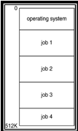
To speed up processing; Jobs with similar needs are batched together.

2. The multiprogrammed systems
- Keeps more than one job in memory simultaneously.
- Jobs are organized so that CPU always has one to execute.
- OS keys several jobs simultaneously in memory.
- OS picks and begins execute one job.
- When a job performs I/O, OS switches to another job.
- It increases CPU scheduling and utilization.
- All jobs enter the system kept in the job pool on a disk scheduler brings jobs from pool into memory.
- Selecting the job from job pool is known as Job scheduling.
- Once the job loaded into memory ,it is ready to execute ,if several jobs are ready to run at the same time ,the system must choose among them ,making this decision is CPU scheduling.
Merit :
- CPU is never idle
DEMERITS :
CPU is often idle.
Speeds of i/o devices are slower.
Executes only one job at a time.

3.Time-Sharing Systems–Interactive Computing

Also called as multi tasking system.
- Extension of multiprogramming.
- Multi user ,single processor OS
- Time sharing or multi tasking allows more than one program to run concurrently.
- Multitasking is the ability to execute more than one task at the same time.a task is a program.
- In multitasking only one CPU is involved ,the CPU switches from one program to another so quickly that it gives the appearance of executing all of the program runs at the same time.
- Response time should be short.
Time sharing systems should provide the following mechanisms:
→File system.
→Disk management
→Concurrent Execution
→Job synchronization and communication

- Two types of multitasking

- Pre emptive
Time slice given to CPU by OS
- Cooperative or non preemptive
In this each program can control the CPU for as long as it needs CPU.

2. Write sort notes on Desktop Systems (4)

Personal computers – computer system dedicated to a single user.

I/O devices – keyboards, mice, display screens, small printers.

User convenience and responsiveness.

Can adopt technology developed for larger operating system.

Often individuals have sole use of computer and do not need advanced CPU utilization or protection features.

May run several different types of operating systems (Windows, MacOS, UNIX, Linux)

3. Explain Multiprocessor systems or Parallel Systems (6) (APR 2011)
- Also known as Parrallel systems or tightly coupled systems.

Multiprocessor systems with more than one CPU in close communication.

Tightly coupled system – processors share memory and a clock; communication usually takes place through the shared memory.

Advantages of parallel system:

Increased throughput- By increasing the no of processors work is done in less time.

Economical – multiprocessor system can save more money because they can share periperal, mass storage and power supply.

Increased reliability- If one processors fields then the remaining processors will share the work of the failed processors. This is known as graceful degradation or fault tolerant
TYPES:

Symmetric multiprocessing (SMP)

Each processor runs an identical copy of the operating system.
- Copies communicate with one another.
- All processors are peers; no master – slave relationship.
- Allow processors and resources to be shared.

Many processes can run at once without performance deterioration.

Most modern operating systems support SMP
Eg: All modern OS – Window NT; UNIX, LINUX, Solris.
Symmetric Multiprocessing Architecture
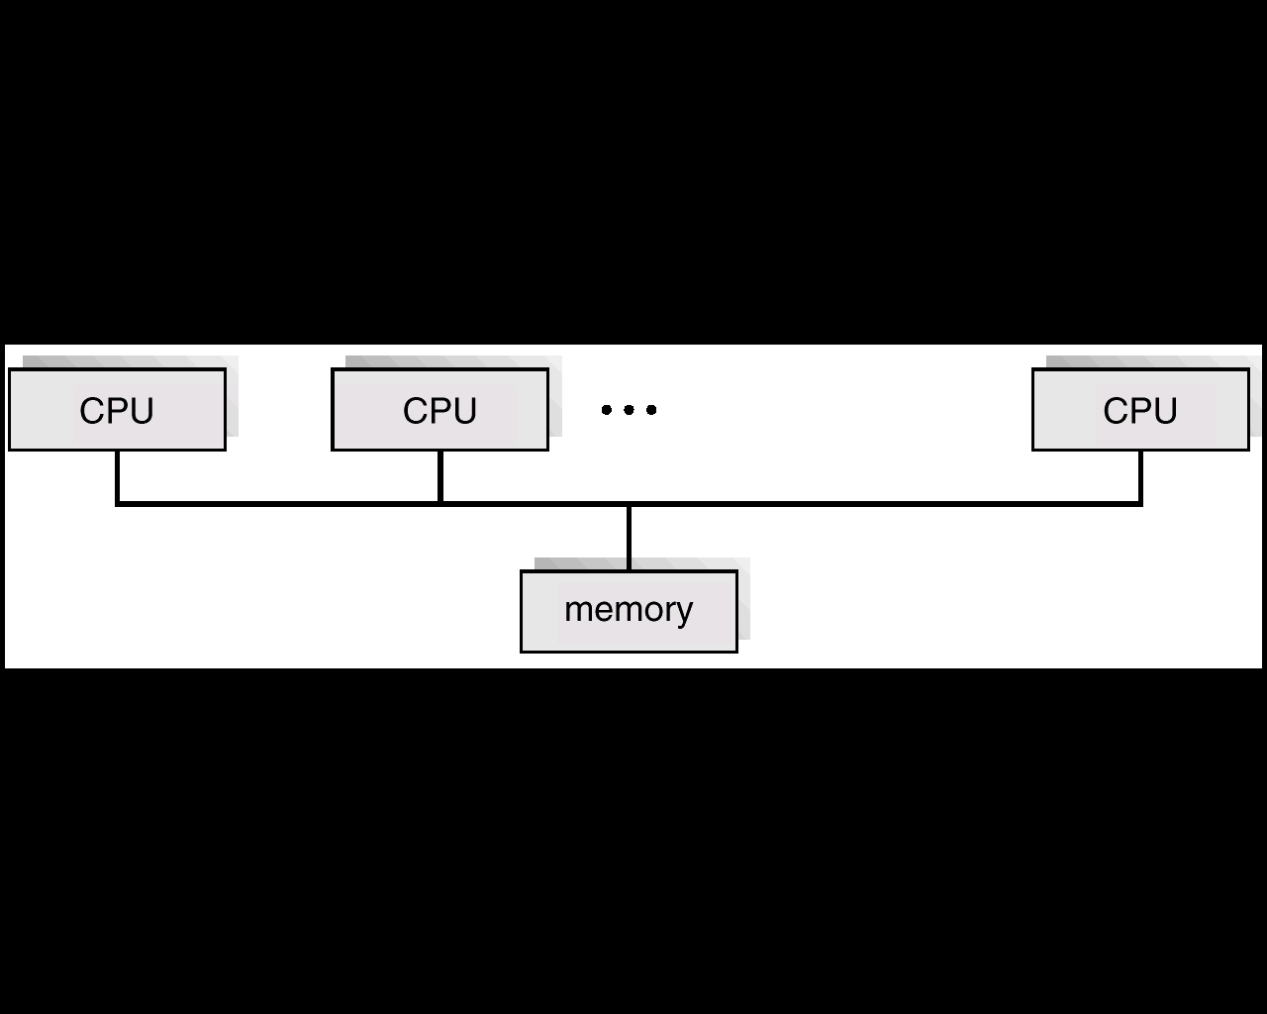

Asymmetric multiprocessing

Each processor is assigned a specific task; master processor schedules and allocates work to slave processors.

More common in extremely large systems
- Follows master – slave relationship.
- Master processor schedules and allocates work to the slave processors.
- Common in extremely large systems.
- Eg: Sun OS(Version4).

4. Write about Distributed Systems (6) (APR 2011)( APR ‘12)
- Depends on networking for their functionality.

Distribute the computation among several physical processors.

Loosely coupled system – each processor has its own local memory; processors communicate with one another through various communications lines, such as high-speed buses or telephone lines.
- Requires networking infrastructure.
- LAN(LOCAL AREA NETWORK) – within a room/building.
- WAN(WIDE AREA NETWORK) – between buildings , cities.
- MAN(METROPOLITAN AREA NETWORK) – link buildings within a city.
- Bluetooth – short distance communication.

Advantages of distributed systems.

Resources Sharing

Computation speed up – load sharing

Reliability

Communications

1. Client server systems
In centralized system acts as a server system to satisfy request generate by client systems it is the server system is categorized as follows
- Compute server system- client can send request to which they execute the actions and send back result to the client.
- File server system – It provides a file system interface where clients can create, update, read and delete files.
General Structure of Client-Server
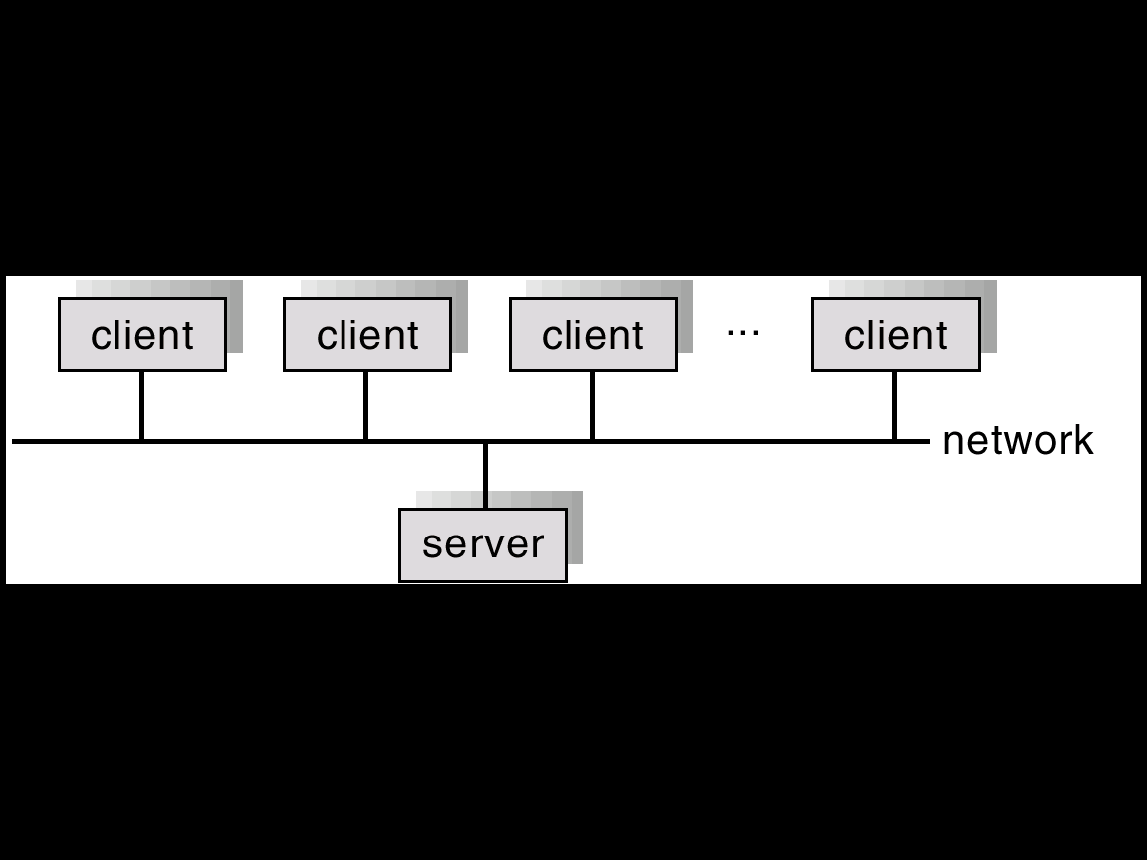
- Peer to Peer System
The growth of the computer networks lead to the internet and WWW. Virtually all modem PCs and workstations are capable of running a web browser for accessing hypertext documents on the web. Several operating systems now include the web browsers, electronic mail, remote login and file transfer clients and servers.
- Network connectivity is an essential component of a computer system.
- These processors do not share memory as a clock.

5. Write short notes on Clustered Systems and real time &hand held systems (8) (NOV 13)
Clustered systems
Clustered systems gather together multiple CPUs to accomplish computational work and runs on cluster nodes.

Clustering allows two or more systems to share storage.

Provides high reliability.
- Each node monitors one or more of others.
- If the monitored machine fails monitoring machine can take ownership of its storage and restart the application running on failed machine.
- The failed machine can remain down, but user’s and clients experience interrupter.

Asymmetric clustering: one server standby while the other runs the application. The standby server monitors the active machine.
- One machine is in hot standby mode
- Other machine runs the application.
- The standby machine monitors the active machine.
- If server fails the standby host becomes active server.

Symmetric clustering: all N hosts are running the application and they monitor each other.
- Two or more hosts runs application and monitors each other.
- More efficient.
- Parrallel clusters:
Allow multiple hosts to access the same data on shared storage.
Eg: Oracle Parallel Server.

Real-Time Systems

Often used as a control device in a dedicated application such as controlling scientific experiments, medical imaging systems, industrial control systems, and some display systems.

Well-defined fixed-time constraints.
- Processing must be done within the defined constraints or the system will fail.

Real-Time systems may be either hard or soft real-time.

Hard real-time:

Secondary storage limited or absent, data stored in short term memory, or read-only memory (ROM)
- System generates that critical tasks be completed on time.

Conflicts with time-sharing systems, not supported by general-purpose operating systems.

Soft real-time

Limited utility in industrial control of robotics
- Restrictive type of system.
- Requires advanced operating system features.

Useful in applications (multimedia, virtual reality) requiring advanced operating-system features.

Handheld Systems

Hand held systems includes Personal Digital Assistants (PDAs) such as palm, pocket PCs/ cellular telephone.

The varies issues of the them are as follows:

Limited space with is a challenging to make the system.

Limited memory space and so in turn limited size of the system.

It has Slow processors.

Web clipping is used to display the content of the web pages because of small display screens.

6. Write short notes on Hardware Protection (6)

Need for hardware protection:
Early os were called resident monitors; the OS began to perform many functions especially I/O .
To improve system utilization ,OS began to share system resources. Protection is needed for any shared resource.

Dual-Mode Operation

I/O Protection

Memory Protection

CPU Protection

Dual-Mode Operation

Sharing system resources requires operating system to ensure that an incorrect program cannot cause other programs to execute incorrectly.

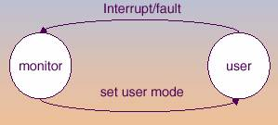

Provide hardware support to differentiate between at least two modes of operations.

1. User mode – execution done on behalf of a user.

2.Monitor mode (also kernel mode or system mode) – execution done on behalf of operating system.
Mode bit added to computer hardware to indicate the current mode: monitor (0) or user (1).
- If bit is set to 1 it is in user mode. If bit is set to 0 it is monitor mode.
- Operating system automatically change the bit value according to the program execution.
When an interrupt or fault occurs hardware switches to monitor mode.
- Initially the hardware starts in monitor mode at system boot time.
- Whenever trap or interrupt occurs, the hardware switches from user mode to monitor mode.
Merits:
- The dual mode operation providers with means of protecting os from current users.
- This protection is accomplished by privileged instructions that can be executed only in monitor mode.

I/O Protection

All I/O instructions are privileged instructions.

Must ensure that a user program could never gain control of the computer in monitor mode (I.e., a user program that, as part of its execution, stores a new address in the interrupt vector).

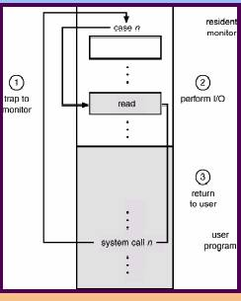

Use of A System Call to Perform I/O
Memory Protection
Use of A Base and Limit Register
- 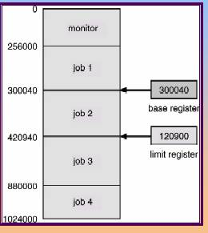

Must provide memory protection at least for the interrupt vector and the interrupt service routines.
- Also protect interrupt service routines in os from modification.

In order to have memory protection, add two registers that determine the range of legal addresses a program may access:

Base register – holds the smallest legal physical memory address.

Limit register – contains the size of the range
Eg: If base register holds 300040 and limit register is 120900, then program can legally access all addresses from 300040 through 420940. This scheme prevents user program from modifying the code of either os or other users.
FIG: Base and a limit register (logical address space)
Any attempt by a program executing in user mode to access monitor memory or other users memory results in a trap to the monitor which is a fatal error.

Memory outside the defined range is protected.
Hardware Address Protection

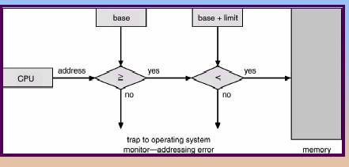

Hardware Protection

When executing in monitor mode, the operating system has unrestricted access to both monitor and user’s memory.

The load instructions for the base and limit registers are privileged instructions.

CPU Protection
- Ensure that the os maintains control.
- Timer can be net to interrupt the computer after aspecified period.
- Periods may be fixed or variable.

Timer – interrupts computer after specified period to ensure operating system maintains control.

Timer is decremented every clock tick.

When timer reaches the value 0, an interrupt occurs.

Timer commonly used to implement time sharing.

Timer also used to compute the current time.

Load-timer is a privileged instruction.

7. List out and discuss operating System Components? (NOV ‘12)(APR’15)

Process Management

Main Memory Management

File Management

I/O System Management

Secondary Management

Networking

Protection System

Command-Interpreter System

Process Management

A process is a program in execution. A process needs certain resources, including CPU time, memory, files, and I/O devices, to accomplish its task.

The operating system is responsible for the following activities in connection with process management.

Process creation and deletion.

Process suspension and resumption.

Provision of mechanisms for:

process synchronization

process communication

Main-Memory Management

Memory is a large array of words or bytes, each with its own address. It is a repository of quickly accessible data shared by the CPU and I/O devices.

Main memory is a volatile storage device. It loses its contents in the case of system failure.

The operating system is responsible for the following activities in connections with memory management:

Keep track of which parts of memory are currently being used and by whom.

Decide which processes to load when memory space becomes available.

Allocate and deallocate memory space as needed.

File Management

A file is a collection of related information defined by its creator. Commonly, files represent programs (both source and object forms) and data.

The operating system is responsible for the following activities in connections with file management:

File creation and deletion.

Directory creation and deletion.

Support of primitives for manipulating files and directories.

Mapping files onto secondary storage.

File backup on stable (nonvolatile) storage media.

I/O System Management

Manage and control I/O operations and I/O devices.

The I/O system consists of:

A buffer-caching system

A general device-driver interface

Drivers for specific hardware devices

Secondary-Storage Management

Since main memory (primary storage) is volatile and too small to accommodate all data and programs permanently, the computer system must provide secondary storage to back up main memory.

Most modern computer systems use disks as the principle on-line storage medium, for both programs and data.

The operating system is responsible for the following activities in connection with disk management:

Free space management

Storage allocation

Disk scheduling

Networking (Distributed Systems)

A distributed system is a collection processors that do not share memory or a clock. Each processor has its own local memory.

The processors in the system are connected through a communication network.

Communication takes place using a protocol.

A distributed system provides user access to various system resources.

Access to a shared resource allows:

Computation speed-up

Increased data availability

Enhanced reliability

Protection System

Protection refers to a mechanism for controlling access by programs, processes, or users to both system and user resources.

The protection mechanism must:

distinguish between authorized and unauthorized usage.

specify the controls to be imposed.

provide a means of enforcement.

Command-Interpreter System

Many commands are given to the operating system by control statements which deal with:

process creation and management

I/O handling

secondary-storage management

main-memory management

file-system access

protection

networking

The program that reads and interprets control statements is called variously:

command-line interpreter

shell (in UNIX)

Its function is to get and execute the next command statement.

8. Write notes on Operating System Services (5) (APR ’12, NOV ‘15)
OS provides services to programs and to users.
Operating system providers services to programs and to users. These services are as follows.
Services to user:

Program execution – system capability to load a program into memory and to run it.

I/O operations – since user programs cannot execute I/O operations directly, the operating system must provide some means to perform I/O.

File-system manipulation – program capability to read, write, create, and delete files.

Communications – exchange of information between processes executing either on the same computer or on different systems tied together by a network. Implemented via shared memory or message passing.

Error detection – ensure correct computing by detecting errors in the CPU and memory hardware, in I/O devices, or in user programs.

Services to programs:

Resource allocation – allocating resources to multiple users or multiple jobs running at the same time.

Accounting – keep track of and record which users use how much and what kinds of computer resources for account billing or for accumulating usage statistics.

Protection – ensuring that all access to system resources is controlled.

9. Discuss and detail about System Calls and system programs (5) (APR ‘12)(NOV ‘12)(NOV’14)

Any request made by the user to OS is called system call for the resources.

System calls provide the interface between a running program and the operating system.

Generally available as assembly-language instructions.

Languages defined to replace assembly language for systems programming allow system calls to be made directly (e.g., C, C++)

Three general methods are used to pass parameters between a running program and the operating system.

Pass parameters in registers.

Store the parameters in a table in memory, and the table address is passed as a parameter in a register.

Push (store) the parameters onto the stack by the program, and pop off the stack by operating system.
Passing of parameters as a table.
System calls provide an interface between the process an the operating system. System calls allow user-level processes to request some services from the operating system which process itself is not allowed to do. In handling the trap, the operating system will enter in the kernel mode, where it has access to privileged instructions, and can perform the desired service on the behalf of user-level process. It is because of the critical nature of operations that the operating system itself does them every time they are needed. For example, for I/O a process involves a system call telling the operating system to read or write particular area and this request is satisfied by the operating system.
system programs provide basic functioning to users so that they do not need to write their own environment for program development (editors, compilers) and program execution (shells). In some sense, they are bundles of useful system calls.

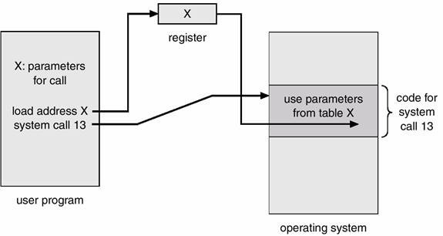

Types of System Calls

Process control
Load and execute, create process, terminate process, end, abort, get/set process attributes, wait, get process attribute, set process attribute, wait for time, wait event, signal event, allocate and free memory etc.

File management
Open, close, create process, delete, read, write, reposition, get/set file attribute.

Device management
Request, release, read, write, reposition
Read, write, reposition
Get device attributes, set device attributes
Logically attach or detach devices.

Information maintenance
Get/set time, date
Get system data, set system data
Get process, file or device attribute
Set process, file or device attributes

Communications
Open/close connection, send/receive messages.
Transfer status information.
Attach or detach remote devices.

10. Explain Different type of system calls? (NOV 12)(APR’15)
Process Control
A running program needs to be able to halt its execution either normally (end) or abnormally (abort). If a system call is made to terminate the currently running program abnormally, or if the program runs into a problem and causes an error trap, a dump of memory is sometimes taken and an error message generated. The dump is written to disk and may be examined by a debugger to determine the cause of the problem. Under either normal or abnormal circumstances, the operating system must transfer control to the command interpreter. The command interpreter then reads the next command. In an interactive system, the command interpreter simply continues with the next command; it is assumed that the user will issue an appropriate command to respond to any error. In a batch system, the command interpreter usually terminates the entire job and continues with the next job. Some systems allow control cards to indicate special recovery actions in case an error occurs. If the program discovers an error in its input and wants to terminate abnormally, it may also want to define an error level. More severe errors can be indicated by a higher-level error parameter. It is then possible to combine normal and abnormal termination by defining a normal termination as error at level 0. The command interpreter or a following program can use this error level to determine the next action automatically.
Types of system calls- Process Control
Process control
- end, abort
- load, execute
- create process, terminate process
- get process attributes, set process attributes
- wait for time
- wait event, signal event
- allocate and free memory
File management
  - create file, delete file
  - open, close
  - read, write, reposition
  - get file attributes, set file attributes
Device management
  - request device, release device
  - read, write, reposition
  - get device attributes, set device attributes
  - logically attach or detach devices
Information maintenance
  - get time or date, set time or date
  - get system data, set system data
  - get process, file, or device attributes
  - set process, file, or device attributes
Communications
  - create, delete communication connection
  - send, receive messages
  - transfer status information
  - attach or detach remote devices
File Management
System call requires the name of the file and perhaps some of the file's attributes. Once the file is created, we need to open it and to use it. We may also read, write, or reposition (rewind or skip to the end of the file, for example). Finally, we need to close the file, indicating that we are no longer using it. We may need these same sets of operations for directories if we have a directory structure for organizing files in the file system. In addition, for either files or directories, we need to be able to determine the values of various attributes, and perhaps to reset them if necessary. File attributes include the file name, a file type, protection codes, accounting information, and so on. At least two system calls, get file attribute and set file attribute, are required for this function. Some operating systems provide many more calls.
Device Management
A program, as it is running, may need additional resources to proceed. Additional resources may be more memory, tape drives, access to files, and so on. If the resources are available, they can be granted, and control can be returned to the user program; otherwise, the program will have to wait until sufficient resources are available.
Files can be thought of as abstract or virtual devices. Thus, many of the system calls for files are also needed for devices. If the system has multiple users, however, we must first request the device, to ensure exclusive use of it. After we are finished with the device, we must release it. These functions are similar to the open and close system calls for files.
Once the device has been requested (and allocated to us), we can read, write, and (possibly) reposition the device, just as we can with ordinary files. In fact, the similarity between I/O devices and files is so great that many operating systems, including UNIX and MS-DOS, merge the two into a combined file-device structure. In this case, 1/0 devices are identified by special file names.
Information Maintenance
Many system calls exist simply for the purpose of transferring information between the user program and the operating system. For example, most systems have a system call to return the current time and date. Other system calls may return information about the system, such as the number of current users, the version number of the operating system, the amount of free memory or disk space, and so on. In addition, the operating system keeps information about all its processes, and there are system calls to access this information. Generally, there are also calls to reset the process information (get process attributes and set process attributes).
Communication
There are two common models of communication. In the message-passing model, information is exchanged through an interprocess-communication facility provided by the operating system. Before communication can take place, a connection must be opened. The name of the other communicator must be known, be it another process on the same CPU, or a process on another computer connected by a communications network. Each computer in a network has a host name, such as an IP name, by which it is commonly known. Similarly, each process has a process name, which is translated into an equivalent identifier by which the operating system can refer to it. The get hostid and get processid system calls do this translation. These identifiers are then passed to the general-purpose open and close calls provided by the file system, or to specific open connect ion and close connect ion system calls, depending on the system's model of communications. The recipient process usually must give its permission for communication to take place with an accept connect ion call. Most processes that will be receiving connections are special purpose daemons-systems programs provided for that purpose. They execute a wait for connection call and are awakened when a connection is made. The source of the communication, known as the client, and the receiving daemon, known as a server, then exchange messages by read message and write message system calls. The close connect ion call terminates the
Communication.

11.Write short notes on Process (7) (APR 12)(NOV 13)

Process is nothing but a program in execution. Process can create sub process called child .the process of creating as many child processes from a parent process is called spawning. Every process has process states. Current activity of the process is called process state.

A process includes:

program counter

stack

data section

Process State

As a process executes, it changes state

new: The process is being created.

running: Instructions are being executed.

waiting: The process is waiting for some event to occur.

ready: The process is waiting to be assigned to a process.

terminated: The process has finished execution.

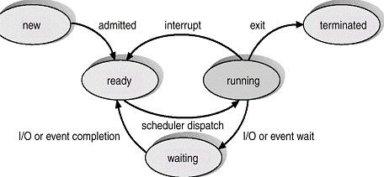
Process control block:

Each process is represented in the operating system by a processes control block(PCB).
- It is also called as task control block(TCB).

It is a data structure maintained by OS for every process control. Information associated with each process.

Process state

Program counter

CPU registers

CPU scheduling information

Memory-management information

Accounting information

I/O status information
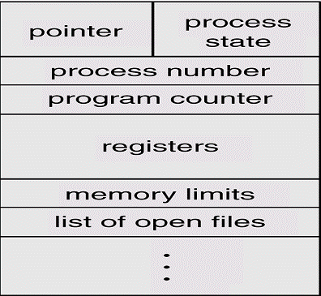

12.Write about process scheduling (6) (NOV’14)

Process Schelduling:
- A microprocessor system can have only one runnig process.
- If more processors exist the rest must wait until the CPU is free and can be rescheduled.

Process Scheduling Queues

Policy which decides the CPU to switch from one process to other is called scheduling.this process method os called process scheduling .it is represented by queuing diagram.

Process migrates between various queues.

Job queue – set of all processes in the system.

Ready queue – set of all processes residing in main memory, ready and waiting to execute.

Device queues – set of processes waiting for an I/O device.

Process migration between the various queues.
Ready queue and various I/O queues
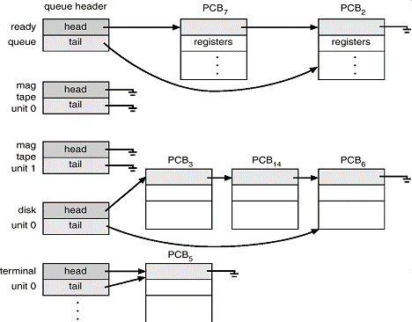
Representation of process scheduling
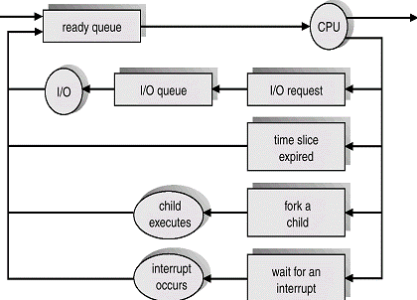

- A process continues the cycle until it terminates at which time it is removed from all queues and has its PCB and resources deallocated.

SCHEDULER:
    - A process migrates between the various scheduling queues throughout its lifetime.
    - The operating system must select, for scheduling purpose processors from these queues in a certain order.
    - The selection process is carried out by the scheduler.

Long-term scheduler (or job scheduler) – selects which processes should be brought into the ready queue. It is also calles as job scheduler.

Short-term scheduler (or CPU scheduler) – selects which process should be executed next and allocates CPU. It is also calles as CPU scheduler.

Medium term scheduler-acts as an intermediate between long term and short term .it uses swapping technique to balance the utilization of CPU.it removes process from memory and later bring it into memory(swapping)

Short-term scheduler is invoked very frequently (milliseconds) ⇒ (must be fast).

Long-term scheduler is invoked very infrequently (seconds, minutes) ⇒ (may be slow).

The long-term scheduler controls the degree of multiprogramming.

Processes can be described as either:

I/O-bound process – spends more time doing I/O than computations, many short CPU bursts.

CPU-bound process – spends more time doing computations; few very long CPU bursts.

Addition of medium term scheduling
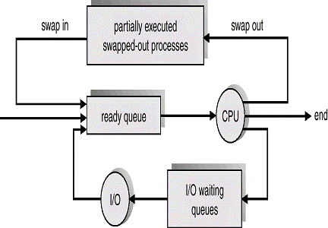

Context switch

When CPU switches to another process, the system must save the state of the old process and load the saved state for the new process.

Context-switch time is overhead; the system does no useful work while switching.

Time dependent on hardware support.

13.Write about operation on Processes (7) (NOV 13) (NOV’14, NOV ‘15)

Process Creation

Fork()-system call used to create child process identical to parent.

Parent process create children processes, which, in turn create other processes, forming a tree of processes.

Resource sharing

Parent and children share all resources.

Children share subset of parent’s resources.

Parent and child share no resources.

Execution

Parent and children execute concurrently.

Parent waits until children terminate.

Address space

Child duplicate of parent.

Child has a program loaded into it.

UNIX examples

fork system call creates new process

exec system call used after a fork to replace the process’ memory space with a new program.

Process Termination

Process executes last statement and asks the operating system to decide it (exit).

Output data from child to parent (via wait).

Process’ resources are deallocated by operating system.

Parent may terminate execution of children processes (abort).

Child has exceeded allocated resources.

Task assigned to child is no longer required.

Parent is exiting.

Operating system does not allow child to continue if its parent terminates.

Cascading termination.

Cooperating Processes

Independent process cannot affect or be affected by the execution of another process.

Cooperating process can affect or be affected by the execution of another process

Advantages of process cooperation

Information sharing

Computation speed-up

Modularity

Convenience

14. Explain how cooperating process can communication in direct and indirect communication?

(APR ‘13)
The processes executing in the operating system may be either independent processes or cooperating processes. Cooperating processes require an inter-process communication mechanism to communicate with each other. Principally, communication is achieved through two schemes: shared memory and message passing. The shared-memory method requires communicating processes through
The use of these shared variables. In a shared-memory system, the responsibility for providing communication rests with the application programmers: the operating system needs to provide only the shared memory. The responsibility for providing communication may rest with the operating system itself. These two schemes are not mutually exclusive and can be used simultaneously within a single operating system.
Co-operating process is a process that can affect or be affected by the other processes while executing. If suppose any process is sharing data with other processes, then it is called co-operating process. Benefit of the co-operating processes are :
1. Sharing of information
2. Increases computation speed
3. Modularity
4. Convenience
Information sharing in co – operating processors:
Co-operating processes share the information: Such as a file, memory etc. System must provide an environment to allow concurrent access to these types of resources. Computation speed will increase if the computer has multiple processing elements are connected together. System is constructed in a modular fashion. System function is divided into number of modules.

Behavior of co-operating processes is nondeterministic i.e. it depends on relative execution sequence and cannot be predicted a priori. Co-operating processes are also Reproducible
. For example, suppose one process writes”ABC”, another writes”CBA” can get different outputs, cannot tell what comes from which. Which process output first “C” in “ABCCBA”. The subtle state sharing that occurs here via the terminal. Not just anything can happen, though. For example,”AABBCC” cannot occur.

15. Explain Producer-Consumer Problem (8)

A common paradigm for cooperating processes, A producer process produces information that is consumed by a consumer process.

Have a buffer of items filled by the producer and emptied by the consumer

unbounded-buffer no limit on the size of the buffer.

bounded-buffer assumes that there is a fixed buffer size.

Buffer is a shared memory .Producer and consumer run concurrently and must be synchronized. In bounded buffer, the consumer must wait if the buffer is empty and the producer must wait if the buffer is full.

In Unbounded Buffer, the consumer may have to wait for new items, but the producer can always produce new items.

Bounded-Buffer – Shared-Memory Solution

Shared data

#define BUFFER_SIZE 10

Typedef struct {

. . .

} item;

item buffer[BUFFER_SIZE];

int in = 0;

int out = 0;

Solution is correct, but can only use BUFFER_SIZE-1 elements

Bounded-Buffer – Producer Process

ItemnextProduced;
while (1)

{

while (((in + 1) % BUFFER_SIZE) == out) ;

/* do nothing */

buffer[in] = next Produced;

in = (in + 1) % BUFFER_SIZE;

}

Bounded-Buffer – Consumer Process

ItemnextConsumed;
while (1) {

while (in == out);

/* do nothing */

next Consumed = buffer[out];

out = (out + 1) % BUFFER_SIZE;

}

16. Write about Inter process Communication (8) (APR ’14, NOV ‘15)
Interprocess communication (IPC)
IPC provides a mechanism to allow processors to communicate and to synchronize their actions without sharing the same address space.
IPC is useful in a distributed environment.

Cooperating process can communicate through facility provided
- By application programmer
- By os [IPC]

Mechanism for processes to communicate and to synchronize their actions.

Message system – processes communicate with each other without resorting to shared variables.

IPC facility provides two operations:

send(message) – message size fixed or variable

receive(message)

If P and Q wish to communicate, they need to:

establish a communication link between them

exchange messages via send/receive

Implementation of communication link

physical (e.g., shared memory, hardware bus)

logical (e.g., logical properties)
A communication link must exist between them. This link can be implemented in a variety of ways.Physical(shared memory, bus) logical(logical properties).
Naming:

Processers that want to communicate must have a way to refer to each other.
    - They can use either direct or indirect communication.

Direct Communication

Processes must name each other explicitly:

send (P, message) – send a message to process P

receive(Q, message) – receive a message from process Q

Properties of communication link

Links are established automatically.

A link is associated with exactly one pair of communicating processes.

Between each pair there exists exactly one link.

The link may be unidirectional, but is usually bi-directional.

Indirect Communication

Messages are directed and received from mailboxes (also referred to as ports).

Each mailbox has a unique id.

Processes can communicate only if they share a mailbox.

Properties of communication link

Link established only if processes share a common mailbox

A link may be associated with many processes.

Each pair of processes may share several communication links.

Link may be unidirectional or bi-directional.

Operations

create a new mailbox

send and receive messages through mailbox

destroy a mailbox

Primitives are defined as:

send(A, message) – send a message to mailbox A

receive(A, message) – receive a message from mailbox A

Solutions

Allow a link to be associated with at most two processes.

Allow only one process at a time to execute a receive operation.

Allow the system to select arbitrarily the receiver. Sender is notified who the receiver was.

Synchronization

Message passing may be either blocking or non-blocking.

Blocking is considered synchronous

Non-blocking is considered asynchronous

Send and receive primitives may be either blocking or non-blocking.
Blocking send: sending is blocked until message is received.
Non –blocking send: sends message and resumes operation.
Blocking receive: receiver blocks until message is available.
Non blocking receive: receiver retrievals either valid message or null.

Buffering

Queue of messages attached to the link; implemented in one of three ways.

1. Zero capacity – 0 messages
Sender must wait for receiver (rendezvous).

2. Bounded capacity – finite length of n messages
Sender must wait if link full.

3. Unbounded capacity – infinite length , rename
Sender never waits.
WRITE short notes on system programs.
System programs:
  - Systems programs provide a convenient environment for program development and execution.
  - They are used for user interface to system calls.
  - Categories are as follows:
File management:
These programs create, delete, copy, rename, print, dump, list and generally manipulate files and directories.
- In addition operating system keeps information about all its processers and there are system calls to acccess this information.
Status information:
- Programs simply ack for date, time, amount of available memory, disk space, number of users or staus information.
- The information is printed to the terminal.
File modification :
- Text editors are available to create and modify the content of files stored on disk/type.
Programming and execution:
- Once program is assembled or compiled, it must be loaded into memory to be executed.
- Provides absolute loaders, relocatable loaders, linkage editors, overlay loaders.
Programming language support:
- Common programming languages: c,c++,java,VB
- Compilers, assemblers and interpreters are provided.
Communications:
- provide mechanism for virtual connections among processors, users and computer systems.
- Allow to send messages, because web pages ,send pages, send emails, login remotely or to transfer files.
Pondicherry University Questions
2 Marks
1. What is the advantage of Multiprogramming?(UQ APR’12) (Ref.Pg.No.04Qn.No.5)
2. List the 2 type of server systems?( UQ NOV ‘13) (Ref.Pg.No.11 Qn.No.39)
3. What is Distributed system? (UQ APR’12, NOV ‘15) (Ref.Pg.No.05 Qn.No.10)
4. What are the advantages of distributed processing?(UQ APR’13) (Ref.Pg.No.05 Qn.No.11)
5. What is a process state and mention the various states of a process?(UQ APR’12 ) (Ref.Pg.No.07 Qn.No.20)
6. What is real time system?( UQ APR’11,NOV ‘11 ) (Ref.Pg.No.09 Qn.No.28)
7. What do you mean by system calls?( UQ APR’12) (Ref.Pg.No.09 Qn.No.29)
8. What are the five major activities of an operating system with regard to process management?( UQ APR’14 ) (Ref.Pg.No.10 Qn.No.36)
9. Describe the differences between symmetric and asymmetric multiprocessing?( UQ APR’11 ) (Ref.Pg.No.10 Qn.No.37)
10. Define Information Sharing?( UQ NOV ‘12) (Ref.Pg.No.11 Qn.No.38)
11. Define PCB and write its contents?(APR’11) (Ref.Pg.No.11 Qn.No.42)
12. What is meant by independent process and cooperating process? (APR’12) (Ref.Pg.No.12 Qn.No.43)
13. What is meant by context switch? (NOV’14) ) (Ref.Pg.No.8 Qn.No.23)
14. What is an Operating system? (APR’15) (Ref.Pg.No.4 Qn.No.1)
15. What are multiprocessor systems & give their advantages?(UQ APR’12,APR’14,APR’15) (Ref.Pg.No.05 Qn.No.8)
16. Name any three components of the system (UQ Nov ’15) (Ref.Pg.No. 12 Qn.No.44)

11 MARKS
1. Explain computer systems which are categorized according to the number of processors used?( UQ APR‘12) (Ref.Pg.No.13 Qn.No.1)

2. Write in detail about Mainframe systems? (UQ APR’14) (Ref.Pg.No.16Qn.No.2)

3. Explain Multiprocessor systems or Parallel Systems?( UQ APR’11 ) (Ref.Pg.No.19Qn.No.3)
4. Write about Distributed Systems ? (UQ APR’11 & APR2012) (Ref.Pg.No.20Qn.No.4)
5. Write short notes on Clustered Systems and real time &hand held systems?(UQ NOV’13) (Ref.Pg.No.21 Qn.No.5)
6. Explain how cooperating process can communication in direct and indirect communication?(UQ APR’ 13) (Ref.Pg.No.39 Qn.No.14)
7. Write notes on Operating System Services?(UQ APR’12, NOV ‘15) (Ref.Pg.No.28 Qn.No.8)
8. Write about Inter process Communication?(UQ APR’ 14, NOV ‘15) (Ref.Pg.No.41 Qn.No.16)
9. Write short notes on Process?(UQ APR‘12NOV ‘13) (Ref.Pg.No.33 Qn.No.11)
10. Write about process scheduling (NOV’14) (Ref.Pg.No.35 Qn.No.12)
11. Write about operation on Processes?(UQ NOV ’13,NOV’14, NOV ‘15) (Ref.Pg.No.37 Qn.No.13)
12. Discuss and detail about System Calls and system programs ?(UQ APR’12 ,NOV ’12 , NOV’14) (Ref.Pg.No.29 Qn.No.9)
13. Explain Different type of system calls?(UQ NOV ’12,APR’15) (Ref.Pg.No.31 Qn.No.10)
14. List out and discuss operating System Components?(UQ NOV’12,APR’15) (Ref.Pg.No.25 Qn.No.7)

