

**Department of Computer Science and Engineering**

Subject Name: **COMPUTER HARDWARE AND NETWORK TROUBLESHOOTING**

Subject Code: **CS T72**

**Prepared By :** Dr. N. Balaji, Professor & HOD / CSE

**Verified by : Approved by : UNIT – IV**

**Input and Output Devices:** Keyboard – Signals and Interface standards – Pointing devices: Mouse -

mechanical and optical – Joystick.

**Video hardware**:Video Display Adaptors – Interfaces – 3D graphics accelerators – LCD and LED

monitors

**Printers:** dot matrix – laser jet - ink jet – Pen plotters – BIOS and DOS Interrupt services for I/O

devices – Troubleshooting I/O related problems.

**1. Give the layouts of a keyboard?**

**2 Marks**

**2. What are the four basic types of keyboard? (NOV 2012)**

83-key PC/XT keyboard

84-key AT keyboard

Enhanced 101-key keyboard

Windows 104- key keyboard

**3. What is meant by Ergonomic keyboard?**

Ergonomics is the study of how equipment and furniture can be arranged in order that people can do work or other activities more efficiently and comfortably. This type of keyboard is used to provide the user with a more natural hand position while typing.

**4. How many connectors are there in a keyboard? What are they?**

**5. What are the two types keyboard interfaces. (NOV 2010)**

PC keyboards connect to the motherboard on the computer using one of three connectors. They are:

5-pin DIN Connector

6-pin MINI DIN Connector

USB Connector

**6. What is the use of Connector? (NOV 2012)**

Connector used to connect keyboard and CPU

**7. Write the types of switches in a keyboard?**

**Pure mechanical switches:** The most basic mechanical switch design is one which depressing the key forces metal contacts together, completing the circuit. A spring forces the key back up to tis original position. The nature of the spring mechanism used in most keyboards.

**Foam element switches:** Similar to pure mechanical switches in so far they use an electric circuit between each key and the circuit board below a spring to pop the key back up. Here each

keytop is connected with a cushion of foam gives the keyboard softier, quieter and more cushiony feeling.

**Rubber-dome switches:** In this design each key is sits a top rubber dome with an electric contact on its concave underside. The shape of the dome then forces the key back up into its original position. This is easier and cheaper comparing to other models. This is the most common type of keyboard used today. Here the rubber domes form a solid sheet.

**Membrane switches:** Similar to rubber-dome switches, except the keytop are all joined into a solid sheet that rest on top of the rubber domes. This provides s a greater amount of protection against the outside environment.

**8. Define USB?**

Universal Serial Bus (USB) is a [serial](http://en.wikipedia.org/wiki/Serial_communications) [bus stan](http://en.wikipedia.org/wiki/Computer_bus)dard to [interface d](http://en.wikipedia.org/wiki/Electrical_connector)evices to a host computer. USB was designed to allow many peripherals to be connected using a single standardized interface socket and to improve the [Plug and play c](http://en.wikipedia.org/wiki/Plug_and_play)apabilities by allowing [hot swapping,](http://en.wikipedia.org/wiki/Hot_swapping) that is, by allowing devices to be connected and disconnected without [rebooting the](http://en.wikipedia.org/wiki/Booting) computer or turning off the device.

**9. Define Mouse?**

A mouse (plural mice or mouses) is a computer [pointing device;](http://en.wikipedia.org/wiki/Pointing_device) it is designed to detect [two- dimensional mo](http://en.wikipedia.org/wiki/Dimension)tion relative to its supporting surface and consists of a small case, to be held under one of the user's hands, and one or more buttons.

**10. What are the types of Mouse? (APR 2012)**

Mechanical Mouse

Ball Mouse

Laser Mouse

Optical Mouse

**11. What is the Joystick? (APR 2011)**

Joystick is an input device consisting of a stick that pivots on a base and reports its angle or direction to the device it is controlling. Joysticks are often used to control video games, and usually have one or more push-buttons whose state can also be read by the computer. Joysticks are also used for controlling machines such as cranes, trucks, underwater unmanned vehicles and zero turning radius lawn mowers.

**12. What is Track Ball? (APR 2012)**

A trackball is a pointing device consisting of a ball held by a socket containing sensors to detect a rotation of the ball about two axes—like an upside-down mouse with an exposed protruding ball. The user rolls the ball with the thumb, fingers, or the palm of the hand to move a pointer.

**13. What is RS-232C?**

RS-232C is a long-established standard ("C" is the current version) that describes the physical interface and [protocol f](http://searchnetworking.techtarget.com/definition/protocol)or relatively low-speed [serial d](http://searchcio-midmarket.techtarget.com/definition/serial)ata communication between computers and related devices. It was defined by an industry trade group, the Electronic Industries Association (EIA), originally for [teletypewriter d](http://whatis.techtarget.com/definition/0,,sid9_gci213663,00.html)evices.

**14. Define Parallel Port?**

A parallel port is a type of interface found on [computers (](http://en.wikipedia.org/wiki/Computers)[personal a](http://en.wikipedia.org/wiki/Personal_computer)nd otherwise) for connecting various peripherals. In [computing,](http://en.wikipedia.org/wiki/Computing) a parallel port is a [parallel communication p](http://en.wikipedia.org/wiki/Parallel_communication)hysical interface. It is also known as a printer port or [Centronics port.](http://en.wikipedia.org/wiki/Centronics#The_interface) The [IEEE 1284 stand](http://en.wikipedia.org/wiki/IEEE_1284)ard defines the bi-directional version of the port, which allows the transmission and reception of data bits at the same time.

**15. What is SPP?**

**Compatibility Mode**, also known as Centronics standard or **SPP**, is a uni-directional implementation with only a few differences from the original Centronics design. This mode is almost exclusively

used for printers. The only signals that the printer can send back to the host are some fixed-meaning status lines that signal common error conditions, such as the printer running out of paper.

**16. What is EPP?**

**Enhanced Parallel Port** (**EPP**) is a half-duplex bi-directional interface designed to allow devices like printers, scanners, or storage devices to transmit large amounts of data while quickly being able to switch channel direction. EPP can provide up to 2 MByte/s bandwidth, approximately 15 times the speed achieved with normal parallel-port communication with far less CPU overhead.

**17. What is ECP?**

**Extended Capability Port** (**ECP**) is a half-duplex bi-directional interface similar to EPP, except that PC implementations use [direct memory access (](http://en.wikipedia.org/wiki/Direct_memory_access)usually ISA DMA on channel 3) to provide even faster data transfer than EPP by having the ISA DMA hardware and the parallel port interface hardware handle the work of transferring the data instead of letting the CPU do this work.

**18. Write about NIC?**

A network card, network adapter or NIC (network interface controller) is a piece of [compute](http://en.wikipedia.org/wiki/Computer_hardware)r [hardware d](http://en.wikipedia.org/wiki/Computer_hardware)esigned to allow computers to communicate over a [computer network. I](http://en.wikipedia.org/wiki/Computer_network)t is both an [OS](http://en.wikipedia.org/wiki/OSI_model)I [layer 1](http://en.wikipedia.org/wiki/OSI_model) (physical layer) and layer 2 (data link layer) device, as it provides physical access to a networking medium and provides a low-level addressing system through the use of [MAC addresses.](http://en.wikipedia.org/wiki/MAC_address)

**19. Define MODEM?**

A **modem** (**mo**dulator-**dem**odulator) is a device that modulates an [analog carrier signal to](http://en.wikipedia.org/wiki/Analog_signal) encode [digital information,](http://en.wikipedia.org/wiki/Digital_information) and also demodulates such a carrier signal to decode the transmitted information.

**20. What is Winmodem?**

A Winmodem or Softmodem is a stripped-down modem for [Windows that](http://en.wikipedia.org/wiki/Microsoft_Windows) replaces tasks traditionally handled in [hardware w](http://en.wikipedia.org/wiki/Hardware)ith [software.](http://en.wikipedia.org/wiki/Software) In this case the modem is a simple digital signal processor designed to create sounds, or voltage variations, on the telephone line.

**21. List the types of Video controllers?**

Video shifters, or "Video shift register based systems"

A CRTC, or Cathode Ray Tube Controller

Video interface controllers

Video coprocessors

**22. List some of the display adapters**. **(APR 2011)**

Monochrome Display Adapter(MDA)

Color/Graphics Adapter (CGA)

Enhanced Graphics Adapter(EGA)

Super Video Graphics Array(SVGA)

**23.Define SVGA?**

**Super Video Graphics Array, SVGA** is a set of video [standards that](http://www.computerhope.com/jargon/s/standard.htm) is one step above VGA. SVGA [monitors a](http://www.computerhope.com/jargon/m/monitor.htm)re capable of displaying up to 16 million colors with a [resolution of](http://www.computerhope.com/jargon/r/resoluti.htm) 800 x 600 on

14" monitors or up to a 1200 x 1600 resolution on a 20" monitor. In the picture to the right, is what the typical VGA/SVGA connection looks like. Today, this connection and cable is being replaced by [the DVI connection.](http://www.computerhope.com/jargon/d/dvi.htm)

**24.What is meant by AGP?**

The **Accelerated Graphics Port** (often shortened to **AGP**) is a high-speed point-to-point channel for attaching a [video card to](http://en.wikipedia.org/wiki/Video_card) a [computer's](http://en.wikipedia.org/wiki/Computer) [motherboard,](http://en.wikipedia.org/wiki/Motherboard) primarily to assist in the acceleration of [3](http://en.wikipedia.org/wiki/3D_computer_graphics)D [computer graphics.](http://en.wikipedia.org/wiki/3D_computer_graphics)

**25.What is a Printer?**

A **computer printer**, or more commonly just a **printer**, is a device that produces a [hard copy](http://en.wikipedia.org/wiki/Hard_copy) (permanent [human-readable](http://en.wikipedia.org/wiki/Human-readable) [text a](http://en.wikipedia.org/wiki/Text)nd/or [graphics)](http://en.wikipedia.org/wiki/Graphics) of documents stored in electronic form, usually on physical print media such as [paper or](http://en.wikipedia.org/wiki/Paper) [transparencies.](http://en.wikipedia.org/wiki/Transparency_%28projection%29) A printer which is combined with a scanner can

essentially function as a [photocopier.](http://en.wikipedia.org/wiki/Photocopier) The printing speed of early printers was measured in units of

**characters per second**. More modern printers are measured in **pages per minute**.

Printers are generally slow devices (10 pages per minute is considered fast; and many consumer printers are far slower than that), and the cost-per-page is relatively high.

**26.Explain Dot Matrix Printer?**

In the general sense many printers rely on a [matrix of](http://en.wikipedia.org/wiki/Matrix_%28math%29) [pixels,](http://en.wikipedia.org/wiki/Pixel) or [dots,](http://en.wikipedia.org/wiki/Dot) that together form the larger image. However, the term [dot matrix printer is](http://en.wikipedia.org/wiki/Dot_matrix_printer) specifically used for impact printers that use a matrix of small [pins to](http://en.wikipedia.org/wiki/Pin) create precise dots. The advantage of dot-matrix over other impact printers is that they can produce [graphical i](http://en.wikipedia.org/wiki/Graphical)mages also. Dot matrix printers can either be [character](http://en.wikipedia.org/wiki/Character_%28computing%29)-based or line- based (that is, a single horizontal series of pixels across the page), referring to the configuration of the [print head. At](http://en.wikipedia.org/wiki/Print_head) one time, dot matrix printers were one of the more common types of printers used for general use - such as for home and small office use. Such printers would have either 9 or 24 pins on the print head. 24 pin print heads were able to print at a higher quality.

**27.What is Laser Jet Printer?**

The LASER Printer produces a printed document using a focused beam of laser light and a rotating mirror to reproduce the image. A laser printer is a page printer. It produces a finished page on each cycle. This is in contrast to the other types of printers that print single characters (daisy wheel, dot matrix) or all the text and graphics of one full page at one time. This has different printing technologies. They are:

**Electrophotographic (EP) process:** The EP process, developed by Xerox and Canon, was the first laser printer technology used. It is the print process used by virtually all laser printers in one form or another.

**Hewlett- Packard (HP) process:** The HP process is essentially the same as the EP process only in some minor operating procedures.

**Light-Emitting Diode (LED) process:** LED printers are not technically laser printers. An LED printer uses an array of around 2,500 light-emitting diodes (like very small light bulbs) place of a laser as the light source used to condition the photosensitive drum.

**Liquid Crystal Display (LCD) process:** LCD printers use light shone through an LCD panel in

place of the laser to condition the photosensitive drum. This is also called as ―LCD Shutter printers‖.

**28.Define Pen Plotter?**

A graphics printer that draws images with ink pens. It actually draws point-to-point lines directly from vector graphics files. The plotter was the first computer output device that could print graphics as well as accommodate full-size engineering and architectural drawings. Pen plotters are still the most affordable printing device for CAD use and offer resolution unlike any other printer. The lines are not made up of dots. They are actually drawn, providing infinite resolution.

**29.What are the different types of Scanner? (NOV 2012)**

Flatbed

Handheld

**30.Define Scanner? (NOV 2010)**

A scanner is a device that captures images from photographic prints, posters, magazine pages, and similar sources for computer editing and display. Scanners come in hand-held, feed-in, and flatbed types and for scanning black-and-white only, or color. Very high resolution scanners are used for scanning for high-resolution printing, but lower resolution scanners are adequate for capturing images for computer display. Scanners usually come with software, such as Adobe's Photoshop product, that lets you resize and otherwise modify a captured image.

**INPUT/OUTPUT DEVICES**

**11 MARKS**

In [computing, **i**](http://en.wikipedia.org/wiki/Computing)**nput/output**, or **I/O**, refers to the communication between an [infor](http://en.wikipedia.org/wiki/Information_processing_system)mation [processing system (su](http://en.wikipedia.org/wiki/Information_processing_system)ch as a [computer),](http://en.wikipedia.org/wiki/Computer) and the outside world, possibly a human, or another information processing system. [Inputs a](http://en.wikipedia.org/wiki/Information)re the signals or data received by the system, and [outputs a](http://en.wikipedia.org/wiki/Output)re the signals or data sent from it. The term can also be used as part of an action; to "perform I/O" is to perform an [input or output operation.](http://en.wikipedia.org/wiki/I/O_scheduling) I/O devices are used by a person (or other system) to communicate with a computer. For instance, a [keyboard or](http://en.wikipedia.org/wiki/Computer_keyboard) a [mouse m](http://en.wikipedia.org/wiki/Computer_mouse)ay be an input device for a computer, while [monitors a](http://en.wikipedia.org/wiki/Computer_monitor)nd [printers a](http://en.wikipedia.org/wiki/Computer_printer)re considered output devices for a computer. Devices for communication between computers, such as [modems a](http://en.wikipedia.org/wiki/Modem)nd [network cards,](http://en.wikipedia.org/wiki/Network_card) typically serve for both input and output.

**1. Explain different layouts of keyboard.**

**2. Explain the two types of keyboards and the functions performed by the keyboard electronics with suitable diagram. (APR 2011)**

**Keyboard:**

The basic functionality of the PC keyboard has changed little in the almost 20 years since the release of the original IBM PC. The number of keys has increased, from **83** to **84** to **101** and now it is

**104**. You can plug a keyboard from virtually any PC to other. Keyboard Layouts:

The four keyboard layouts used for most desktop PCs are as follows:

83-key PC/XT keyboard

84-key AT keyboard

Enhanced 101-key keyboard

Windows 104- key keyboard

**The PC/XT keyboard :( Personal Computer/eXtended Technology)**

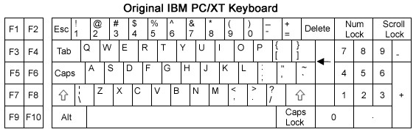

This is different from the later design keyboard. Here only 83 keys are used and placed in the keyboard. Function keys are only 10 (i.e.) F1 to F10. Those keys are placed in the left side. Only one CTRL key and one ALT key is available. Keys like PRINT SCREEN and CAPS LOCK are located in a strange place. Cursor keys like HOME, END, PAGE UP & PAGE DOWN are not available.

There is no LED’s for NUM LOCK, CAPS LOCK and SCROLL LOCK. Because here the communication between the keyboard and computer’s motherboard is unidirectional. Nowadays it is bidirectional.

**The AT keyboard :( Advanced Technology)**

This 84- AT keyboard has 84 keys and a step closer to the standard keyboard layout which is using today. Here also the function keys are only 10 (i.e.) F1 to F10. Those keys are placed in the left side. Cursor keys like HOME, END, PAGE UP & PAGE DOWN are integrated into the keypad, which is now separated on the right side of the keyboard and activated using NUM LOCK key. The size and spacing of the key is better than on the PC/XT keyboard.

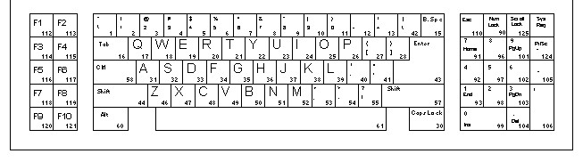

This keyboard does have LED’s for NUM LOCK, CAPS LOCK and SCROLL LOCK, because this can communicate bidirectionally to the motherboard. This AT keyboard is completely compatible with all the models that came later, except the connector used to attach the keyboard to the computer.

*Typematic rate: The speed at which the character repeats when you hold a key down. Repeat delay: The interval between a key press and first repetition of the character.*

**The Enhanced 101-key keyboard:**

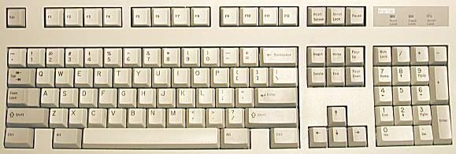

The Enhanced 101-key keyboard is the most familiar to computer used today. Here only 101 keys are used and placed in the keyboard. Function keys are increased into 12 (i.e.) F1 to F12. Those keys are placed in the horizontal row above the number keys, with a ESC key in its upper left corner position. A second CTRL and second ALT key is added to the bottom of row. Here cursor keys are available in an inverted ―T‖ formation and the other navigation keys.

Keys such as PRINT SCREEN, SCROLL LOCK and PAUSE are at the top, and a second ENTER key is added on the right side of the keypad. The main ENTER key also reduced in size for all touch typists.

**The windows 104-key keyboard:**

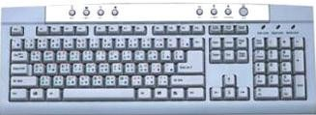

This is identical to the 101 – key layouts, except for the addition of three keys: Two windows keys which is located between the CTRL and ALT keys on both sides and an Application key on the right side, next to the window key. By pressing the window key at any time we can open the start menu, and pressing the application key displays the context menu for currently highlighted item.

Nowadays we are using some key combination i.e. using the windows key (WIN). Some of them are as follows:

**Key combination Function**

WIN Open the Start Menu

WIN-R Opens the Run dialog box WIN-M Minimizes all open windows WIN-F1 Opens a help window

**Ergonomic keyboard:**

**Ergonomics** is the study of how equipment and furniture can be arranged in order that people can do work or other activities more efficiently and comfortably. This type of keyboard is used to provide the user with a more natural hand position while typing.

**Laptop keyboards:**

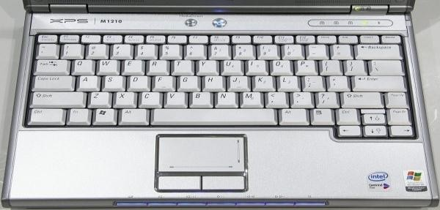

On portable systems, such as laptops and notebooks, the keyboard can be a crucial part of the product evaluation process for two reasons: the keyboard is integrated into the unit and is not easily replaceable and the smaller size of the keyboard often forces to fit all the keys into the space provided in it. The function keys are here integrated with the alphabetic key itself. Using NUM LOCK, we can use those keys.

**3. Explain Signals and interface standards for keyboard.**

**4. Explain briefly about keyboard connectors and switches.**

A keyboard consists of a set of switches mounted in a grid or an array called the *key matrix*.

When a switch is pressed, a processor in the keyboard identifies which key is pressed by determining which grid location in the matrix shows continuity.

The keyboard processor, which also interprets how long the key is pressed, can even handle multiple keypresses at the same time.

A 16-byte hardware buffer in the keyboard can handle rapid or multiple keypresses, passing each one to the system in succession.

When a key is pressed, the contact bounces slightly in most cases, meaning that several rapid on/off cycles occur just as the switch makes contact. This is called *bounce*.

The processor in the keyboard is designed to filter this, or ―debounce‖ the keystroke.

The keyboard communicates with the main system in one of two ways:

Through a special serial data link if a standard PS/2 keyboard connector is used

Through the USB port

**6-pin mini- DIN (PS/2) connector**

The 6-pin MINI-DIN Connector also called as PS/2 connector is smaller than the 5-Pin DIN and this is the 5/16 inch in diameter. This mini-Din connector is designed to use six pins arranged in a circular pattern. Here mostly the two unused pins are omitted from keyboard connectors. The same 6

– pin is used for mice also. So, we should be connecting the cable to the relevant socket. Then only it functions properly.

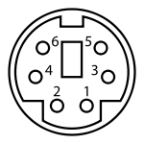

**6-pin MINI-DIN Connector**

|  |  |  |
| --- | --- | --- |
| **Pin 1** | Keyboard Data | Data |
| **Pin 2** | Not connected | Not connected* |
| **Pin 3** | [Ground](http://en.wikipedia.org/wiki/Vcc) | GND |
| **Pin 4** | +5V power | Vcc |
| **Pin 5** | Keyboard Clock | CLK |
| **Pin 6** | Not connected | Not connected** |

**USB Connector**

**Universal Serial Bus** (**USB**) is a [serial](http://en.wikipedia.org/wiki/Serial_communications) [bus sta](http://en.wikipedia.org/wiki/Computer_bus)ndard to [interface d](http://en.wikipedia.org/wiki/Electrical_connector)evices to a host computer. USB was designed to allow many peripherals to be connected using a single standardized interface socket and to improve the [Plug and play c](http://en.wikipedia.org/wiki/Plug_and_play)apabilities by allowing [hot swapping,](http://en.wikipedia.org/wiki/Hot_swapping) that is, by allowing devices to be connected and disconnected without [rebooting the](http://en.wikipedia.org/wiki/Booting) computer or turning off the device.

USB is intended to replace many legacy varieties [of serial a](http://en.wikipedia.org/wiki/Serial_port)nd [parallel ports.](http://en.wikipedia.org/wiki/Parallel_port) USB can connect [computer peripherals s](http://en.wikipedia.org/wiki/Computer_peripheral)uch as [mice,](http://en.wikipedia.org/wiki/Computer_mouse) [keyboards,](http://en.wikipedia.org/wiki/Computer_keyboard) [PDAs,](http://en.wikipedia.org/wiki/Personal_digital_assistant) [gamepads a](http://en.wikipedia.org/wiki/Gamepad)nd [joysticks,](http://en.wikipedia.org/wiki/Joystick) [scanners,](http://en.wikipedia.org/wiki/Image_scanner) [digi](http://en.wikipedia.org/wiki/Digital_camera)tal [cameras,](http://en.wikipedia.org/wiki/Digital_camera) [printers, p](http://en.wikipedia.org/wiki/Computer_printer)ersonal [media players,](http://en.wikipedia.org/wiki/Media_player) [flash drives,](http://en.wikipedia.org/wiki/USB_flash_drive) and [external hard drives.](http://en.wikipedia.org/wiki/External_hard_drive) For many of those devices USB has become the standard connection method.



The USB *trident* logo

USB1.1 maximum cable length is 3m and USB2.0 maximum cable length is 5m. A maximum hub connected in series is 5. A maximum device connected in total is 127. Although a single cable is limited to 5 meters, the USB2.0 specification permits up to five USB hubs in a long chain of cables and hubs. This allows for a maximum distance of 30 meters between host and device, using six 5- meter cables and five hubs. In actual use, since some USB devices have built-in cables for connecting to the hub, the maximum achievable distance is 25 meters + the length of the device's cable. **Keyboards switch Types:**

**Pure mechanical switches:** The most basic mechanical switch design is one which

depressing the key forces metal contacts together, completing the circuit. A spring forces the key back up to tis original position. The nature of the spring mechanism used in most keyboards.

**Foam element switches:** Similar to pure mechanical switches in so far they use an electric circuit between each key and the circuit board below a spring to pop the key back up. Here each keytop is connected with a cushion of foam gives the keyboard softier, quieter and more cushiony feeling.

**Rubber-dome switches:** In this design each key is sits a top rubber dome with an electric contact on its concave underside. The shape of the dome then forces the key back up into its original position. This is easier and cheaper comparing to other models. This is the most common type of keyboard used today. Here the rubber domes form a solid sheet.

**Membrane switches:** Similar to rubber-dome switches, except the keytop are all joined into a solid sheet that rest on top of the rubber domes. This provides s a greater amount of protection against the outside environment.

**5. Explain the working principles of keyboard and mouse. (APR 2012) Keyboard**

The keyboard work as: Inside the keyboard, there are metallic plate, circuit board (key matrix) and

processor, which are responsible for transferring information from the keyboard to the computer. Depending upon the working principle, there are two main types of keys, namely, capacitive and hard-contact. Let's discuss in brief about the functioning of capacitive and hard contact key.

Capacitive Key

On the underside of a capacitive key, a metal plunger is fixed, which helps in activating the circuit flow. When a capacitive key is pressed, the metal plunger applies a gentle pressure to the circuit board. The pressure is identified by the computer and the circuit flow is initiated, resulting in the transfer of information from the circuit to the currently installed software.

Hard Contact Key

A hard contact key is attached with a metallic plate that helps in connecting the circuit board. When the hard contact key is pressed, it pushes a metallic plate, which in turn touches the metallic portion of the circuit plate. This overall process of completing a circuit results in a circuit flow, allowing the transfer of the message to the central processing unit (CPU), which is further transmitted to the software.

In both the key types, the circuit signals the processor to read and/or identify the character that has been pressed. For example, in a hard contact key, the processor reads that pressing 'shift' and 'a' keys at the same time corresponds to 'A'. Hence accordingly, the letter, sign or symbol is displayed on the screen. Releasing the pressed key breaks the circuit flow, after which the key retains its original position. The communication between a computer keyboard and main computer is bi-directional, meaning that message or information can be sent within each other.

**Mouse**

With most of the system you will find mechanical mouse.The primary mechanical part of a mouse is a ball on the bottom of the mouse. There are these little wheels which turn/rotate when the ball moves against them. The wheels are monitored electronically. When they trun or rotate they transmit how much they have turned to the computer. Out of these three wheels the two wheels perpendicular to each other are used for tracking the motion on X-axis and Y-axis. The third one just balances the two. When the mouse is moved on a flat surface the roller ball moves in the locking ring. When the mouse is positioned on the desktop the actuators register the mouse balls movement in X-axis and Y-axis direction. The sensors attached to it generate a series of pulses representing movement on both axis. The pulse generated are in same ratio as the mouse movement i.e. More pulse mean more movement. Normally a mouse is used along with a mouse pad. Place the mouse pad on a flat surface and place the mouse on it. Move the mouse pad and the pointer moves in the direction of the movement of mouse.

Various terms related to the use of mouse are :-

>Click

>Doubleclick

>Drag

1. When the left button of mouse is pressed and released quickly then this we can say ' clicking the mouse'.

2. The double clicking is used to initiate some action on the selected item. Basically it selects and

initiases the action. For this the enter key is pressed and released sticky twice.

3. If AN object is to be moved from one part of screen to other part then dragging is used. For this bring the pointer to the required object, press the key and hold it while moving to other place. When the mouse pointer reaches at required position, release the button.

**6. Explain about Mouse.**

**7. What are the different point devices available explain. (NOV 2012)**

A **mouse** (plural **mice** or **mouses**) is a computer [pointing device;](http://en.wikipedia.org/wiki/Pointing_device) it is designed to detect two- [dimensional mo](http://en.wikipedia.org/wiki/Dimension)tion relative to its supporting surface and consists of a small case, to be held under one of the user's hands, and one or more buttons. It sometimes features other elements, such as "wheels", which allow the user to perform various system-dependent operations, or extra buttons or features can add more control or dimensional input. The mouse's motion typically translates into the mot[ion of a pointer](http://en.wikipedia.org/wiki/Cursor_%28computers%29) on a [display.](http://en.wikipedia.org/wiki/Computer_display)

The first computer mouse, held by inventor [Douglas Engelbart,](http://en.wikipedia.org/wiki/Douglas_Engelbart) showing the wheels that make contact with the working surface.[Douglas Engelbart of](http://en.wikipedia.org/wiki/Douglas_Engelbart) the [Stanford Research Institute invent](http://en.wikipedia.org/wiki/Stanford_Research_Institute)ed the mouse in 1964 after extensive [usability testing. T](http://en.wikipedia.org/wiki/Usability_testing)he first mouse, a bulky device (pictured) used two gear-wheels perpendicular to each other: the rotation of each wheel translated into motion along one [axis.](http://en.wikipedia.org/wiki/Coordinate_axis) "X-Y Position Indicator for a Display System". At the time, the user would hold the mouse continuously in one hand and type on a five-key [chord keyset with](http://en.wikipedia.org/wiki/Chord_keyset) the other.

**Early mice**

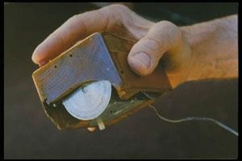

**Mechanical mice**

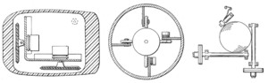

*Early mouse patents. From left to right: Opposing track wheels by Engelbart, Nov. 1970,* [*U.S. Pate*](http://patft.uspto.gov/netacgi/nph-Parser?patentnumber=3,541,541)*nt*

*3,541,541 . Ball and wheel by Rider, Sept. 1974,* [*U.S. Patent 3,835,464 .*](http://patft.uspto.gov/netacgi/nph-Parser?patentnumber=3,835,464) *Ball and two rollers with spring by Opocensky, Oct.* [*1976, U.S. Patent*](http://patft.uspto.gov/netacgi/nph-Parser?patentnumber=3,987,685) *3,987,685 .*

[Bill English invent](http://en.wikipedia.org/wiki/William_English_%28computer_engineer%29)ed the so-called **ball mouse** in the [1972 while](http://en.wikipedia.org/wiki/1972) working for [Xerox PARC.](http://en.wikipedia.org/wiki/Xerox_PARC) The ball-mouse replaced the external wheels with a single ball that could rotate in any direction and came as part of the hardware package of the [Xerox Alto c](http://en.wikipedia.org/wiki/Xerox_Alto)omputer. Perpendicular chopper wheels housed inside the mouse's body chopped beams of light on the way to light sensors, thus detecting in their turn the motion of the ball.

Modern computer mice took form a single ball and two buttons and remained a common design until the mainstream adoption of the scroll-wheel mouse during the 1990s. [Honeywell](http://en.wikipedia.org/wiki/Honeywell) produced another short-lived [type of mechanical mouse.](http://www.bergen.org/AAST/Projects/Engineering_Graphics/_EG2001/mouse/improvements.html#honeywell) Instead of a ball, it had two plastic "feet" on the bottom which sensed movement.

Another type of mechanical mouse is the **trackball** mouse, which operates like an inverted mouse. Users rotate a large ball in the mouse with their fingertips instead of moving the mouse itself. The trackball is usually located where a centre mouse button would be, with the buttons on either side. The first trackball mouse was invented in 1991 by Logitech, and was launched with the Apple Power book. Trackballs required less wrist movement than traditional mice, and thus decrease the risk of strain injuries.

**Optical mice**

An **optical mouse** uses a [light-emitting diode a](http://en.wikipedia.org/wiki/Light-emitting_diode)nd [photodiodes to](http://en.wikipedia.org/wiki/Photodiode) detect movement relative to the underlying surface, rather than moving some of its parts — as in a mechanical mouse. Early optical mice, circa 1980, came in two different varieties:

1. Some, such as those invented by [Steve Kirsch of](http://en.wikipedia.org/wiki/Steve_Kirsch) [Mouse Systems Corporation,](http://en.wikipedia.org/wiki/Mouse_Systems_Corporation) used an infrared LED and a four-quadrant infrared sensor to detect grid lines printed on a special metallic surface with infrared absorbing ink. Predictive [algorithms in](http://en.wikipedia.org/wiki/Algorithm) the [CPU of](http://en.wikipedia.org/wiki/CPU) the mouse calculated the speed and direction over the grid.

2. Others, invented by [Richard F. Lyon a](http://en.wikipedia.org/wiki/Richard_Francis_Lyon)nd sold by [Xerox,](http://en.wikipedia.org/wiki/Xerox) used a 16-pixel visible-light image sensor with integrated motion detection on the same chip and tracked the motion of light dots in a dark field of a printed paper or similar mouse pad.

These two mouse types had very different behaviors, as the Kirsch mouse used an x-y coordinate system embedded in the pad, and would not work correctly when rotated, while the Lyon mouse used the x-y coordinate system of the mouse body, as work like a mechanical mice.

Modern surface-independent optical mice work by using an [optoelectronic](http://en.wikipedia.org/wiki/Optoelectronic) [sensor to](http://en.wikipedia.org/wiki/Sensor) take successive pictures of the surface on which the mouse operates. Most of these mice use LEDs to illuminate the surface that is being tracked; LED optical mice are often mislabeled as "laser mice". Changes between one frame and the next are processed by the [image processing p](http://en.wikipedia.org/wiki/Image_processing)art of the [chip a](http://en.wikipedia.org/wiki/Integrated_circuit)nd translated into movement on the two [axes using](http://en.wikipedia.org/wiki/Coordinate_axis) an [optical flow e](http://en.wikipedia.org/wiki/Optical_flow)stimation algorithm. The optical mouse sensor processes 1512 frames per second: each frame is a rectangular array of 18×18 [pixels,](http://en.wikipedia.org/wiki/Pixel) and each pixel can sense 64 different levels of gray.

Optomechanical mice detect movements of the ball optically, giving the precision of optical without the surface compatibility problems, whereas optical mice detect movement relative to the surface by examining the light reflected off it.

**Laser mice**

As early as 1998, [Sun Microsystems p](http://en.wikipedia.org/wiki/Sun_Microsystems)rovided a laser mouse with their servers and workstations. However, laser mice did not enter the mainstream market until 2004, when [Logitech, i](http://en.wikipedia.org/wiki/Logitech)n partnership with [Agilent Technologies, in](http://en.wikipedia.org/wiki/Agilent_Technologies)troduced the **laser mouse** with its MX 1000 model. This mouse uses a small [infrared](http://en.wikipedia.org/wiki/Infrared) [laser ins](http://en.wikipedia.org/wiki/Laser)tead of an LED, which increases the [resolution of](http://en.wikipedia.org/wiki/Image_resolution) the image taken by the mouse. This leads to around 20× more sensitivity to the surface features used for navigation compared to conventional optical mice, via [interference](http://en.wikipedia.org/wiki/Interference) effects.

Engineers designed the laser mouse — as a wireless mouse — to save as much power as possible. In order to do this, the mouse blinks the laser when in standby mode (8 seconds after the last motion). This function also increases the laser life.

**Optical versus mechanical mice**

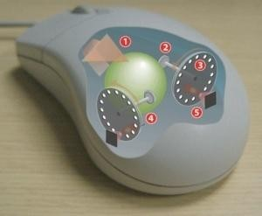

**Operating a mechanical mouse.**

1. Moving the mouse turns the ball.

2. X and Y rollers grip the ball and transfer movement.

3. Optical encoding disks include light holes.

4. Infrared [LEDs](http://en.wikipedia.org/wiki/Light-emitting_diode) shine through the disks.

5. Sensors gather light pulses to convert to X and Y velocities.

Optical mice supporters claim that optical rendering works better than mechanical mice, that it requires no [maintenance a](http://en.wikipedia.org/wiki/Maintenance)nd that optical mice last longer due to having no moving parts. Optical mice do not normally require maintenance other than removing debris that might collect under the light-emitter. Supporters of mechanical mice point out that optical mouse generally cannot track on glossy and [transparent sur](http://en.wikipedia.org/wiki/Transparent)faces.

**Buttons**

Engelbart's very first mouse had a single button; Xerox PARC soon designed a three-button model, but reduced the count to two for Xerox products. Apple reduced it back to one button with the Macintosh in 1984, while Unix workstations from Sun and others used three buttons. Commercial mice usually have between one and three buttons, although in the late [1990s some](http://en.wikipedia.org/wiki/1990s) mice had five or more.

**Additional buttons**

Manufacturers have built mice with five or more buttons. Depending on the user's preferences, the extra buttons may allow forward and backward web navigation, [scrolling throu](http://en.wikipedia.org/wiki/Scrolling)gh a browser's history, or other functions. As with similar features in [keyboards, how](http://en.wikipedia.org/wiki/Computer_keyboard)ever, these functions may not be supported by all software. The additional buttons are generally more useful in [computer games,](http://en.wikipedia.org/wiki/Computer_game) where quick and easy access to a wide variety of functions (for example, weapon-switching in [first- person shooters)](http://en.wikipedia.org/wiki/First-person_shooter) can be very beneficial.

**Wheels**

The [scroll wheel, a](http://en.wikipedia.org/wiki/Scroll_wheel) notably different form of mouse-button, consists of a small wheel that the user can rotate to provide immediate one-dimensional input. Usually, this input translates into "scrolling" up or down within the active [window or](http://en.wikipedia.org/wiki/Window_%28computing%29) [GUI-](http://en.wikipedia.org/wiki/GUI)element. This is especially helpful in navigating a long document. The scroll wheel can often be pressed too, thus being in fact a third (center) button. Under many Windows applications, the wheel pressure activates auto scrolling and in conjunction with the [control key (Ctrl)](http://en.wikipedia.org/wiki/Control_key) may zoom in and out (applications which support this feature [include Adobe Reader,](http://en.wikipedia.org/wiki/Adobe_Reader) [Microsoft Word,](http://en.wikipedia.org/wiki/Microsoft_Word) [Internet Explore](http://en.wikipedia.org/wiki/Internet_Explorer)[r, Opera a](http://en.wikipedia.org/wiki/Opera_%28web_browser%29)nd [Mozilla Firefox).](http://en.wikipedia.org/wiki/Mozilla_Firefox)

**3D mice**

In the late 1990s [Kantek in](http://en.wikipedia.org/w/index.php?title=Kantek&action=edit)troduced the 3D Ring Mouse. This wireless mouse was worn on a ring around a finger, which enabled the thumb to access three buttons. The mouse was tracked in three dimensions by a base station. Despite a certain appeal, it was finally discontinued because it did not provide sufficient resolution.

**8. Explain Joy stick with neat diagram.**

Joystick is an input device consisting of a stick that pivots on a base and reports its angle or direction to the device it is controlling. Joysticks are often used to control video games, and usually have one or more push-buttons whose state can also be read by the computer. Joysticks are also used for controlling machines such as cranes, trucks, underwater unmanned vehicles and zero turning radius lawn mowers. Joysticks are used mostly for [computer g](http://www.webopedia.com/TERM/J/computer.html)ames a[nd other applications.](http://www.webopedia.com/TERM/J/application.html)

Most joysticks are two-dimensional, having two axes of movement (similar to a [mouse),](http://en.wikipedia.org/wiki/Computer_mouse) but one and three-dimensional joysticks do exist. A joystick is generally configured so that moving the stick left or right signals movement along the X axis, and moving it forward (up) or back (down) signals movement along the Y axis. In joysticks that are configured for three-dimensional movement, twisting the stick left (counter-clockwise) or right (clockwise) signals movement along the Z axis. The name "joystick" is introduced by [French p](http://en.wikipedia.org/wiki/France)ilot [Robert Esnault-Pelterie.](http://en.wikipedia.org/wiki/Robert_Esnault-Pelterie) He is alleged to have invented the "George Stick" which became more popularly known as the joystick.

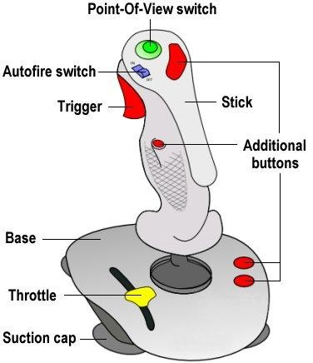

**Different types of joysticks:**

**Digital Joysticks**

The most common joystick type in home [computers h](http://www.epanorama.net/documents/joystick/intro.html)ave been Atari-style digital joysticks. The joystick itself consisted of five switched which are arranged to that four of them told about the joystick direction (UP, DOWN, LEFT, RIGHT) and one was for fire button. The joystick connector was 9 pin D-shell connector. Normally all of those switches are open, but when joystick is turned from the center position, one or two position switches are closed (according to what direction the stick is turned). The fire button worked so that it closes when button is pressed.

**Paddle controllers**

Paddle controller is a simple controller which consists of one knob which is used to control the game. Paddle controllers were used in videogames since the first TV-games to control the racket on the screen. Paddle controllers use analogue principle for control, and they simply consist of one potentiometer and button in one controller.

**Analogue Joysticks**

Analogue joysticks were like a combination of ideas of both joystick and paddle. The idea was that potentiometers were used to measure the movement of stick (instead of switches like in digital joystick).

**PC analogue joystick interface**

Nowadays the most common analogue joystick type is PC analogue joystick. This joystick model was presented by IBM together with their first IBM PC computer. The joystick is just a basic analogue joystick with two buttons. The original joystick interface had circuit for connecting two joysticks, but had only one joystick connector. A special Y-[cable w](http://www.epanorama.net/documents/joystick/intro.html)as needed if there was need for two joysticks at the same time. Later time some manufacturers put two connectors to their interface card and some card manufacturers implemented only one joystick input. Fortunately most of the card nowadays has option for two joysticks like the original IBM joystick card.

**9. Explain briefly about Video Display Adapters.**

A video display adapter (aka video card) provides the interface between your computer and your monitor and transmits the signals that appear as images on the display.

The following list of standards can serve as an abbreviated history of PC video-display technology:

MDA (Monochrome Display Adapter)

HGC (Hercules Graphics Card)

CGA (Color Graphics Adapter)

EGA (Enhanced Graphics Adapter)

VGA (Video Graphics Array)

SVGA (Super VGA)

XGA (Extended Graphics Array) and beyond

**Video Adapter Types**

A monitor requires a source of input. The signals that run to your monitor come from one or more video display adapters in the system. There are four basic types of video display adapters:

**Discrete plug-in video cards**—These cards require the use of an expansion slot but provide

the highest possible level of features and performance.

**Discrete video on the motherboard**—The same discrete circuitry that can be found on a video card can also be directly built in or mounted on the motherboard.

**Motherboard chipset integrated video**—This is video circuitry integrated into the motherboard chipset. Because it shares the system random access memory (RAM) and other components, it provides an economical solution that also uses less power (ideal for laptops).

**Processor integrated video**—This is video circuitry integrated into the processor, either as a separate die within the processor package or directly in the processor die. This form of integrated video also shares the system RAM and requires a motherboard with specific chipsets and video interface connectors on-board. It has the lowest cost of any video solution. It is economical on power,

integrated video is used in many laptops for improved battery life.

**Integrated Video/Motherboard Chipsets**

Silicon Integrated Systems (SiS) pioneered chipsets with integrated video in 1996 and 1997 for laptop and desktop systems.

**Table Intel Chipset Integrated Video**

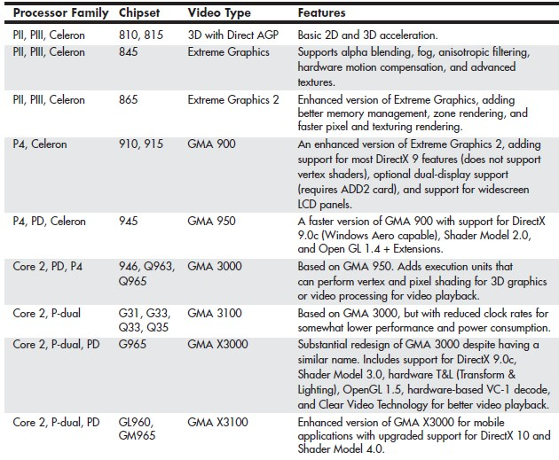

Intel introduced motherboard chipsets with integrated graphics in 1999.

Intel has offered versions of both desktop and mobile chipsets with integrated graphics and

has become the world’s largest supplier of graphics chips.

Table shows the types and features for the integrated graphics available in Intel motherboard chipsets over the years.

Most other chipset vendors supporting Intel processors have also made versions with integrated graphics.

There are many AMD and third-party chipsets with integrated video for AMD processors, including the most recent models.

**CPUs with Integrated Video**

Placing video and 3D rendering within the processor itself, is both on Intel and AMD

platforms.

By moving video functions within the processor itself, improvements in processor speed, memory speed, and bus speed directly affect video and 3D speeds.

**Video Adapter Components**

Video display adapters contain certain basic components, usually including the following:

**Video basic input/output system (BIOS)**. Provides the firmware controlling the video card.

**Video processor/video accelerator**. Places text or graphics information on-screen, and provides 3D acceleration.

**Video memory**. Holds the information.

**Digital-to-analog converter (DAC).** Formerly a separate chip, the DAC is usually incorporated into the video processor/accelerator chip. The DAC is not necessary on a purely digital subsystem (digital video card and display); however, most display subsystems still include analog VGA support.

**Bus connector**. Connects a discrete video card to the motherboard.

**Video driver**. Software that communicates with the OS to control the card.

On mid-range and high-performance video cards, such as the card shown in Figure, most of the components are underneath the cooling system.

This card uses a combination of a fan and a heatsink to cool its GPU and memory modules.

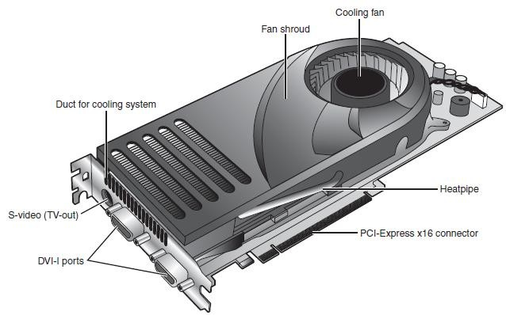

**Fig.** A typical example of a mid-range video card optimized for dual-GPU gaming (NVIDIA SLI)

and HDTV support.

**Identifying the Video and System Chipsets**

The system which uses the integrated video will have the following:

A better comparison of the card or system to others

Access to technical specifications

Access to reviews and opinions

The ability to make a better buying decision

The choice of card manufacturer or chipset manufacturer support and drivers

**Video RAM**

table.

Many types of memory have been used with video adapters. Some of them are as shown in

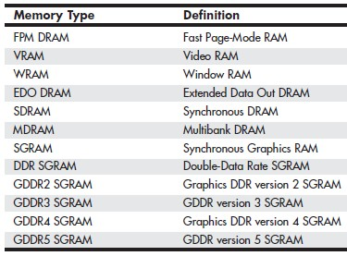

**VRAM and WRAM**

VRAM and WRAM and WRAM are dual-ported memory types that can read from one port and write data through the other port.

**SGRAM**

It differs from SDRAM by including circuitry to perform block-writes to increase the speed of graphics fill and 3DZ-buffer operations.

**DDR SGRAM**

DDR SGRAM is designed to transfer data at speeds twice that of conventional SGRAM by transferring data on both the rising and falling parts of the processing clock cycle.

**GDDR2 SGRAM**

The several variations are 2.5V DDR SDRAM with some enhancements, with some enhancements, and 1.8V DDR2 SDRAM with much higher performance and cooler operation. **GDDR3 SGRAM**

GDDR3 SGRAM is based on DDR2 memory, but with two major differences:

GDDR3 separates reads and writes with a single-ended unidirectional strobe.

GDDR3 uses an interface technique known as pseudo-open drain, which uses voltage instead of current.

**GDDR4 SGRAM**

GDDR4 has the following features:

Higher bandwidth. GDDR4 running at half the speed of GDDR3 provides

Greater memory density, enabling fewer chips to be needed to reach a particular memory size.

**GDDR5 SGRAM**

The main differences is

Signal optimization using data/address bit inversion, adjustable driver strength, adjustable voltage, and adjustable termination

Adaptive interface timing using data training that is scalable per bit or byte

Error compensation, including real-time error detection on both read/write and fast resending

**10. Explain briefly about Video Display Interfaces.**

Video display adapters connect a PC to a display and therefore must work through two main interfaces.

The first is the system interface, meaning the connection between the video adapter and the PC, and the second is the display interface, meaning the connection between the video adapter and the display.

**The System Interface**

Peripheral Component Interconnect (PCI)-based adapters are still found in some old systems or AGP- based systems that utilize a second adapter.

**AGP**

The AGP, an Intel-designed dedicated video bus introduced in 1997, delivers a maximum bandwidth up to 16 times greater than that of a comparable PCI bus.

AGP has been replaced by the more versatile and faster PCIe standard.

Systems with AGP have only one AGP slot.

Windows 98 and later versions support AGP’s Direct Memory Execute (DIME) feature.

**PCIe**

PCIe began to show up in systems in mid-2004 and has filtered down to all systems that use discrete video cards or have integrated video that can be upgraded.

Despite the name, PCIe uses a high-speed bidirectional serial data transfer method, and PCIe channels can be combined to create wider and faster expansion slots.

Most PCIe implementations include one x16 slot for video and two or more x1 slots for other add-on cards, as well as legacy PCI slots.

**The Display Interface**

The display interfaces have been analog and others have been digital.

Earlier PCs were all digital interfaces.

The video interfaces (and connectors) you are likely to encounter in PCs dating from the late

1980s to the present include the following:

VGA

DVI

HDMI

DisplayPort

The connectors for these interfaces are shown in Figure.

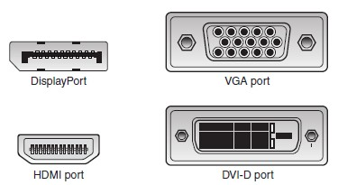

**Figure** Video interface connectors used in PCs from the late 1980s to the present.

**VGA**

IBM introduced the VGA interface and display standard on April 2, 1987, along with a family of systems it called PS/2.

VGA is an analog design.

VGA was designed to be addressed through the VGA BIOS interface, a software interface that forced programs to talk to the BIOS-based driver rather than directly to the hardware.

VGA also describes a 15-pin analog interface connection that can support a variety of modes.

The VGA connector is shown in Figure, the pinouts are shown in Table.

**Table 15-Pin Analog VGA Connector Pinout**

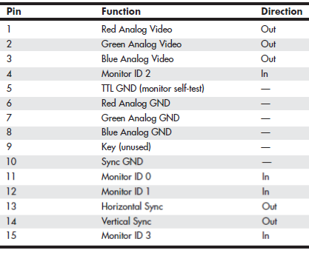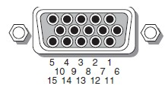

**Figure** The standard 15-pin analog VGA connector

The mating VGA cable connector that plugs into this connector normally has pin 9 missing.

Pin 5 is used only for testing purposes, and pin 15 is rarely used.

In addition to the connector and electrical interface, the original VGA standard also defined a number of text and graphics display modes with various resolutions and colors.

**DVI**

DVI was introduced on 1999 by the Digital Display Working Group (DDWG).

DVI uses Transition Minimized Differential Signaling (TMDS), which was developed by

Silicon Image and trademarked under the name PanelLink.

TMDS is designed to support cables up to 10 meters (32.8 feet) in length, although the limits may be shorter or longer depending on cable quality.

If more bandwidth is necessary, the DVI standard supports a second TMDS link in the same cable and connector.

This uses three additional TMDS signal pairs and shares the same clock and DDC signals as the primary link.

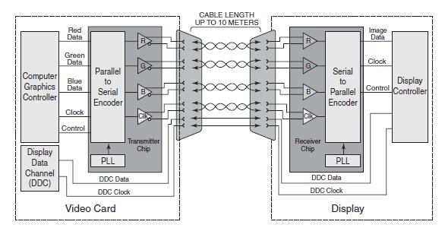

**Figure** A single-link TMDS connection.

This is called dual-link DVI, and it increases the maximum raw bandwidth and the true data bandwidth.

The DVI-D (digital) connector supports only digital devices, whereas the DVI-I (integrated)

connector supports both digital and analog devices via the addition of extra pins.

Table 12.10 show the DVI-I (integrated) connector and pinout and pinout.

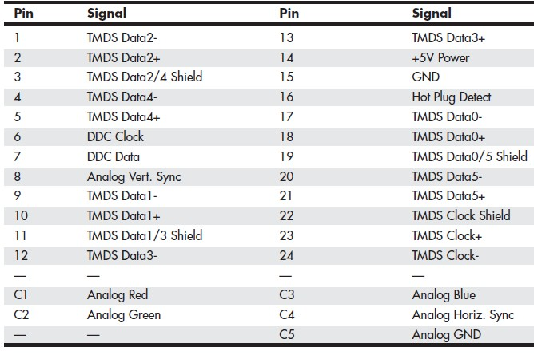

Table DVI-I Connector Pinout

**HDMI**

HDMI was designed by a group of multimedia companies as a way to provide a single-cable connection for transporting digital video and audio signals between consumer electronics hardware such as big-screen TVs, video games, DVD players, and home theater systems.

HDMI uses the DDC to identify the capabilities of an HDMI display, such as resolutions, color depth, and audio.

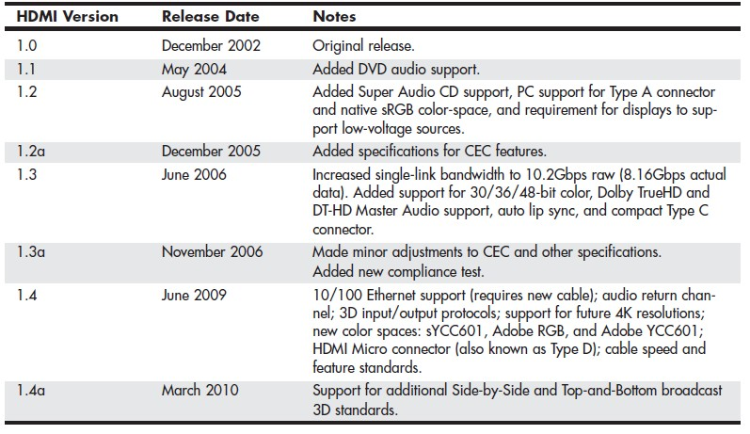

**Table 12.11 HDMI Versions**

HDMI is essentially a superset of DVI, it is backward-compatible with DVI.

**DisplayPort**

DisplayPort is the latest digital display interface standard.

DisplayPort is designed both as an internal and an external interface, meaning it can replace the FPD-Link (Flat Panel Display-Link) interface used internally in most laptops as well as providing connections to external displays.

As it is a license-free, royalty-free design, DisplayPort has seen rapid adoption throughout the industry.

DisplayPort is a high-speed serial interface with up to four main data lanes carrying multiplexed video and audio data, each of which supports a raw data.

Table 12.13 compares the versions of DisplayPort.

**Table DisplayPort Versions**

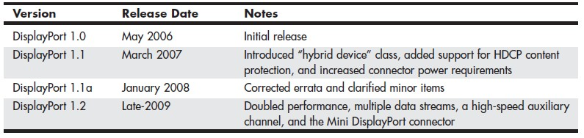

**TV Display Interfaces**

To display computer screens on standard TV or to record them to videotape, you can use the

TV-out connector on your video card or integrated motherboard video.

To connect your PC to an HDTV monitor, it is preferable to use a digital signal via a DVI, HDMI, or DisplayPort connection.

**11. How 3D Graphics Accelerators work?**

3D acceleration designed for hardcore game players in the PC world.

Low-cost integrated chipsets offer some 3D support, virtually any user of a recent model computer can enjoy 3D lighting, perspective, texture, and shading effects.

**Working of 3D Accelerators**

The basic function of 3D software is to convert image abstractions into the fully realized images that are then displayed on the monitor.

The image abstractions typically consist of the following elements:

**Vertices**—Locations of objects in three-dimensional space, described in terms of their x, y, and z coordinates on three axes representing height, width, and depth.

**Primitives**—The simple geometric objects the application uses to create more complex

constructions, described in terms of the relative locations of their vertices.

**Textures**—Two-dimensional bitmap images or surfaces designed to be mapped onto primitives. The software enhances the 3D effect by modifying the appearance of the textures, depending on the location and attitude of the primitive.

The abstract image descriptions must then be rendered, meaning they are converted to visible form. The standard functions performed in rendering are as follows:

**Geometry**—The sizing, orienting, and moving of primitives in space and the calculation of the effects produced by the virtual light sources that illuminate the image

**Rasterization**—The converting of primitives into pixels on the video display by filling the

shapes with properly illuminated shading, textures, or a combination of the two

Most chipsets with 3D acceleration perform the following rasterization functions right on the adapter:

**Scan conversion**—The determination of which onscreen pixels fall into the space delineated by each primitive

**Shading**—The process of filling pixels with smoothly flowing color using the flat or Gouraud shading technique

**Texture mapping**—The process of filling pixels with images derived from a 2D sample picture or surface image

**Visible surface determination**—The identification of which pixels in a scene are obscured by other objects closer to the viewer in three-dimensional space

**Animation**—The process of switching rapidly and cleanly to successive frames of motion sequences

**Antialiasing**—The process of adjusting color boundaries to smooth edges on rendered objects

**APIs**

APIs provide hardware and software vendors a means to create drivers and programs that can work quickly and reliably across a variety of platforms.

When APIs exist, drivers can be written to interface with the API rather than directly with the

OS and its underlying hardware.

Currently, OpenGL and Direct3D are available for virtually all leading graphics cards.

**OpenGL**

Windows XP and newer can support OpenGL either through software or through hardware acceleration.

For a particular graphics card to support hardware acceleration of OpenGL, the driver developer must include an installable client driver (ICD).

The ICD is distributed as part of the driver package that the video card or GPU vendor provides.

Thus, driver updates can improve OpenGL performance as well as DirectX (Direct3D)

performance.

**Microsoft DirectX**

Direct3D is part of Microsoft’s comprehensive multimedia API, DirectX.

DirectX 9.0c uses separate pixel and vertex shaders to create 3D objects.

DirectX 10, developed for Windows Vista, includes a completely rebuilt Direct3D rendering engine with a brand-new shader design.

DirectX 11 was originally developed for Windows 7 (and is also available for Windows

Vista) and adds several new features:

**Tessellation**—Provides additional pipeline stages that increase the number of visible polygons at runtime.

**Multithreaded rendering**—Enables the execution of Direct3D commands on multiple

processor cores.

**Compute shaders**—Provides an additional stage independent of the Direct3D pipeline that enables general-purpose computing on the graphics processor.

**Dynamic shader linkage**—A limited runtime shader linkage that allows for improved

shader specialization during application execution.

**Dual-GPU Scene Rendering**

The ability to connect two cards to render a single display more quickly.

The long-defunct 3dfx Voodoo 2 offered an option called scan-line interfacing (SLI) that pairs two Voodoo 2 cards on the PCI bus, with each card writing half the screen in alternating lines.

**NVIDIA SLI**

NVIDIA uses the term SLI to refer to scalable link interface.

The scaling refers to load-balancing, which adjusts how much of the work each card performs to render a particular scene, depending on how complex the scene is.

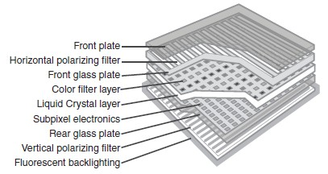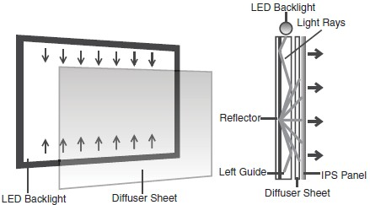

**12. Explain briefly about LCD and LED Monitors. LCD Monitors:**

A **liquid-crystal display** (**LCD**) is a [flat-panel display o](https://en.wikipedia.org/wiki/Flat_panel_display)r other [electronic visual display that](https://en.wikipedia.org/wiki/Electronic_visual_display) uses the

light-modulating properties of [liquid crystals.](https://en.wikipedia.org/wiki/Liquid_crystal) Liquid crystals do not emit light directly.

LCDs are available to display arbitrary images (as in a general-purpose computer display) or fixed images with low information content, which can be displayed or hidden, such as preset words, digits, a[nd 7-segment](https://en.wikipedia.org/wiki/7-segment) displays as in a [digital clock.](https://en.wikipedia.org/wiki/Digital_clock) They use the same basic technology, except that arbitrary images are made up of a large number of small [pixels,](https://en.wikipedia.org/wiki/Pixel) while other displays have larger elements.

LCDs are used in a wide range of applications including [computer monitors,](https://en.wikipedia.org/wiki/Computer_monitor) televisions, [instrume](https://en.wikipedia.org/wiki/Dashboard)nt [panels,](https://en.wikipedia.org/wiki/Dashboard) [aircraft cockpit displays, a](https://en.wikipedia.org/wiki/Flight_instruments)nd signage. They are common in consumer devices such as DVD players, gaming devices, [clocks,](https://en.wikipedia.org/wiki/Clock) [watches,](https://en.wikipedia.org/wiki/Watch) [calculators,](https://en.wikipedia.org/wiki/Calculator) and telephones, and have replaced [cathode ra](https://en.wikipedia.org/wiki/Cathode_ray_tube)y tube (CRT) displays in nearly all applications. They are available in a wider range of screen sizes than CRT and [plasma displays,](https://en.wikipedia.org/wiki/Plasma_display) and since they do not use phosphors, they do not suffer [image burn-in.](https://en.wikipedia.org/wiki/Screen_burn-in) LCDs are, however, susceptible to [image persistence.](https://en.wikipedia.org/wiki/Image_persistence)

The LCD screen is more energy-efficient and can be disposed of more safely than a CRT can. Its low electrical power consumption enables it to be used in [battery-](https://en.wikipedia.org/wiki/Battery_(electricity))powered [electronic e](https://en.wikipedia.org/wiki/Electronics)quipment more efficiently than CRTs can be. It is an [electronically modulated optical device made](https://en.wikipedia.org/wiki/Electro-optic_modulator) up of any number of segments controlling a layer of [liquid crystals a](https://en.wikipedia.org/wiki/Liquid_crystal)nd arrayed in front of a [light source (](https://en.wikipedia.org/wiki/Light_source)[backlight)](https://en.wikipedia.org/wiki/Backlight) or [reflector to](https://en.wikipedia.org/wiki/Reflector_(photography)) produce images in color or [monochrome.](https://en.wikipedia.org/wiki/Monochrome) Liquid crystals were first discovered in 1888. By 2008, annual sales of televisions with LCD screens exceeded sales of CRT units worldwide, and the CRT became obsolete for most purposes.

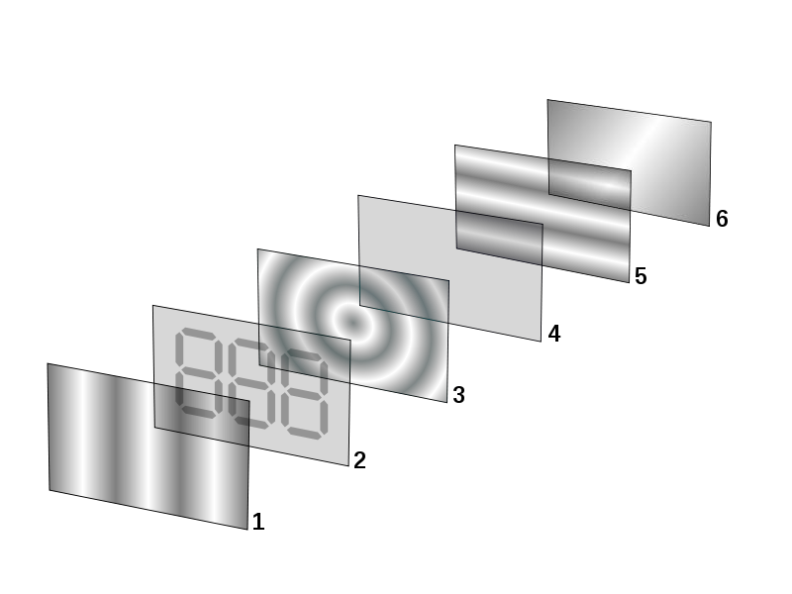

Reflective twisted nematic [liquid crystal disp](https://en.wikipedia.org/wiki/Liquid_crystal)lay.

[1. Polarizing filter](https://en.wikipedia.org/wiki/Polarizer) film with a vertical axis to polarize light as it enters.

2. Glass substrate with [ITO](https://en.wikipedia.org/wiki/Indium_tin_oxide) [electrodes.](https://en.wikipedia.org/wiki/Electrode) The shapes of these electrodes will determine the shapes that will appear when the LCD is turned ON. Vertical ridges etched on the surface are smooth.

3. Twisted nematic liquid crystal.

4. Glass substrate with common electrode film (ITO) with horizontal ridges to line up with the horizontal filter.

5. Polarizing filter film with a horizontal axis to block/pass light.

6. Reflective surface to send light back to viewer. (In a backlit LCD, this layer is replaced with a light source.)

**LED Monitors:**

In the previous decade, the display technology has changed significantly. LED displays are one of the

latest developments in this field. LED monitors use light emitting diodes that acts as a performance booster in the monitors. Basically LED monitors are the LCD monitors with a LED backlight to power up the LCD panel. It means that LEDs are placed behind or around the LCD panel to enhance the luminosity and video definition of the monitor screen.

LCD monitors, use a cold cathode light as backlight. In the LED monitors all the concepts are same except this backlight, which is replaced by LEDs.

There are three different types of LED monitors available based on the manner how the diodes are arranges in the monitor. These are – Direct LEDs, Edge LEDs and RGB LEDs. Both Edge and Direct LED display monitors use white diodes that are used to illuminate the LCD panel to produce the improved picture quality.

The arrangement of LEDs in the monitor is shown in the below image:

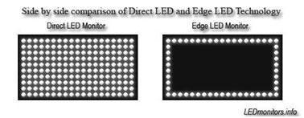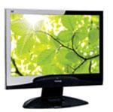

In the Direct LEDs display, white diodes are placed all over the panel to produce higher quality image while the Edge LEDs display uses LEDs only on the borders of the LCD panel. Direct LEDs are generally used in the production of high definition TV whereas the Edge LEDs is mainly used in the production of computer screens. RGB LEDs display is better among the three types of LED monitors as it uses red, green and blue diodes to produce the lifelike images with amazing contrast ratio.

**Comparison between LCD and LED Monitors / Why LED displays are better than the LCD**

**displays:**

Both types of monitors work on the same technology. LED monitors are LCD monitors with

replaced cold cathode backlight to LED backlight. Here are the differences that make the LED

displays better than the LCDs:

Contrast and Black level of the LED screen is better than the LCD screens because the liquid crystals cannot stop 100% of the backlight from cold cathode backlight and hence when the black screen is to be shown on the monitor, it is not completely black (as shown in the below image). But Edge LED screens perfectly show the black screen as there is no backlight at all.

Color accuracy for direct and edge LED displays and LCD displays are almost same but the RGB LEDs display has quite better color accuracy.

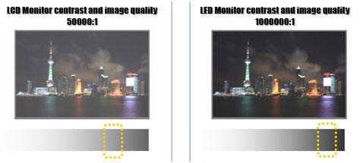

When comparing the LED and LCD monitors with respect to viewing angle, they are same as backlight has nothing to do with viewing angles. LED displays consume less power. It is reported that they consume up to 40% less power than the LCD displays.

LED displays do not use mercury (used in cathode lamps in LCD backlight) so they are environment friendly.

The size of Edge and RGB monitors is slight thinner than the LCD monitors while prices are slight higher.

**13. What are the types of printer.**

**14. Explain any three types of printing mechanism in detail. (NOV 2010)**

**15. Discuss any three types of printer in detail and point out the functions and characteristics. (APR 2011)**

**16. What are the major output devices for a computer? (NOV 2013)**

**17. Explain in detail about peripheral devices. (NOV 2012)**

**18. What are the major difference between an impact printer and non-impact printer discuss.( NOV 2012)**

A **computer printer**, or more commonly just a **printer**, is a device that produces a [hard copy](http://en.wikipedia.org/wiki/Hard_copy)

(permanent [human-readable](http://en.wikipedia.org/wiki/Human-readable) [text a](http://en.wikipedia.org/wiki/Text)nd/or [graphics)](http://en.wikipedia.org/wiki/Graphics) of documents stored in electronic form, usually on physical print media such as [paper or](http://en.wikipedia.org/wiki/Paper) [transparencies.](http://en.wikipedia.org/wiki/Transparency_%28projection%29) A printer which is combined with a scanner can essentially function as a [photocopier.](http://en.wikipedia.org/wiki/Photocopier) The printing speed of early printers was measured in units of **characters per second**. More modern printers are measured in **pages per minute**.

Printers are generally slow devices (10 pages per minute is considered fast; and many consumer printers are far slower than that), and the cost-per-page is relatively high. The world's first computer printer was a 19th-century mechanically driven apparatus invented by [Charles Babbage f](http://en.wikipedia.org/wiki/Charles_Babbage)or his [Difference Engine.](http://en.wikipedia.org/wiki/Difference_Engine)

**Toner-based printers**

Toner-based printers work using the [Xerographic principle that](http://en.wikipedia.org/wiki/Xerography) is at work in most [photocopiers i.e.](http://en.wikipedia.org/wiki/Photocopier) by adhering [toner to](http://en.wikipedia.org/wiki/Toner) a light-sensitive print drum, then using static electricity to transfer the toner to the printing medium to which it is fused with heat and pressure.

The most common type of toner-based printer is the [laser printer, whi](http://en.wikipedia.org/wiki/Laser_printer)ch uses [precision](http://en.wikipedia.org/wiki/Precision) [lasers](http://en.wikipedia.org/wiki/Laser) to cause adherence. Laser printers are known for high quality prints, good print speed, and a low cost- per-copy; they are the most common printer for many general-purpose office applications. They are far less commonly used as consumer printers due to a high initial cost. Laser printers are available in both color and monochrome varieties.

The LASER Printer produces a printed document using a focused beam of laser light and a rotating mirror to reproduce the image. A laser printer is a page printer. It produces a finished page on each cycle. This is in contrast to the other types of printers that print single characters (daisy wheel, dot matrix) or all the text and graphics of one full page at one time. This has different printing technologies. They are as follows:

**Electrophotographic (EP) process:** The EP process, developed by Xerox and Canon, was the first laser printer technology used. It is the print process used by virtually all laser printers in one form or another. Its characteristics are the use of a laser beam to produce an electrostatic charge and a dry toner to create the printed image.

**Hewlett- Packard (HP) process:** The HP process is essentially the same as the EP process only in some minor operating procedures.

**Light-Emitting Diode (LED) process:** LED printers are not technically laser printers. An LED printer uses an array of around 2,500 light-emitting diodes (like very small light bulbs) place of a laser as the light source used to condition the photosensitive drum.

**Liquid Crystal Display (LCD) process:** LCD printers use light shone through an LCD panel in place of the laser to condition the photosensitive drum. This is also called as ―LCD Shutter printers‖.

**Liquid inkjet printers**

[Inkjet printers](http://en.wikipedia.org/wiki/Inkjet_printer) [spray v](http://en.wikipedia.org/wiki/Atomization)ery small, precise amounts (usually a few [picolitres)](http://en.wikipedia.org/wiki/Picolitre) of [ink onto](http://en.wikipedia.org/wiki/Ink) the media. Inkjet printing (and the related bubble-jet technology) are the most common consumer print technology; as high-quality inkjet printers are inexpensive to produce.

Inkjet printers consist of nozzles that produce very small ink bubbles that turn into tiny droplets of ink. The dots formed are the size of tiny pixels. Ink-jet printers can print high quality text and graphics. They are also almost silent in operation. Inkjet printers have a much lower initial cost than do laser printers, but have a much higher cost-per-copy, as the ink needs to be frequently replaced.

Inkjet printers are also far slower than laser printers. Inkjet printers also have the disadvantage that pages must be allowed to dry before being aggressively handled; premature handling can cause the inks (which are adhered to the page in liquid form) to run.

**Solid Ink printers**

This is also known as **phase-change printers**, are a type of [thermal transfer printer.](http://en.wikipedia.org/wiki/Thermal_transfer_printer) They use solid sticks of [CMYK c](http://en.wikipedia.org/wiki/CMYK)olored ink (similar in consistency to candle wax), which are melted and fed into a piezo crystal operated print-head. The print head sprays the ink on a rotating, oil coated drum. The paper then passes over the print drum, at which time the image is transferred, or transfixed, to the page. Acquisition and operating costs are similar to laser printers. Drawbacks of the technology include high power consumption and long warm-up times from a cold state.

**Dye-sublimation printers**

A **dye-sublimation printer** (or **dye-sub printer**) is a printer which employs a printing process that uses heat to transfer dye to a medium such as a plastic card, paper or [canvas.](http://en.wikipedia.org/wiki/Canvas_print) The process is usually to lay one color at a time using a ribbon that has color panels. Dye-sub printers are intended primarily for high-quality color applications, including color photography; and are less well-suited for text. While once the province of high-end print shops, dye-sublimation printers are now increasingly used as dedicated consumer photo printers.

**Typewriter-derived printers**

Several different computer printers were simply computer-controlable versions of existing electric typewriters. The [Friden Flexowriter a](http://en.wikipedia.org/wiki/Friden_Flexowriter)nd [IBM Selectric typewriter w](http://en.wikipedia.org/wiki/IBM_Selectric_typewriter)ere the most-common examples. The Flexowriter printed with a conventional type bar mechanism while the Selectric used IBM's well-known "golf ball" printing mechanism. In either case, the letter form then struck a ribbon

which was pressed against the paper, printing one character at a time. The maximum speed of the

Selectric printer (the faster of the two) was 15.5 characters per second.

**Teletypewriter-derived printers**

The common [teleprinter c](http://en.wikipedia.org/wiki/Teleprinter)ould easily be interfaced to the computer and became very popular except for those computers manufactured by [IBM. S](http://en.wikipedia.org/wiki/IBM)ome models used a "typebox" that was positioned (in the X- and Y-axes) by a mechanism and the selected letter from was struck by a hammer. Others used a type cylinder in a similar way as the Selectric typewriters used their type ball. In either case, the letter form then struck a ribbon to print the letterform. Most teleprinters operated at ten characters per second although achieved 15 CPS.

**Daisy wheel printers**

Daisy-wheel printers operate in much the same fashion as a [typewriter. A](http://en.wikipedia.org/wiki/Typewriter) hammer strikes a wheel with petals (the daisy wheel), each petal containing a letter form at its tip. The letter form strikes a ribbon of [ink, d](http://en.wikipedia.org/wiki/Ink)epositing the ink on the page and thus printing a character. By rotating the daisy wheel, different characters are selected for printing. These printers were also referred to as letter-quality printers because, during their heyday, they could produce text which was as clear and crisp as a typewriter (though they were nowhere near the quality of [printing presses).](http://en.wikipedia.org/wiki/Printing_press) The fastest letter-quality printers printed at 30 characters per second.

**Dot-matrix printers**

In the general sense many printers rely on a [matrix of](http://en.wikipedia.org/wiki/Matrix_%28math%29) [pixels,](http://en.wikipedia.org/wiki/Pixel) or [dots,](http://en.wikipedia.org/wiki/Dot) that together form the larger image. However, the term [dot matrix printer is](http://en.wikipedia.org/wiki/Dot_matrix_printer) specifically used for impact printers that use a matrix of small [pins to](http://en.wikipedia.org/wiki/Pin) create precise dots. The advantage of dot-matrix over other impact printers is that they can produce [graphical i](http://en.wikipedia.org/wiki/Graphical)mages also.

Dot matrix printers can either be [character](http://en.wikipedia.org/wiki/Character_%28computing%29)-based or line-based (that is, a single horizontal series of pixels across the page), referring to the configuration of the [print head.](http://en.wikipedia.org/wiki/Print_head) At one time, dot matrix printers were one of the more common types of printers used for general use - such as for home and small office use. Such printers would have either 9 or 24 pins on the print head. 24 pin print heads were able to print at a higher quality. Once the price of inkjet printers dropped to the point where they were competitive with dot matrix printers, dot matrix printers began to fall out of favor for general use.

Some dot matrix printers, such as the NEC P6300, can be upgraded to print in color. This is achieved through the use of a four-color ribbon mounted on a mechanism. Dot matrix printers are still commonly used in low-cost, low-quality applications like [cash registers.](http://en.wikipedia.org/wiki/Cash_register)

**Line printers**

This Line printer, as the name implies, print an entire line of text at a time. Three principle designs existed. In drum printers, a drum carries the entire character set of the printer repeated in each column that is to be printed. In chain printers (also known as train printers), the character set is arranged multiple times around a chain that travels horizontally past the print line. In either case, to print a line, precisely timed hammers strike against the back of the paper at the exact moment that the correct character to be printed is passing in front of the paper. The paper presses forward against a ribbon which then presses against the character form and the impression of the character form is printed onto the paper.

Comb printers represent the third major design. These printers were a hybrid of dot matrix printing and line printing. In these printers, a comb of hammers printed a portion of a row of pixels at one time (for example, every eighth pixel). By shifting the comb back and forth slightly, the entire pixel row could be printed (continuing the example, in just eight cycles). The paper then advanced and the next pixel row was printed. Because far less motion was involved than in a conventional dot matrix printer, these printers were very fast compared to dot matrix printers and were competitive in speed with formed-character line printers while also being able to print dot-matrix graphics.

Printing mode

The data received by a printer may be:

[1. a string of characters](http://en.wikipedia.org/wiki/Plain_text)

[2. a bitmapped image](http://en.wikipedia.org/wiki/Raster_graphics)

[3. a vector image](http://en.wikipedia.org/wiki/Vector_graphics)

Some printers can process all three types of data, others not.

[Daisy wheel printers c](http://en.wikipedia.org/wiki/Daisy_wheel_printer)an handle only plain text data or rather simple point plots.

[Plotters t](http://en.wikipedia.org/wiki/Plotter)ypically process vector images.

Modern printing technology, such as [laser printers a](http://en.wikipedia.org/wiki/Laser_printer)nd [inkjet printers,](http://en.wikipedia.org/wiki/Inkjet_printer) can adequately reproduce all three.

**Monochrome, color and photo printers**

A [monochrome p](http://en.wikipedia.org/wiki/Monochrome)rinter can only produce an [image c](http://en.wikipedia.org/wiki/Image)onsisting of one [color,](http://en.wikipedia.org/wiki/Color) usually [black. A](http://en.wikipedia.org/wiki/Black)

monochrome printer may also be able to produce various [hues](http://en.wikipedia.org/wiki/Hue) of that color, such as a [grey-scale.](http://en.wikipedia.org/wiki/Grayscale)

A color printer can produce images of multiple colors.

A [photo printer is](http://en.wikipedia.org/wiki/Photo_printer) a color printer that can produce images that mimic the [color range (gamut)](http://en.wikipedia.org/wiki/Gamut) and [resolution of](http://en.wikipedia.org/wiki/Image_resolution) [photographic methods](http://en.wikipedia.org/wiki/Photograph) of printing. Many can be used [autonomously (](http://en.wikipedia.org/wiki/Autonomous)without a computer)[, with a memory card](http://en.wikipedia.org/wiki/Memory_card) or [USB c](http://en.wikipedia.org/wiki/USB)onnector.

**19. Explain the working principle of Laser Printer.**

A **laser printer** is a common [computer](http://en.wikipedia.org/wiki/Computer) [peripheral that](http://en.wikipedia.org/wiki/Peripheral) rapidly produces high quality text and graphics on [plain paper.](http://en.wikipedia.org/wiki/Special_fine_paper) As with digital [photocopiers a](http://en.wikipedia.org/wiki/Photocopier)nd [multifunction printers (](http://en.wikipedia.org/wiki/Multifunction_printer)MFPs), laser [printers e](http://en.wikipedia.org/wiki/Computer_printer)mploy a [xerographic p](http://en.wikipedia.org/wiki/Xerography)rinting process, but differ from analog photocopiers in that the image is produced by the direct scanning of a [laser](http://en.wikipedia.org/wiki/Laser) beam across the printer's photoreceptor.

When you print something, your computer sends a vast stream of electronic data (typically a few megabytes or million characters) to your laser printer. An electronic circuit in the printer figures out what all this data means and what it needs to look like on the page. It makes a laser beam scan back and forth across a drum inside the printer, building up a pattern of static electricity. The static electricity attracts onto the page a kind of powdered ink called toner. Finally, as in a photocopier, a fuser unit bonds the toner to the paper.

1. Millions of bytes (characters) of data stream into the printer from your computer.

2. An electronic circuit in the printer (effectively, a small computer in its own right) figures out how to print this data so it looks correct on the page.

3. The electronic circuit activates the corona wire. This is a high-voltage wire that gives a static electric charge to anything nearby.

4. The corona wire charges up the photoreceptor drum so the drum gains a positive charge spread uniformly across its surface.

5. At the same time, the circuit activates the laser to make it draw the image of the page onto the drum. The laser beam doesn't actually move: it bounces off a moving [mirror that](http://www.explainthatstuff.com/howmirrorswork.html) scans it over the drum. Where the laser beam hits the drum, it erases the positive charge that was there and creates an area of negative charge instead. Gradually, an image of the entire page builds up on the drum: where the page should be white, there are areas with a positive charge; where the page should be black, there are areas of negative charge.

6. An ink roller touching the photoreceptor drum coats it with tiny particles of powdered ink (toner). The toner has been given a positive electrical charge, so it sticks to the parts of the photoreceptor drum that have a negative charge (remember that opposite electrical charges

attract in the same way that opposite poles of a magnet attract). No ink is attracted to the parts of the drum that have a positive charge. An inked image of the page builds up on the drum.

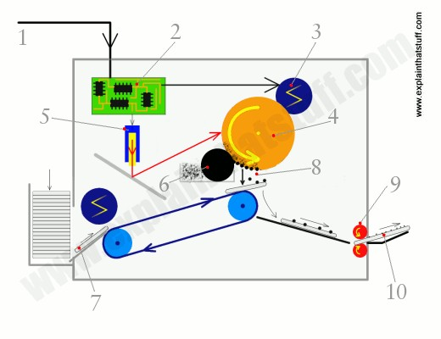

7. A sheet of paper from a hopper on the other side of the printer feeds up toward the drum. As it moves along, the paper is given a strong positive electrical charge by another corona wire.

8. When the paper moves near the drum, its positive charge attracts the negatively charged toner particles away from the drum. The image is transferred from the drum onto the paper but, for the moment, the toner particles are just resting lightly on the paper's surface.

9. The inked paper passes through two hot rollers (the fuser unit). The heat and pressure from the rollers fuse the toner particles permanently into the fibers of the paper.

10. The printout emerges from the side of the copier. Thanks to the fuser unit, the paper is still warm. It's literally hot off the press.

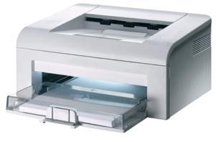

**20. Explain the working principle of Inkjet Printer.**

An **inkjet printer** is a type of [computer printer that](http://en.wikipedia.org/wiki/Printer_%28computing%29) creates a [digital image b](http://en.wikipedia.org/wiki/Digital_image)y propelling droplets of ink onto paper. Inkjet printers are the most commonly used type of printer[[1] a](http://en.wikipedia.org/wiki/Inkjet_printer#cite_note-0)nd range from small inexpensive consumer models to very large professional machines that can cost tens of thousands of dollars.

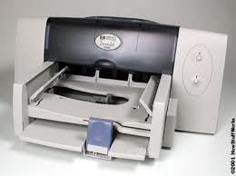

The concept of inkjet printing originated in the 19th century, and the technology was first extensively developed in the early 1950s. Starting in the late 1970s inkjet printers that could reproduce digital images generated by computers were developed, mainly by [Epson,](http://en.wikipedia.org/wiki/Epson) [Hewlett-Packard](http://en.wikipedia.org/wiki/Hewlett-Packard) (HP), and [Canon.](http://en.wikipedia.org/wiki/Canon_Inc.)

Inkjet printers contain hundreds of parts all working together to put millions of microscopic dots onto paper. There are five main components of an inkjet printer: print head, paper feeder,circuit board, power supply, and the case. Of these, the print head and paper feeder are the most interesting. **The Print Head**

The print head contains an array of microscopic nozzles that fire drops of ink onto the paper. In some cheap printers, the print head is not even part of the printer, but part of the ink cartridge. There are two main types of print head: thermal ("Bubblejet") and piezoelectric.

Thermal print heads have an array of microscopic nozzles with a small heater filament in each one. When a dot needs to be placed on the paper, current is passed through a filament to boil the ink in that nozzle and create a steam bubble. When the bubble pops, ink is shot out the nozzle end while more ink is sucked into the nozzle, ready for the next firing. This process is repeated thousands of times for every page printed. The term "Bubblejet" is actually a brand name owned by Canon, a major printer manufacturer, and is just another name for these inkjets.

Piezoelectric print heads use a special crystal that vibrates when electrified. This vibrating crystal acts like a plunger, pushing ink out of the nozzles and drawing more ink in. The main advantage over the thermal print heads is the larger range of inks they can use. It also allows for higher resolutions because the ink nozzles are closer together. Almost all inkjet printers made today use a piezoelectric print head.

Both types of print head are stabilized by a solid metal bar, and belt driven by a stepper motor. A stepper motor is special type of electric motor that moves in a precise amount for each electrical pulse it receives. As the print head moves back and forth, the printer fires the ink drops at the right time to form the array of dots that make up a printed shape.

**The Paper Feeder**

The paper feeder consists of the paper tray, pickup rollers, main rollers, and the stepper motors which drive the rollers. The pickup rollers lift a sheet of paper from the tray and move it into the main rollers. These long rollers, along with a fixed guide, keep the sheet align while it is moving. With each pass of the print head, the rollers move the sheet forward a little, until finally ejecting it after printing has finished.

The print quality depends as much on the type of paper as it does on the resolution. Photo paper has a waxy surface that prevents "feathering", which is the spreading out of ink dots as they are absorbed by the paper. It is important to note that, why many printers have high resolutions, low grade paper can never reach these resolutions due to feathering. Uncoated paper has about half the maximum resolution of coated paper.

**21. What is Pen Plotters? Explain.**

A graphic printer that draws images with ink pens. It actually draws point-to-point lines directly from vector graphics files. The plotter was the first computer output device that could print graphics as well as accommodate full-size engineering and architectural rawings. Pen plotters are still the most affordable printing device for CAD use and offer resolution unlike any other printer. The lines are not made up of dots. They are actually drawn, providing infinite resolution.

Pen plotters print by moving a [pen o](http://en.wikipedia.org/wiki/Pen)r other instrument across the surface of a piece of paper. This means that plotters are restricted to line art, rather than [raster graphics a](http://en.wikipedia.org/wiki/Raster_graphics)s with other [printers.](http://en.wikipedia.org/wiki/Computer_printer) Pen

plotters can draw complex line art, including text, but do so slowly because of the mechanical movement of the pens. They are often incapable of efficiently creating a solid region of color, but can [hatch](http://en.wikipedia.org/wiki/Hatching) an area by drawing a number of close, regular lines.

Plotters offered the fastest way to efficiently produce very large drawings or color high- resolution vector-based artwork when [computer memory w](http://en.wikipedia.org/wiki/Computer_memory)as very expensive and processor power was very limited, and other types of printers had limited graphic output capabilities.

Pen plotters have essentially become obsolete, and have been replaced by [large-format](http://en.wikipedia.org/wiki/Large-format) [inkje](http://en.wikipedia.org/wiki/Inkjet_printer)t [printers a](http://en.wikipedia.org/wiki/Inkjet_printer)nd LED toner based printers. Such devices may still understand vector languages originally designed for plotter use, because in many uses, they offer a more efficient alternative to raster data.

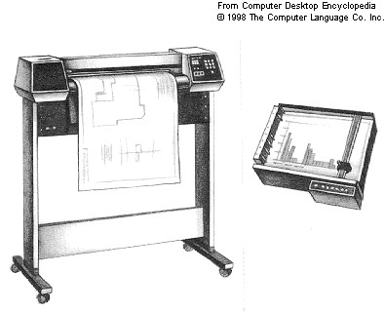

**22. What are the service routines provided by BIOS to handle mouse and printers? Explain. (NOV**

**2014)**

**BIOS** [**interrupt c**](http://en.wikipedia.org/wiki/Interrupt)**alls** are a facility that operating systems and application programs use to invoke the facilities of the [Basic Input/Output System on](http://en.wikipedia.org/wiki/BIOS) [IBM PC compatible c](http://en.wikipedia.org/wiki/IBM_PC_compatible)omputers. Traditionally, BIOS calls are mainly used by [MS-DOS p](http://en.wikipedia.org/wiki/MS-DOS)rograms and some other software such as [boot loaders. B](http://en.wikipedia.org/wiki/Boot_loader)IOS only runs in the [real address mode (Real Mode) of](http://en.wikipedia.org/wiki/Real_mode) the x86 CPU, so programs that call BIOS either must also run in real mode or must switch from protected mode to real mode before calling BIOS and then switch back again. For this reason, modern [operating systems that](http://en.wikipedia.org/wiki/Operating_system) use the CPU in [Protected Mode g](http://en.wikipedia.org/wiki/Protected_Mode)enerally do not use the BIOS to support system functions, although some of them use the BIOS to probe and initialize hardware resources during their early stages of [booting.](http://en.wikipedia.org/wiki/Booting)

In all computers, software instructions control the physical hardware (screen, disk, keyboard, etc.) from the moment the power is switched on. In a PC, the BIOS, preloaded in ROM on the mainboard, takes control immediately after the processor is reset, including during power-up or when a hardware reset button is pressed. The BIOS initializes the hardware, finds, loads and runs the boot program (usually, but not necessarily, an OS loader), and provides basic hardware control to the

operating system running on the machine, which is usually an operating system but may be a directly booting single software application.

Many modern operating systems (such as newer versions of [Windows a](http://en.wikipedia.org/wiki/Windows)nd [Linux)](http://en.wikipedia.org/wiki/Linux) bypass the built-in BIOS interrupt communication system altogether, preferring to use their own software to control the attached hardware directly. The original reason for this was primarily that these operating systems run the processor in protected mode, whereas calling BIOS requires switching to real mode and back again, and switching to real mode is slow. However, there are also serious security reasons not to switch to real mode, and the BIOS code has limitations both in functionality and speed that motivate operating system designers to find a replacement for it. In fact, the speed limitations of the BIOS made it common even in the MS-DOS era for programs to circumvent it in order to avoid its performance limitations, especially for video graphics display and fast serial communication. The problems with BIOS functionality include limitations in the range of functions defined, inconsistency in the subsets of those functions supported on different computers, and variations in the quality of BIOSes (i.e. some BIOSes are complete and reliable, others are abridged and buggy). By taking matters into their own hands and avoiding reliance on BIOS, operating system developers can eliminate some of the risks and complications they face in writing and supporting system software. On the other hand, by doing so those developers become responsible for providing "bare-metal" driver software for every different system or peripheral device they intend for their operating system to work with (or for inducing the hardware producers to provide those drivers). Thus it should be apparent that compact operating systems developed on small budgets would tend to use BIOS heavily, while large operating systems built by huge groups of software engineers with large budgets would more often opt to write their own drivers instead of using BIOS—that is, even without considering the compatibility problems of BIOS and protected mode.

For IBM's part, they provided all the information needed to use their BIOS fully or to directly utilize the hardware and avoid BIOS completely, when programming the early IBM PC models (prior to the PS/2). From the beginning, programmers had the choice of using BIOS or not, on a per- hardware-peripheral basis. Today, the BIOS in a new PC still supports most, if not all, of the BIOS interrupt function calls defined by IBM for the [IBM AT (introdu](http://en.wikipedia.org/wiki/IBM_AT)ced in 1984), along with many more newer ones, plus extensions to some of the originals (e.g. expanded parameter ranges). This, combined with a similar degree of hardware compatibility, means that most programs written for an IBM AT can still run correctly on a new PC today, assuming that the faster speed of execution is acceptable (which it typically is for all but games that use CPU-based timing). Despite the considerable limitations of the services accessed through the BIOS interrupts, they have proven extremely useful and durable to technological change.

**Purpose of BIOS calls**

BIOS interrupt calls perform hardware control or I/O functions requested by a program, return system information to the program, or do both. A key element of the purpose of BIOS calls is abstraction—the BIOS calls perform generally defined functions, and the specific details of how those functions are executed on the particular hardware of the system are encapsulated in the BIOS and hidden from the program. So, for example, a program that wants to read from a hard disk does not need to know whether the hard disk is an [ATA,](http://en.wikipedia.org/wiki/Parallel_ATA) [SCSI, or](http://en.wikipedia.org/wiki/SCSI) [SATA d](http://en.wikipedia.org/wiki/SATA)rive (or in earlier days, an [ESDI](http://en.wikipedia.org/wiki/Enhanced_Small_Disk_Interface) drive, or an [MFM o](http://en.wikipedia.org/wiki/Modified_Frequency_Modulation)r [RLL d](http://en.wikipedia.org/wiki/Run_Length_Limited)rive with perhaps a Seagate [ST-506 c](http://en.wikipedia.org/wiki/ST-506)ontroller, perhaps one of the several [Western Digital c](http://en.wikipedia.org/wiki/Western_Digital#1980s)ontroller types, or with a different proprietary controller of another brand). The program only needs to identify the number of the drive it wishes to access and the address of the sector it needs to read or write, and the BIOS will take care of translating this general request into the specific sequence of elementary operations required to complete the task through the particular disk

controller hardware that is connected to that drive. The program is freed from needing to know how to control at a low level every type of hard disk (or display adapter, or port interface, or real-time clock peripheral) that it may need to access. This both makes programming operating systems and applications easier and makes the programs smaller, reducing the duplication of program code, as the functionality that is included in the BIOS does not need to be included in every program that needs it; relatively short calls to the BIOS are included there instead. (In operating systems where the BIOS is not used, service calls provided by the operating system itself generally fulfill the same function and purpose.)

The BIOS also frees computer hardware designers (to the extent that programs are written to use the BIOS exclusively) from being constrained to maintain exact hardware compatibility with old systems when designing new systems, in order to maintain compatibility with existing software. For example, the keyboard hardware on the [IBM PCjr wo](http://en.wikipedia.org/wiki/IBM_PCjr)rks very differently than the keyboard hardware on earlier IBM PC models, but to programs that use the keyboard only through the BIOS, this difference is nearly invisible. (As a good example of the other side of this issue, a significant share of the PC programs in use at the time the PCjr was introduced did not use the keyboard through BIOS exclusively, so IBM also included hardware features in the PCjr to emulate the way the [original IB](http://en.wikipedia.org/wiki/IBM_Personal_Computer)M [PC a](http://en.wikipedia.org/wiki/IBM_Personal_Computer)nd [IBM PC XT k](http://en.wikipedia.org/wiki/IBM_Personal_Computer_XT)eyboard hardware works. The hardware emulation is not exact, so not all programs that try to use the keyboard hardware directly will work correctly on the PCjr, but all programs that use only the BIOS keyboard services will.)

In addition to giving access to hardware facilities, BIOS provides added facilities that are implemented in the BIOS software. For example, the BIOS maintains separate cursor positions for up to eight text display pages and provides for TTY-like output with automatic line wrap and interpretation of basic control characters such as carriage return and line feed, whereas the CGA- compatible text display hardware has only one global cursor and cannot automatically advance the cursor or interpret control characters.

**Keyboard**

|  |  |  |  |  |
| --- | --- | --- | --- | --- |
| Interrupt vector Description | Interrupt vector Description | | | |
| 17h | Printer services | | | |
|  | **AH** | **Description** |  |
| 00h | Print Character to  Printer |
| 01h | Initialize Printer |
| 02h | Check Printer Status |

**Cursor Control**

Each display of the current time by INT 21h, function 9, will advance the cursor

o If a new time is displayed, it appears at a different screen position

o So, to view the time updated at the same screen position we must restore the cursor to its original position before we display the time

o This is achieved by first determining the current cursor position; then, after each print string operation, we move the cursor back

We use INT 10h, functions 2 and 3, to save the original cursor position and to move the cursor to its original position after each print string operation

**INT 10h, Function 2**

*Described in I/O module, repeated here for convenience*

**Move Cursor**

Input:

o AH = 2

o DH = new cursor row (0-24)

o DL = new cursor column (0-79 for 80x25 mode)

o BH = page number

Output: none

**INT 10h, Function 3**

*Described in I/O module, repeated here for convenience*

**Get Cursor Position and Size**

Input:

o AH = 3

o BH = page number

Output:

o DH = cursor row

o DL = cursor column

o CH = cursor starting scan line

o CL = cursor ending scan line

**23. How to troubleshoot Input/Output related problems. Keyboard Troubleshooting and Repair**

The most frequent problems are as follows:

Defective cables

Stuck keys

If the keyboard stops working altogether or every keystroke results in an error or incorrect character, simply replace it.

Most modern keyboards have nonreplaceable cables, at least from the outside.

The only source for one would be another keyboard as a replacement.

Replacement keyboards are so inexpensive, it’s almost always cheaper to replace the entire

unit than to get a new cable.

Many times you first discover a problem with a keyboard because the system has an error during the POST.

Many systems use error codes in a 3xx numeric format to distinguish the keyboard.

Some BIOS versions do not use cryptic numeric error codes; they state something such as the following:

*Keyboard stuck key failure*

This message is usually displayed by a system with a Phoenix BIOS if a key is stuck.

But, the message does not identify which key it is.

If your system displays a 3xx (keyboard) error preceded by a two-digit hexadecimal number, the number is the scan code of a failing or stuck keyswitch.

Look up the scan code in the tables provided in the Technical Reference section on the book’s

DVD to determine which keyswitch is the culprit.

By removing the keycap of the offending key and cleaning the switch, can solve the problem.

**Cleaning a Keyboard**

One of the best ways to keep a keyboard in top condition is periodic cleaning.

As preventive maintenance, you should vacuum the keyboard weekly, or at least monthly.

When vacuuming, you should use a soft brush attachment to dislodge the dust.

Use a small, handheld vacuum cleaner made for cleaning computers.

**Repairing Monitors**

Although a display often is replaced as a whole unit, some larger displays might be cheaper to repair than to replace.

If decided to repair the monitor, best bet is to either contact the company from which you purchased the display or contact one of the companies that specialize in monitor depot repair.

Depot repair means sending a display to a repair specialist who either fixes your particular unit or returns an identical unit it has already repaired.

The price is the same no matter what the company has done to repair your actual unit.

Late-model monitors have built-in self-diagnostic circuitry.

Check your monitor’s manual for details.

If available, helps you determine whether the problem is really in the monitor, in a cable, or somewhere else in the system.

If self-diagnostics produce an image onscreen, look to other parts of the video subsystem.

**24. What is a scanner? Explain its different types. (APR 2012)**

A scanner is an [input device that](http://techterms.com/definition/inputdevice) scans documents such as photographs and pages of text. When a document is scanned, it is converted into a [digital fo](http://techterms.com/definition/digital)rmat. This creates an electronic version of the document that can be viewed and edited on a computer.

Most scanners are [flatbed d](http://techterms.com/definition/flatbed)evices, which means they have a flat scanning surface. This is ideal for photographs, magazines, and various documents. Most flatbed scanners have a cover that lifts up so that books and other bulky objects can also be scanned. Another type of scanner is a sheet-fed scanner, which can only accept paper documents. While sheet-fed scanners cannot scan books, some models include an automatic document feeder, or [ADF, whi](http://techterms.com/definition/adf)ch allows multiple pages to be scanned in sequence.

Scanners work in conjunction with computer [software p](http://techterms.com/definition/software)rograms, which import data from the scanner. Most scanners include basic scanning software that allows the user to configure, initiate, and import scans. Scanning [plug-ins c](http://techterms.com/definition/plugin)an also be installed, which allow various software programs to import scanned images directly. For example, if a scanner plug-in is installed for Adobe Photoshop, a user can create new images in Photoshop directly from the connected scanner.

While Photoshop can edit scanned images, some programs like Acrobat and OmniPage can actually recognize scanned text. This technology is called optical character recognition, or [OCR.](http://techterms.com/definition/ocr) Scanning software that includes OCR can turn a scanned text document into a digital text file that can be opened and edited by a [word processor. S](http://techterms.com/definition/wordprocessor)ome OCR programs even capture page and text formatting, making it possible to create electronic copies of physical documents.

**Flatbed Scanners**

Flatbed scanners will take up some desktop space but provide a lot of bang for the buck. They look like miniature printers with a flip-up cover protecting the glass platen.Depending on its size, a flatbed scanner can fit standard or legal-sized documents, and the flexible cover allows you to scan large items such as books. These scanners are great for scanning the occasional newspaper article, book

chapter, or photograph; or for those who may need to scan or bulky items such as the cover of a

DVD. Flatbed scanners are often built into [multifunction printers (M](http://printscan.about.com/od/printerscannertypes/a/multifunctions.htm)FPs).

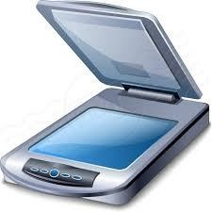

**Photo Scanners**

Scanning documents doesn’t require high resolution or [color depth;](http://printscan.about.com/od/printerscannerspecs/a/scanbasics.htm) but scanning photos does. Many all-purpose scanners can also scan photos, meaning that you don’t need a separate device to handle your photographs. But if you need a scanner primarily to digitize film negatives or slides, a photo [scanner is](http://printscan.about.com/od/printerscannerreviews/tp/Scanner-Gift-Guide-A-Guide-To-Buying-Scanners-For-The-Holidays.htm) a better deal (even if it is considerably more expensive than an all-purpose scanner). Photo scanners include specialized technology so that they can deal with slides and negatives; they also have built-in software to clean up old photos.

**Sheetfed Scanners**

Sheetfed scanners are smaller than flatbed scanners; as the name implies, you feed a document or photo into the scanner rather than place it on top. You’ll win back some of that desktop space with a sheetfed scanner but you may sacrifice some resolution in the process. If you’re only scanning documents, however, it may be a worthwhile trade, especially if you’ve got a lot of them since you can feed them in bunches. With a flatbed scanner, you’ll have to scan one page at a time.

**Portable Scanners**

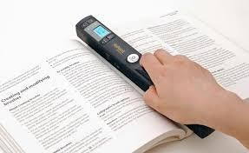

[Portable scanners a](http://printscan.about.com/od/scanners/gr/Docupen.htm)re small enough to bring on the road. In fact, some are small enough to put in your

pocket; pen scanners are just a bit bigger than fountain pens and can scan the text of a document line by line. Some are as wide as a page and roll easily down the page. They’re not going to give high-resolution scans and so aren’t good for scanning photographs or other applications where you need a high-quality result. Since they’re not cheaper than flatbed scanners.

**Pondicherry University Questions**

**PART A**

1. What are the four basic types of keyboard? **(NOV 2012)**

2. What are the two types keyboard interfaces. **(NOV 2010)**

3. What is the use of Connector? **(NOV 2012)**

4. What are the types of Mouse? **(APR 2012)**

5. What is the Joystick? **(APR 2011)**

6. What is Track Ball? **(APR 2012)**

7. What are the different types of Scanner? **(NOV 2012)**

8. List some of the display adapters. **(APR 2011)**

9. Define MTBF. **(NOV 2010)**

10. Define Scanner? **(NOV 2010)**

11. What are the print directions? **(NOV 2014)**

12. Expand MFM. **(NOV 2012)**

13. What do you mean by SVGA? **(NOV 2012)**

14. What is PPP? **(NOV 2013)**

15. What are the services included in LANE? **(NOV 2013)**

16. What is the function of modem?

PART - B

1. Explain different layouts of keyboard. (Ref.Pg.No.5,Qn.No.1)

2. Explain the two types of keyboards and the functions performed by the keyboard electronics with suitable diagram. **(APR 2011)** (Ref.Pg.No.5,Qn.No.2).

3. Explain Signals and interface standards for keyboard. (Ref.Pg.No.7,Qn.No.3).

4. Explain briefly about keyboard connectors and switches. (Ref.Pg.No.7,Qn.No.4).

5. Explain the working principles of keyboard and mouse. (APR 2012) (Ref.Pg.No.9,Qn.No.5).

6. Explain about Mouse. (Ref.Pg.No.10,Qn.No.6).

7. What are the different point devices available explain. (NOV 2012) (Ref.Pg.No.10,Qn.No.7).

8. Explain Joy stick with neat diagram. (Ref.Pg.No.12,Qn.No.8).

9. Explain briefly about Video Display Adapters. (Ref.Pg.No.13,Qn.No.9).

10. Explain briefly about Video Display Interfaces. (Ref.Pg.No.17,Qn.No.10).

11. How 3D Graphics Accelerators work? (Ref.Pg.No.20,Qn.No.11).

12. Explain briefly about LCD and LED Monitors. (Ref.Pg.No.23,Qn.No.12).

13. Explain any three types of printing mechanism in detail.(NOV 2010) (Ref.Pg.No.25,Qn.No.14).

14. Discuss any three types of printer in detail and point out the functions and characteristics.(APR 2011) (Ref.Pg.No.25,Qn.No.15).

15. What are the major output devices for a computer? (NOV 2013) (Ref.Pg.No.25,Qn.No.16).

16. Explain in detail about peripheral devices. (NOV 2012) (Ref.Pg.No.25,Qn.No.17).

17. What are the major difference between an impact printer and non-impact printer discuss. (NOV

2012) (Ref.Pg.No.25,Qn.No.18).

18. Explain the working principle of Laser Printer.(Ref.Pg.No.28,Qn.No.19).

19. Explain the working principle of Inkjet Printer. (Ref.Pg.No.29,Qn.No.20).

20. What is Pen Plotters? Explain. (Ref.Pg.No.30,Qn.No.21).

21. What are the service routines provided by BIOS to handle mouse and printers? Explain. (NOV 2014) (Ref.Pg.No.31,Qn.No.22).

22. How to troubleshoot Input/Output related problems. (Ref.Pg.No.34,Qn.No.23).

23. What is a scanner? Explain its different types. (APR 2012) (Ref.Pg.No.35,Qn.No.24).

**38 Computer Hardware and Troubleshooting**