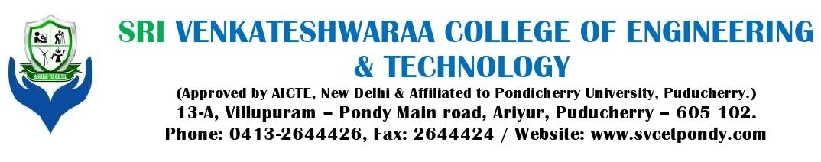**DEPARTMENT OF COMPUTER SCIENCE AND ENGINEERING**

**CS T72 - COMPUTER HARDWARE AND NETWORK TROUBLESHOOTING**

**UNIT - III**

**PARTA (2 Marks)**

* 1. Write few memory types?
  2. What are two categories of memory?
  3. Define RAM & what is Memory Module.
  4. What is the function of the memory? **(NOV 2012)**
  5. What is the hard disk and how does it work? **(NOV 2012)**
  6. What are the types of RAM module? **(NOV 2013)**
  7. Write about serial ATA. **(NOV 2013)**
  8. What are the two types of semiconductor memory? **(NOV 2014)**
  9. Classify the floppy diskette according to the sector organization. **(NOV 2014**
  10. Differentiate hard sector and soft sector disk. **(APR 2011)**
  11. What are the two formats for recording on a magnetic disk? **(APR 2011)**
  12. What is mean by disk and diskette? **(APR 2012)**
  13. Differentiate single and dual head assembly drive. **(NOV 2010)**
  14. What is DVD? **(APR 2012)**
  15. Write any two common aspects between HDD and FDD. **(NOV 2012)**
  16. Define SCSI?
  17. Define CD?
  18. What is Floppy Drive?
  19. How to troubleshoot memory problems?
  20. What is PATA?

**PART B (11 Marks)**

1. What is Memory? Explain the types of memory. (Ref.Pg.No.5,Qn.No.1)

2. How memory works with the processor? Discuss. **(NOV 2012)** (Ref.Pg.No.5,Qn.No.2)

3. Explain briefly about Memory modules. Explain briefly: SIMM, DIMM,DDR (Ref.Pg.No.12,Qn.No.3)

4. Explain about Memory Banks (Ref.Pg.No.14,Qn.No.4)

5. Explain about Parity and ECC in detail. (Ref.Pg.No.15,Qn.No.5)

6. Explain about Logical Memory Layout. (Ref.Pg.No.15,Qn.No.6)

7. Explain about data-encoding schemes. (Ref.Pg.No.16,Qn.No.7)

8. Briefly explain about Hard Disk Drive. **(APR 2011)** (Ref.Pg.No.19,Qn.No.8)

9. Discuss in detail about auxiliary storage device. **(NOV 2012)** (Ref.Pg.No.19,Qn.No.9)

10. Explain components available in hard disk. **(NOV 2013)** (Ref.Pg.No.19,Qn.No.10)

11. Describe the function of HDD. (APR 2012) (Ref.Pg.No.19,Qn.No.11)

12. What is SATA? Explain. (Ref.Pg.No.25,Qn.No.12)

13. Explain Flash Memory Devices. (Ref.Pg.No.25,Qn.No.13)

14. Explain briefly about Compact Disk (CD) (Ref.Pg.No.27,Qn.No.14)

15. What are the criteria to be considered when selecting a CD / DVD drive? Explain them. **(NOV2014)** (Ref.Pg.No.27,Qn.No.15)

16. Explain the structure and operating principles of CD-ROM in detail. **(NOV 2010)**

(Ref.Pg.No.27,Qn.No.16)

17. Explain in detail about CD and DVD technologies. **(APR 2012)** (Ref.Pg.No.27,Qn.No.17)

18. What are the types of Disk Drives? Explain it. **(NOV 2012)** (Ref.Pg.No.27,Qn.No.18)

19. Explain briefly about Digital Versatile Disc (DVD) (Ref.Pg.No.31,Qn.No.19)

20. Discuss about Optical Disc Format. (Ref.Pg.No.36,Qn.No.20)

21. Discuss in detail about Optical drive performance specifications (Ref.Pg.No.37,Qn.No.21)

22. Explain how can you test and troubleshoot the memory. **(NOV 2014)** (Ref.Pg.No.39,Qn.No.22)

23. What are the problems occurred in memory and how to troubleshoot it. (Ref.Pg.No.39,Qn.No.23)

24. Troubleshooting memory using BIOS Beep Codes (Ref.Pg.No.39,Qn.No.24)

25. What is SCSI? Discuss the eight bus phases of SCSI. **(APR 2011)** (Ref.Pg.No.40,Qn.No.25)

26. Discuss both FM and RLL recording methods of a magnetic disk drive. **(NOV 2010)**

(Ref.Pg.No.41,Qn.No.26)

27. Explain the following : a) Double Density Format, b) RLL Recording standards. **(NOV 2012)** (Ref.Pg.No.41,Qn.No.26)

**STAFF-INCHARGE HOD DEAN PRINCIPAL**